Dr. Santosh Kumar Prajapati
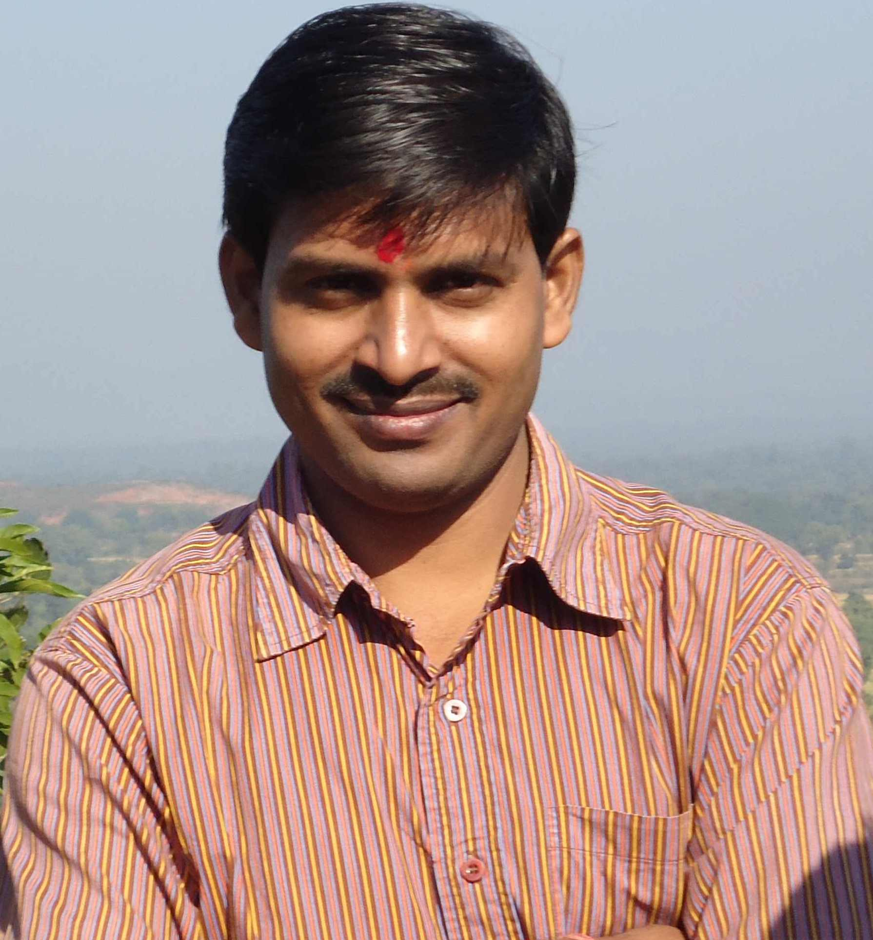
M.Sc., NET, Ph.D. (BHU)
Assistant Professor (ad-hoc)
Department of Botany
Guru Ghasidas Vishwavidyalaya
Bilaspur (C.G.) – 495009
Mobile – 09479168632
e-mail: sntshprjpt@rediffmail.com

Ph.D. Topic: “Ecological Investigation on Vehicular Pollution and its Impact on Plants”

Specialization
1. Stress Ecology, Terrestrial Ecology
2. Vehicular pollution

FELLOWSHIP/AWARDS/HONOURS
- Awarded Dr. D.S. Kothari Postdoctoral Fellowship by UGC, (May, 2009)
- Awarded Extended SRF in Earth Sciences (2008) by CSIR, New Delhi.
- Selected as Post Doctoral fellow in Université de Corse, UMR CNRS 6134, Sciences Pour l'Environnement, B.P. 52, 20 250 Corte (France) under Prof. Vanina Pasqualini for the year 2009 (tenure 1 year)
- Selected for Postdoctoral scholarship by Ministry of National Education and Religious Affairs, General Directorate of European & International Affairs,Directorate of International Relations in Education, Section A', Scholarship Department, Andrea Papandreou 37, 15180 Marousi, Greece for the academic year 2008-2009. Decision No. 109572/I/26.08.08
- Awarded CSIR-JRF in Life Sciences (2004).

PUBLICATIONS
- Ten research papers in journals of international repute
- One book (Lambert Academic Publishing, Germany)
- E-letter in Science (Native and Non-Native Species for Biofuels., Science(2006;313:1742)

