**CURRICULUM VITAE**

**Blessi Naresh Uikey**

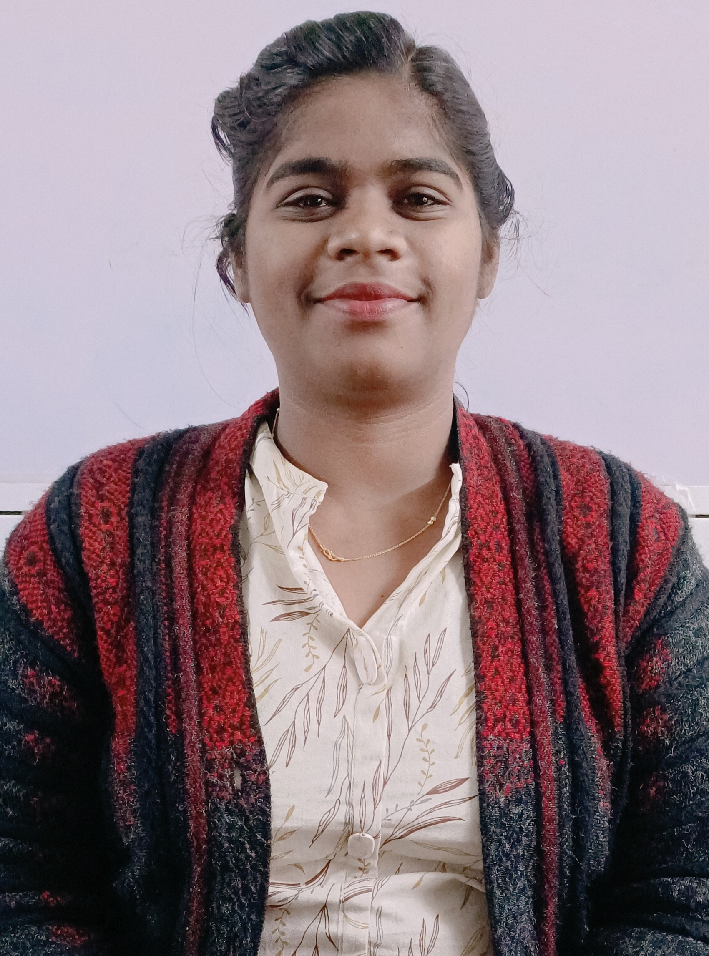

Assistant Professor,

Department of Forensic Science,

Guru Ghasidas Vishwavidyalaya,

Koni, Bilaspur, Chhattisgarh495009

Contact No.: +91 9370120118

Email: [blessiuikey@gmail.com](mailto:blessiuikey@gmail.com)

|  |
| --- |
| **WORK EXPERIENCE** |

July 2019 Onwards:

**Assistant Professor**

Department of Forensic Science,

Guru Ghasidas Vishwavidyalaya, Bilaspur, C.G

January 2018 to December 2018

**Scientific Assistant (Contractual)**

(Biology /DNA Division)

Regional Forensic Science Laboratory, Nagpur, M.H

|  |
| --- |
| **EDUCATIONAL QUALIFICATIONS** |

**Doctor of Philosophy (Ongoing),** Forensic Science, Department of Forensic Science, Guru Ghasidas Vishwavidyalaya, Bilaspur, C.G-495009

**Master of Science (2018**), Forensic Science, Govt. Institute of Forensic Science, Nagpur, Maharashtra, 440001- India.

**Bachelor of Science (2016)**, Forensic Science, Govt. Institute of Forensic Science, Nagpur, Maharashtra, 440001- India.

|  |
| --- |
| **OTHER QUALIFICATIONS AND ACHIEVEMENTS-** |

* Qualified NET (National Eligibility test) November 2017.
* Qualified NET (National Eligibility test) July 2018.
* Paper presentation on “Use of Nanoparticles for Latent Fingerprint Development”at National Conference on Forensic Science: An Interface between Science, Law and Justice.

|  |
| --- |
| **CERTIFICATION AND SKILLS** |

* Basic Biostatics data Analysis using SPSS(2023)
* Handling of Video spectral Comparator (VSC).
* Completed MSCIT course with 93% in March 2017.

|  |
| --- |
| **PUBLICATIONS** |

* Yadav, M**., Uikey, B**., Rathore, S., Gupta, P., Kashyap, D.,Kumar, C., Shukla, D.,Mahantesh, V.**,** Chandel, A. S.**,** Ahirwar, B.,Singh, A.,Suman, S. S., Priyadarshi, Amit.,Amit, A**.,** (2023). Role of Cytokine in Malignant T-Cell Metabolism and Subsequent Alternation In T-Cell Tumor Micro-environment.*Frontiers in Oncology*, 13,1235711.
* Kashyap, D. ., Yadav, M**.,** Rathore, S. S. ., Gupta , P. **., Uikey, B**. N., Kumar, C., Kanwal, N. K., Nishad, B. ., Jain , R. ., Chandra, T. L. ., Singh, A. K., Yadav, D., & Amit, A. (2024). Emerging Technologies to Combat Poaching. *Journal of Wildlife and Biodiversity*, *9*(1), 414–432. <https://doi.org/10.5281/zenodo.14635224>
* Kashyap, D., Yadav, M**.,** Rathore, S. S., Gupta, P., Rane, P., **Uikey, B**. N., ... & Amit, A. (2024). A Comparative Microscopic and Micrometric Analysis of Birds of Different Feather Types for Identification of Species. *Journal of International Wildlife Law & Policy*, 1-12.<https://doi.org/10.1080/13880292.2024.2440189>

**BOOK CHAPTERS**

* Megha Yadav , Shantnu Singh Rathore, Lt. Col. Kautuk Shrivastav, Dr. Chanchal Kumar, **Blessi N. Uikey**,"BIOMETRICS –AN EMERGING TOOL FOR PERSONAL IDENTIFICATION IN FORENSIC ", Futuristic Trends in Social Sciences Volume 3 Book 19,IIP Series, Volume 3, May, 2024, Page no.149- 168, e-ISBN: 978-93-5747-397-2, DOI/Link: <https://www.doi.org/10.58532/V3BJSO19P2CH5>
* Megha Yadav, Riya Tiwari, **Blessi N. Uikey**, Dr. Ashish Kumar Singh, Dr. Ajay Amit, "NANOPARTICLES AS AN EMERGING TOOL FOR FORENSIC INVESTIGATION ", Futuristic Trends in Social Sciences Volume 3 Book 19, IIP Series, Volume 3, May, 2024, Page no.194-226, e-ISBN: 978-93-5747-397-2, DOI/Link: <https://www.doi.org/10.58532/V3BJSO19P2CH7>
* Shantnu Singh Rathore , Sibani Panda , Megha Yadav , **Blessi N. Uikey** , Dr. Ajay Amit,"THE DIVERGENT IMPACT OF DRUG ABUSE ON SOCIETY", Futuristic Trends in Social Sciences Volume 3 Book 19,IIP Series, Volume 3, May, 2024, Page no.227-246, e-ISBN: 978-93-5747-397-2, DOI/Link: <https://www.doi.org/10.58532/V3BJSO19P2CH8>

**Orcid Profile** -https://orcid.org/0009-0009-4495-0925

|  |
| --- |
| **PERSONAL DETAILS** |

Name- Blessi N Uikey

Father’s Name- Naresh S Uikey

Mother’s name- Vasanti N Uikey

Date of Birth- 11 November 1995

Languages Known- English, Hindi, Marathi

Address- Plot N0. 95 Trust lay out pandhrabodi near Sukhniwas Apt. Nagpur 440033.

**Blessi Naresh Uikey**