# Prof. Namita Sharma

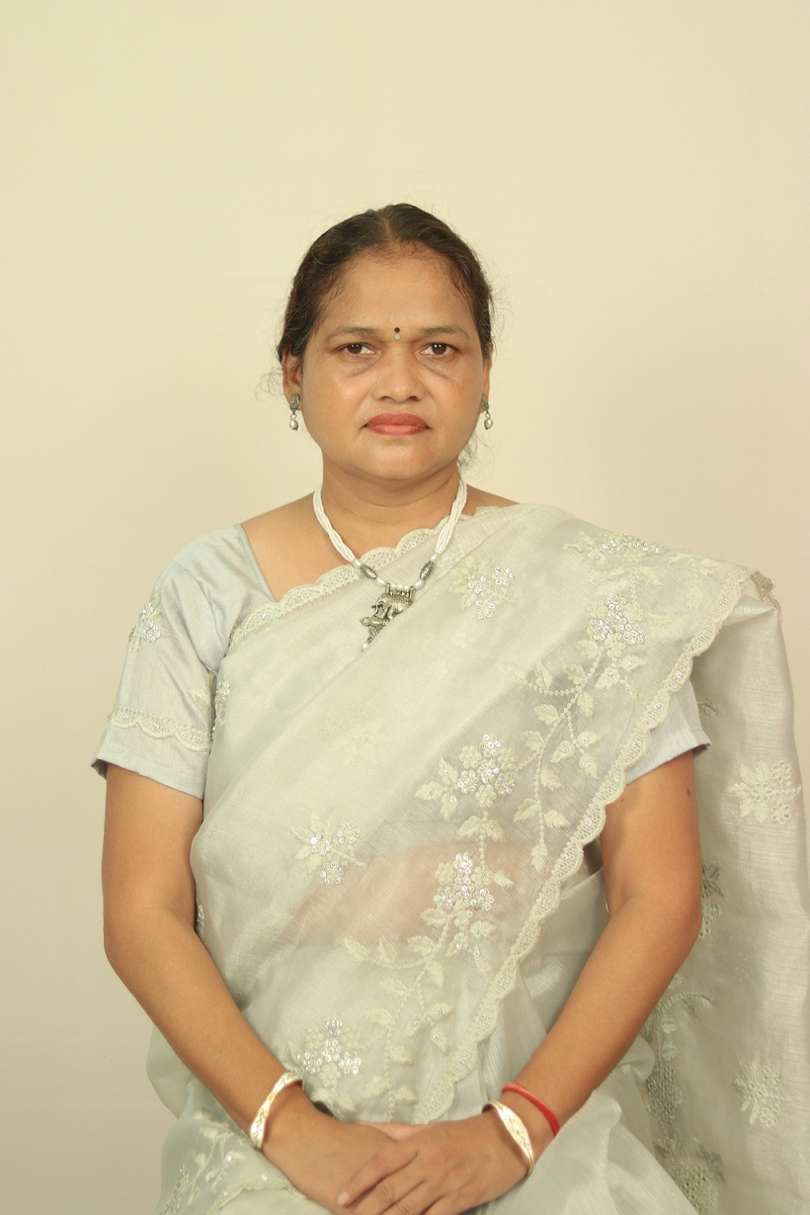

***(Professor)***

***Qualifications:*** *M.A., Ph.D. (Economics)*

***Area of Interest/Specialization:*** *Indian Economy ,Money and Banking*

***Experience:*** *18 years*

***Best Peer Reviewed Publication***

1 .Peer reviewed International Journal of Advanced Academic Studies 2706-8919 Contribution of Women in Indian Economy Vol. 2(1) 39 43 Dec, 2019

2. Peer reviewed International Journal of Applied Research 2394-7500 Poverty and Economic Development with relation of Social justicesVol. 6(1)96 98 Dec, 2019

3. Peer reviewed Remarking An Analysation 2394-034 Bharat me garibi ki samasya evam samadhan ka ek adhyayan Vol. 4, issue 2 H-76 H-78 May 2019

***Best UGC Care Publication***

1.UGC CARE Listed Think India Journal 0971-1260 A Comparative Study of the situation in India and Chhattisgarh in Achieving the Sustainable Development Goal SDG-4 (Quality Education) Vol. 22, issue14 9033 9045 Dec, 2019

2.UGC CARE Listed Think India Journal 0971-1260 An Analytical Study of the Challenges and Solutions of Child Labour Prevention Vol 22, issue 149000 9006 Dec, 2019

3. UGC CARE Listed Think India Journal 0971-1260 Study of Schemes Run by the Government for Rural Unemployment Prevention in Chhattisgarh Vol. 22, issue 1090899093 Nov, 2019

4.UGC Listed Review of Research 2249-894X Role and Importance of Agricultural Policy for the Development of Indian Economy Vol 8, issue 8 33 38 May- 2019

5. UGC Listed Review of Research 2249-894X An analytical Study of FDI in India (Article serial no. ROR-9076) Vol.8, issue 8 18 May 2019

6. UGC Listed Review of Research 2249-894X Agriculture Scenario in Chhattisgarh State (Article serial no. ROR-9079)Vol.8, issue 8 17May 2019

7.UGC Listed Review of Research 2249-894X Mook badhir balikaon par yog vyayaam v khel ke prabhav ka adhyayan (Bilaspur jile mein sthith mook baghir vidyalaya ke sandarvh par aadharit adhyayan) (Article serial no. ROR-9078) Vol. 8, issue 8 1 12 May 2019

# Recent Books- 03/Book Chapters-05 /Monographs etc.:

*Research Supervision: 1 Phd (Awarded); 3( Submitted); 3( Ongoing****)*** *Dissertation Supervised PG-(22) UG(45)*

***Administrative Responsibilities:***

# Statutory/Administrative Positions held/holding at GGV :

* + - *Working as a member of Acedemic Council at GGV, w.e.f..2019 to 2021*
    - *Working as the In-charge HOD, Department of Economics GGV, 29.08.2019 to 11.12.2021*
    - *Working as the Hostel Worden at GGV, w.e.f 15.10.2015 to 26.06.2021*
    - *Working as a member of Media Cell 2015 .*
    - *Working as a member of DRC, Department of Economics, GGV.*
    - *Working as a member of Cafeteria Monitoring Committee at GGV (2017-2021).*
    - *Working as a member of Anti- Ragging Committee*
    - *In-charge Departmental Library, Department of Economics, GGV 2010 to till date.*
    - *Former Director of women study centre.GGV, Bilaspur*
    - *Admin Warden of Research Girls Hostel,GGV Bilaspur*

## Conference/Seminar: 35 Workshop: 08