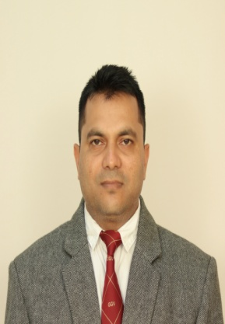

**OMPRAKASH GANGEY**

Assistant Professor

Department of Physical education

Guru Ghasidas Vishwavidyalaya, Koni, Bilaspur, C.G.

Mob- 08251037426, Emai:[**jaigangey@gmail.com**](mailto:jaigangey@gmail.com)**,** [**jai.gangey@ggu.ac.in**](mailto:jai.gangey@ggu.ac.in)

**Qualifications:**

1. B.P. Ed (2011) from LNIPE, Gwalior, M.P., India
2. M.P. Ed. (2013) from GGV Central University, Bilaspur, C.G.
3. UGC-NET examination in December, 2013.
4. CG-SET examination in December, 2013.

**Area of Interest/Specialization:**Specialization in Volleyball.Subject Teaching: History, Principles & Introduction in Physical Education and Sports management and curriculum design.

**Teaching Experience:** UG-11 Years PG- 11 Years

**Awards and Honors: Nil**

**Research Projects: Nil**

**International Collaboration/Consultancy: Nil**

**Best Peer Reviewed Publication (up-to 10): 10**

**Recent Books/Book Chapters/Monographs etc.: 04**

**Research Supervision: Nil**

**Administrative Responsibilities:**

1. Member of University Housekeeping monitoring committee.
2. Member of Ek Bharat Shresth Bharat.
3. Assistant superintendent of Examination.
4. Member of University Proctorial Board.
5. Member of University Anti Ragging Cell.
6. Programme officer of NSS.
7. AQAR Co- Coordinator.

**Additional Information:**

1. Alumni In-charge of Department of Physical Education.
2. Co- Coordinator of Department Exmination.
3. Student’s Mentor for B.P. Ed. Class.
4. Class Teacher.
5. Intramural House In charge.
6. Member of sports selection Committee for various interuniversity tournaments.
7. Examiner of internal/ external Exam.
8. Department Sports Store In-charge.