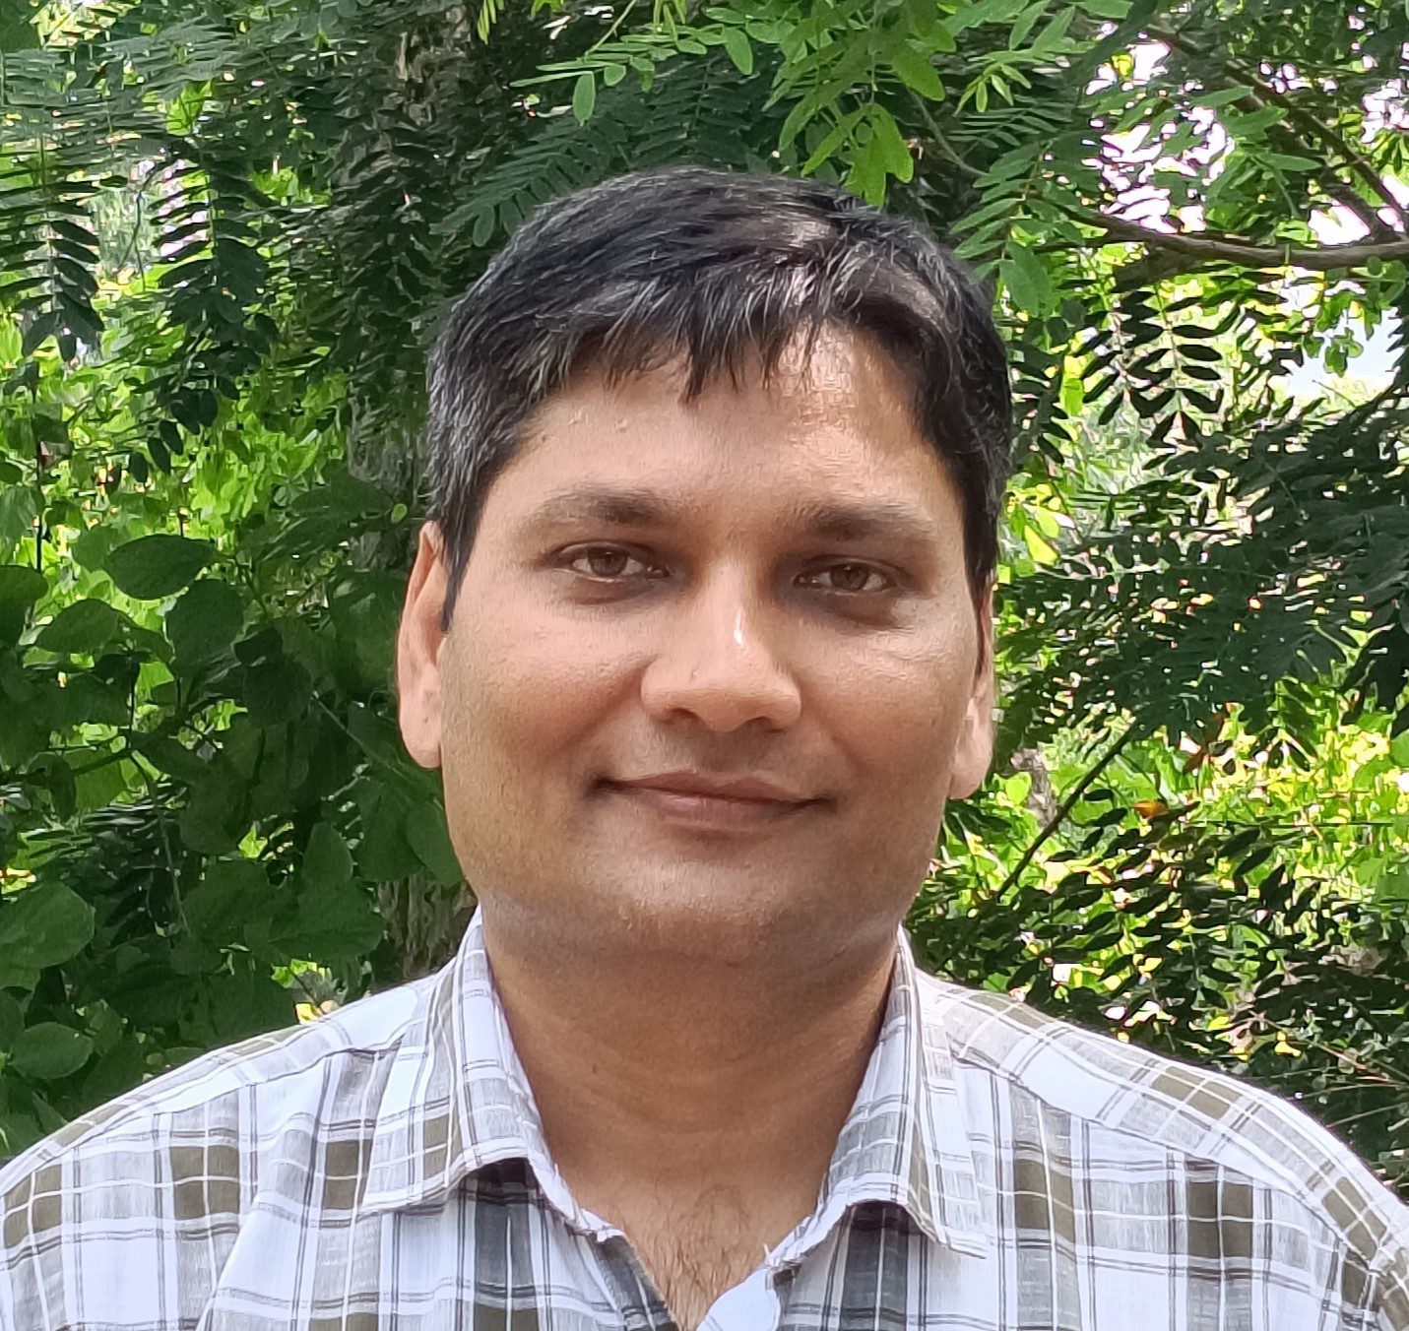

**Name:**

**School:**

Deepanker Yadav

School of Studies in Life Science

**Department:** Botany

**Phone:** 9491863302

**Email:** [deepankerbhu@gmail.com](mailto:deepankerbhu@gmail.com)

**Personal Webpage Link:** [ORCID](https://orcid.org/0000-0001-6186-7052) | [Google Scholar](https://scholar.google.com/citations?user=FhifyL0AAAAJ&hl=en&authuser=1)

**Qualifications**: M.Sc., Ph.D.

**2010 – 2016** Ph.D. Work carried out under the supervision of Prof. P.B. Kirti at Department of plant sciences, University of Hyderabad, Hyderabad, India

**2007 – 2009** M.Sc. Botany, Banaras Hindu University, India

**2002 – 2005** B.Sc. Botany, D.D.U. Gorakhpur University, India

**Area of Interest/Specialization**: Plant stress physiology and molecular biology

# Experience:

**12/2019 to date** Assistant Professor in Department of Botany, Guru Ghasidas Vishwavidyalaya, koni, Bilaspur.

**3/2017 – 09/2019** Postdoctoral Research in the Department of fruit tree Sciences, Institute of Plant Sciences, Agricultural Research Organization (ARO), Ministry of Agriculture and Rural Development, Volcani, Israel

**7/2011 -10/2011** Visiting scholar in DAAD Program “A new passage to India” and “Pre PhD-Module in Life Sciences” at the University of Münster, Germany

# Awards and Honors:

**Research Projects**: Completed: UGC StartUP, Budget (10 Lacs), Duration (2 years)

# International Collaboration/Consultancy List of Publication

# Journal

* Sahoo, L., Swain, B., & Yadav, D. (2025). A review on different priming strategies to mitigate abiotic stress in plants. *Discover Applied Sciences*, *7*(6), 618. <https://doi.org/10.1007/s42452-025-07009-x>
* Swain, B., & Yadav, D. (2025). Genome-wide identification and characterization of annexin family in cowpea (Vigna unguiculata (L.) Walp.). *Genetic Resources and Crop Evolution*, 1-24. <https://doi.org/10.1007/s10722-025-02417-9>
* Swain, B., Gupta, P., & Yadav, D. (2024). Genome-wide identification and in silico analysis of annexins in chickpea (Cicer arietinum L.). *Biochemical Genetics*, 1-27. <https://doi.org/10.1007/s10528-024-10979-z>
* Boyidi, P., Trishla, V.S., Botta, H.K., Yadav, D. and Kirti, P.B., 2021. Heterologous expression of rice annexin OsANN5 potentiates abiotic stress tolerance in transgenic tobacco through ROS amelioration. Plant Stress, 2, p.100022. <https://doi.org/10.1016/j.stress.2021.100022>
* Joshi, N. C., Yadav, D., Ratner, K., Kamara, I., Aviv‐Sharon, E., Irihimovitch, V., & Charuvi, D. (2020). Sodium hydrosulfide priming improves the response of photosynthesis to overnight frost and day high light in avocado (Persea americana Mill, cv.‘Hass’). Physiologia plantarum, 168(2),394-405. <https://doi:10.1111/ppl.13023>
* Yadav, D. , Zemach, H., Belausov, E., Charuvi, D. (2019), Initial proplastid-to-chloroplast differentiation in the developing vegetative shoot apical meristem of Arabidopsis. Biochemical and Biophysical Research Communications. <https://doi.org/10.1016/j.bbrc.2019.09.019>
* Yadav, D., Boyidi, P., Ahmed, I., & Kirti, P. B. (2018). Plant annexins and their involvement in stress responses. Environmental and Experimental Botany, 155, 293-306. <https://doi.org/10.1016/j.envexpbot.2018.07.002>
* Ahmed, I., Yadav, D., Shukla, P., & Kirti, P. B. (2018). Heterologous expression of Brassica juncea annexin, AnnBj2 confers salt tolerance and ABA insensitivity in transgenic tobacco seedlings. Functional & Integrative Genomics, 18(5), 569-579. <https://doi.org/10.1007/s10142-018-0614-z>
* Ahmed, I., Yadav, D., Shukla, P., Vineeth, T. V., Sharma, P. C., & Kirti, P. B. (2017). Constitutive expression of Brassica juncea annexin, AnnBj2 confers salt tolerance and glucose and ABA insensitivity in mustard transgenic plants. Plant Science, 265, 12-28. <https://doi.org/10.1016/j.plantsci.2017.09.010>
* Shukla, P., Singh, N. K., Gautam, R., Ahmed, I., Yadav, D., Sharma, A., & Kirti, P. B. (2017). Molecular approaches for manipulating male sterility and strategies for fertility restoration in plants. Molecular Biotechnology, 59(9-10), 445-457. <https://doi.org/10.1007/s12033-017-0027-6>
* Yadav, D., Ahmed, I., Shukla, P., Boyidi, P., & Kirti, P. B. (2016). Overexpression of Arabidopsis AnnAt8 alleviates abiotic stress in transgenic Arabidopsis and tobacco. Plants, 5(2), 18[. https://doi.org/10.3390/plants5020018](https://doi.org/10.3390/plants5020018)
* Yadav, D., Ahmed, I., & Kirti, P. B. (2015). Genome-wide identification and expression profiling of annexins in Brassica rapa and their phylogenetic sequence comparison with B. juncea and A. thaliana annexins. Plant Gene, 4, 109-124. <https://doi.org/10.1016/j.plgene.2015.10.001>
* Dalal, A., Kumar, A., Yadav, D., Gudla, T., Viehhauser, A., Dietz, K.-J., & Kirti, P. B. (2014). Alleviation of methyl viologen-mediated oxidative stress by Brassica juncea annexin-3 in transgenic Arabidopsis. Plant Science, 219, 9-18. <https://doi.org/10.1016/j.plantsci.2013.12.016>

**Conference**

* Ratner, K., Joshi, N. C., Yadav, D., Many, Y., Kamara, I., Esquira, I., et al. (2020). Application of LED-interlighting for improving the yield of passive tunnel-grown bell pepper. doi: 10.17660/ActaHortic.2020.1268.3.
* Tiwari, V., Kamara, I., Yadav, D., Irihimovitch, V., & Charuvi, D. (2022, August). Testing chemical priming with sodium hydrosulfide in commercial avocado (Persea americana Mill. Hass) orchards for improving the response to chilling conditions. In *XXXI International Horticultural Congress (IHC2022): International Symposium on Adaptation of Horticultural Plants to Abiotic 1372* (pp. 193-198). <http://doi.org/10.17660/ActaHortic.2023.1372.25>

# Recent Books/Book Chapters/Monographs etc.

# Books

# Ethnomedicinal Plants for Drug Discovery - Current Developments (Springer Nature)

# Book Chapters

* Swain, B., Sahoo, L., Tiwari, V., Kumar, C., Joshi, N. C., Singh, P. K., ... & Yadav, D. (2025). Reactive Oxygen Species: Their Generation and Signalling during Abiotic Stress in Plants. In *Soil Health and Nutrition Management* (pp. 169-181). GB: CABI. [**https://doi.org/10.1079/9781800624597.0010**](https://doi.org/10.1079/9781800624597.0010)
* Ahirwar, R. K., Kumar Srivastava, A., Yadav, D., Bhoi, D. K., & Jangde, R. (2024). Exploration of Ethnomedicinal Plants for Drug Discovery in High-Throughput Omics Era. In *Ethnomedicinal Plants for Drug Discovery: Current Developments* (pp. 423-442). Singapore: Springer Nature Singapore. <https://doi.org/10.1007/978-981-97-3405-4_18>
* Kilambi, H. V., Shweta, Yadav, D., and Tyagi, K. (2022). “Secondary metabolites and plant abiotic stress responses,” in Molecular Response and Genetic Engineering for Stress in Plants, Volume 1 2053-2563. (IOP Publishing), 13–1 to 13–17. doi: 10.1088/978-0-7503-4921-5ch13
* Singh, A., Roychowdhury, R., Singh, T., Wang, W., Yadav, D., Kumar, A., et al. (2020). Improvement of Crop’s Stress Tolerance by Gene Editing CRISPR/CAS9 System. Sustain. Agric. Era Clim. Chang., 557–587.
* Singh, J., Gupta, M., Singh, K. K., Kumar, A., Yadav, D., Wenjing, W., & Singh, P. K. (2021). Advancement in bioinformatics and microarray-based technologies for genome sequence analysis and its application in bioremediation of soil and water pollutants. In Microbe Mediated Remediation of Environmental Contaminants (pp. 209-225). Woodhead Publishing.
* Singh, S. K., Shrivastava, A. K., Kumar, A., Singh, V. K., Yadav, D., Modi, A., ... & Singh, P. K. (2020). Cyanobacterial genome editing toolboxes: Recent advancement and future projections for basic and synthetic biology researches. In Advances in Cyanobacterial Biology (pp. 129-149). Academic Press.
* Kumar, C., Chatterjee, A., Wenjing, W., Yadav, D., & Singh, P. K. (2020). Cyanobacteria: Potential and role for environmental remediation. In Abatement of Environmental Pollutants (pp. 193-202). Elsevier.
* Singh, T., Singh, A., Wang, W., Yadav, D., Kumar, A., & Singh, P. K. (2019). Biosynthesized nanoparticles and its implications in agriculture. Biological Synthesis of Nanoparticles and Their Applications, 257-274.

**Research Supervision**: Ph.D.: 3 (pursuing), PG level: 23 (completed), UG level: 22 (completed)

# Additional Information:

**Editor**

* **Editor, Scientific Report, Nature publishing group**
* **Frontiers in Plant Science**

**Invited Reviewer**

* Plant Cell, ASPB
* Frontiers in Genetics, Frontiers
* Frontiers in Plant Science
* Journal of Nanobiotechnology, BMC
* Plant Gene, Elsevier
* Journal of Plant Physiology, Elsevier
* Journal of Soil Science and plant nutrition
* BMC plant biology

# Responsibilities

* Department DRC Member
* Departmental co-coordinator energy literacy training program (September 2025 - present)
* Criteria II co-coordinator IQAC (September 2025- present)
* Criteria IV coordinator department level (September 2025 - present)
* Time table incharge (December 2024-present)
* ICT incharge Department Level (December 2024 - present)
* Assistant in charge officer (Jawahar guest house and international guest house) (2022-23)
* NSS program officer (Botany Unit) (2022 -2024)
* Assistant Centre superintendent (Biotech and Botany Building 2022-23)
* Department Coordinator for placement cell (2021 onwards)
* Stationary shop / technical committee (2022-23)
* Department Instrument committee (2021-2024)
* Department Sports coordinator (2019-20)
* UG and PG admission committee (2020-21, 2022-23)
* Member of Scrutiny committee of faculty interview (2019-20)