REPORT OF FIRST INTRA NEGOTIATION

COMPETITION

[Oct 17th to Oct, 19th, 2023]

*Prepared by Dr. Sagar Kumar Jaiswal*

*(Convenor of the Event)*

Alternative Dispute Resolution Cell (ADRC), a newly established student committee supervised by faculty members of which the Coordinator is Mr. Sudhansu Shekhar Bisen, hosted 3 days Negotiation Competition under the convenorship of Dr. Sagar Kumar Jaiswal. This event served as a testament to the ADRC's commitment to its mission, i.e., to enable students to learn the art of alternative dispute resolution mechanism.

The competition revolved around the dispute between two corporate giants in the technology industry: one is a renowned hardware manufacturer, and another is an innovative software development company. These companies had embarked on a joint venture to create a groundbreaking smart home system that combined the features of both hard ware and software. Their collaboration was governed by a Joint Venture Agreement (JVA) that defined profitsharing, intellectual property rights, project milestones, and dispute resolution mechanisms. However, as the project progressed, conflicts emerged. Disagreements over responsibilities, delays in achieving project milestones, and disputes about ownership of critical intellectual property arose, making the situation very much complex. One party went to the court, but the court mandated the disputes be resolved through Alternative Dispute Resolution Mechanism.

Although the event commenced on 17th of October but in reality, it started much before than the starting day. As the success of this event required that students must be sufficiently trained,

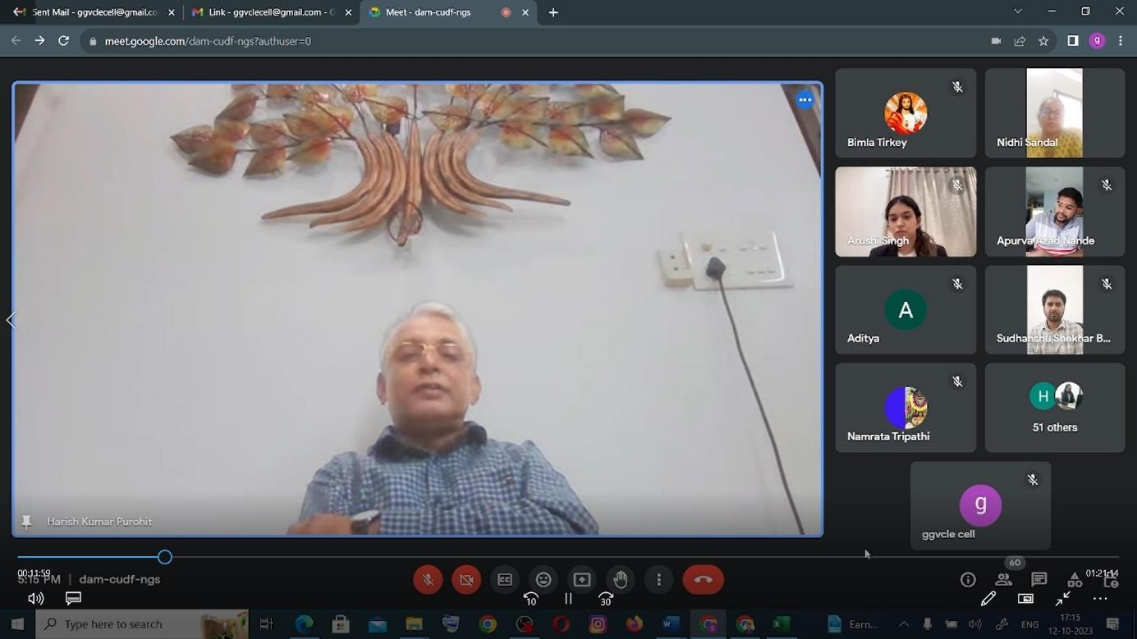

therefore, in order to make them enable, the ADR cell, by using the resources of Nidhi Madam, has organised one day workshop on **12th of** **October,** on the topic “**The Art of Negotiation in**

**Mediation Proceeding**”. For this purpose, **Shri Harish Purohit ji**, a Senior Advocate of High Court of Rajasthan, was invited for gracing the occasion. And he wonderfully delivered an online lecture on this. This educational event equipped our students with valuable skills in the field.

To make participants and students more enabled, ADR Cell organised one more workshop, this time on “**The Art of Procedures of Arbitration Proceedings**. It was an offline workshop, and was conducted on 13th of October, and **Shir Ashok Kumar Panda Sir**, A Retired District Judge

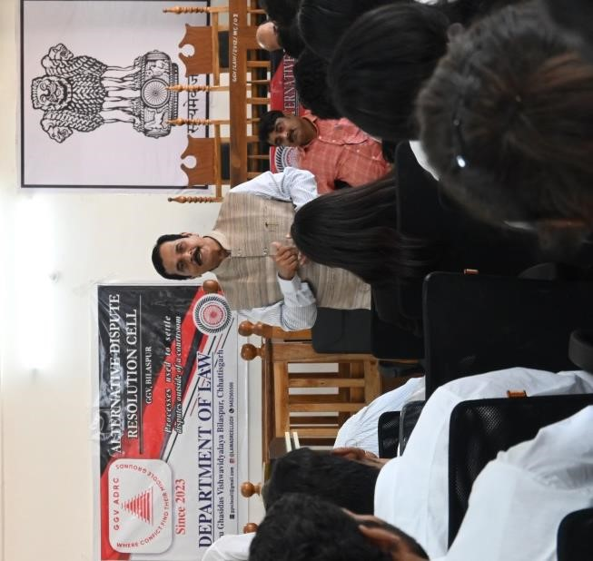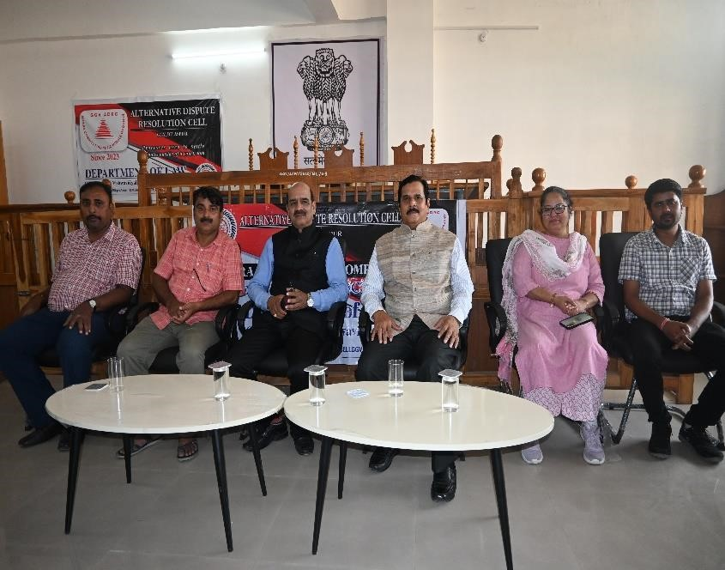

and former Registrar of Hon’ble High Court of Chhattisgarh, graced the occasion. This session also enabled our students and participants. I congratulate Mr. Apurva Azad, a student coordinator of this event, who manage hard to bring him in our department.

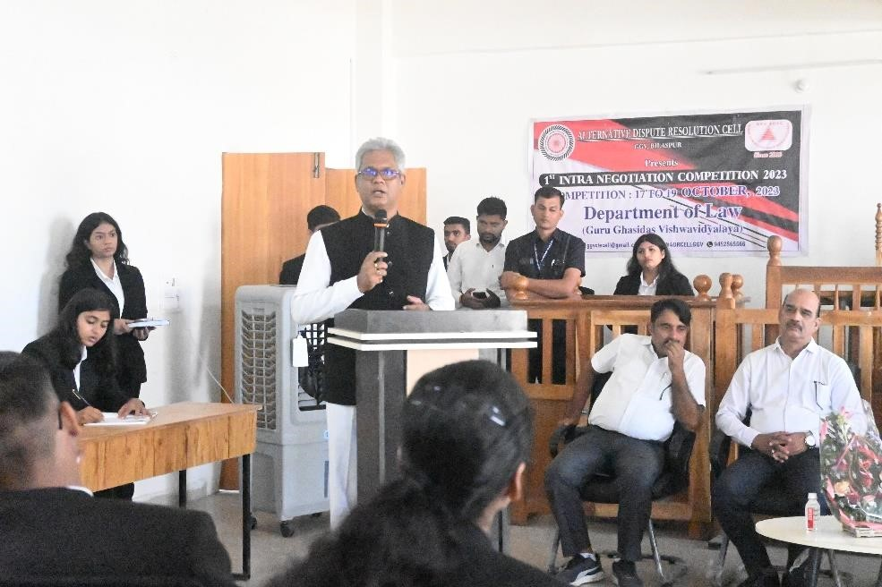Then come the date of commencement of negotiation competition, everyone was are waiting for. In its augural ceremony, head of department, Dr. Ajaiy Singh did a wonderful job, and it is because of his effort that the department witnessed the presence of **Advocate General of Hon’ble High Court of Chhattisgarh** in our department. **Shri Satish Chandra Verma Ji,** the said advocate general, graced the occasion, encouraged our students, and also cut a ribbon for starting of the Negotiation

Competition. He also gave the tips to our participants.

This Negotiation Competition aimed to create a platform where participants could enhance their negotiation skills and foster the spirit of teamwork and diplomacy. And certainly, during these three days the department witnessed some of the brightest legal minds engage in fierce yet constructive negotiations. This Intra Negotiation competition brought together 84 numbers of students across 3rd, 4th and 5th years students. Where 3rd year students played roles of clients, 4th years students—mediator, the role of counsel and coach were played by the students of 5th year.

Two clients, one mediator, three counsel, and one coach constituted one team, thus total 12 team were involved in this competition. And total number of matches among team including semifinal and final were **fifteen**. The teams who played a final round matches actually were involved in 4 matches.

These teams **showcased** their skills not only in negotiation but also in adaptability, creativity, and problem-solving. It was cheering to witness the passion and dedication of each participant, who contributed to the success of this event.

The competition comprised two preliminary rounds, one semi-final round, and one final round. Each round presented a unique set of challenges designed to test the negotiation skills of the participants. The scenarios and case studies were carefully crafted to reflect real-world negotiation situations, including legal disputes, business transactions, and diplomatic affairs.

The judges, who actually are faculty members and research scholars, and among them whom some have practical experiences in the field of negotiation, have played a pivotal role in ensuring the fairness and objectivity of the judging process.

The responsibility of conducting the round was posed on Moderator, and I, without any hesitation, can say that these moderators, who actually are our students, they have done wonderful job, have kept the business of conducting the round, regularly instructing and within control.

Throughout the competition, the department have observed remarkable performances, creative negotiation strategies, and excellent teamwork. The winner and the participants both deserved congratulations for showing their dedication and hard work. Their commitment to this competition has set a high standard for future events.

Following the final round match, that was held on the morning of 19.10.2023, the department witnessed valedictory session. The session was graced by the presence of Hon'ble Vice Chancellor, Prof. (Dr.) Aloke Chakrawal, and Registrar, Prof (Dr.) Manish Srivastava, who were the Chief Guest and Guests for both opening ceremony of Computer Lab in the department and the Valedictory Session, respectively. While appraising the computer lab, he was very much particular to need of the students of law. Towards fulfilling the expectation of law students he disclosed that these students will soon have access to database like Manupatra or SCC Online, as per

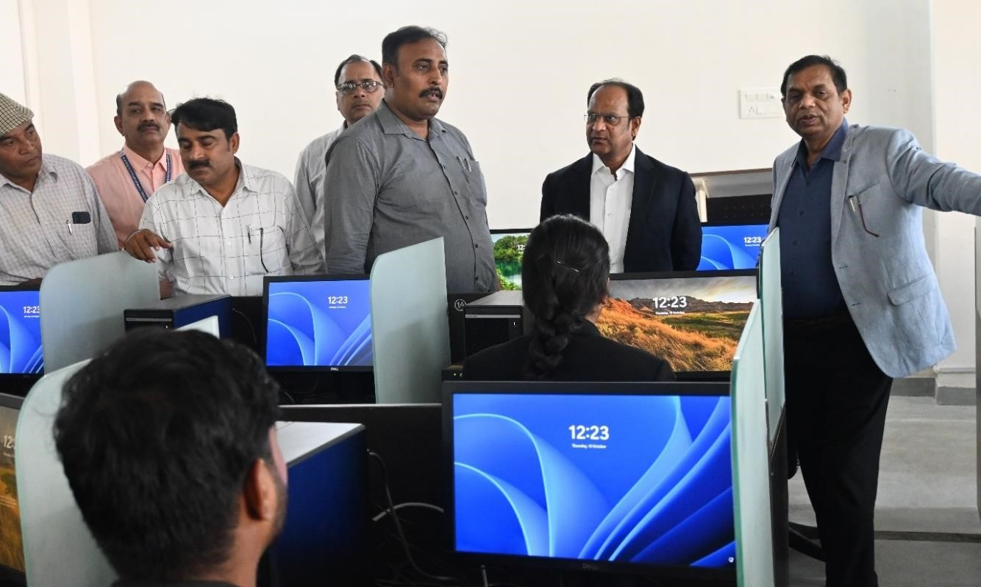

rule.

Their presence in the Valedictory session were marked by great honor and significance for both the faculty and students within the department, as they had the privilege of receiving words of encouragement and inspiration from these distinguished guests, further motivating them towards academic excellence. Hon’ble Vice Chancellor sir in speech consist of how a law student has to

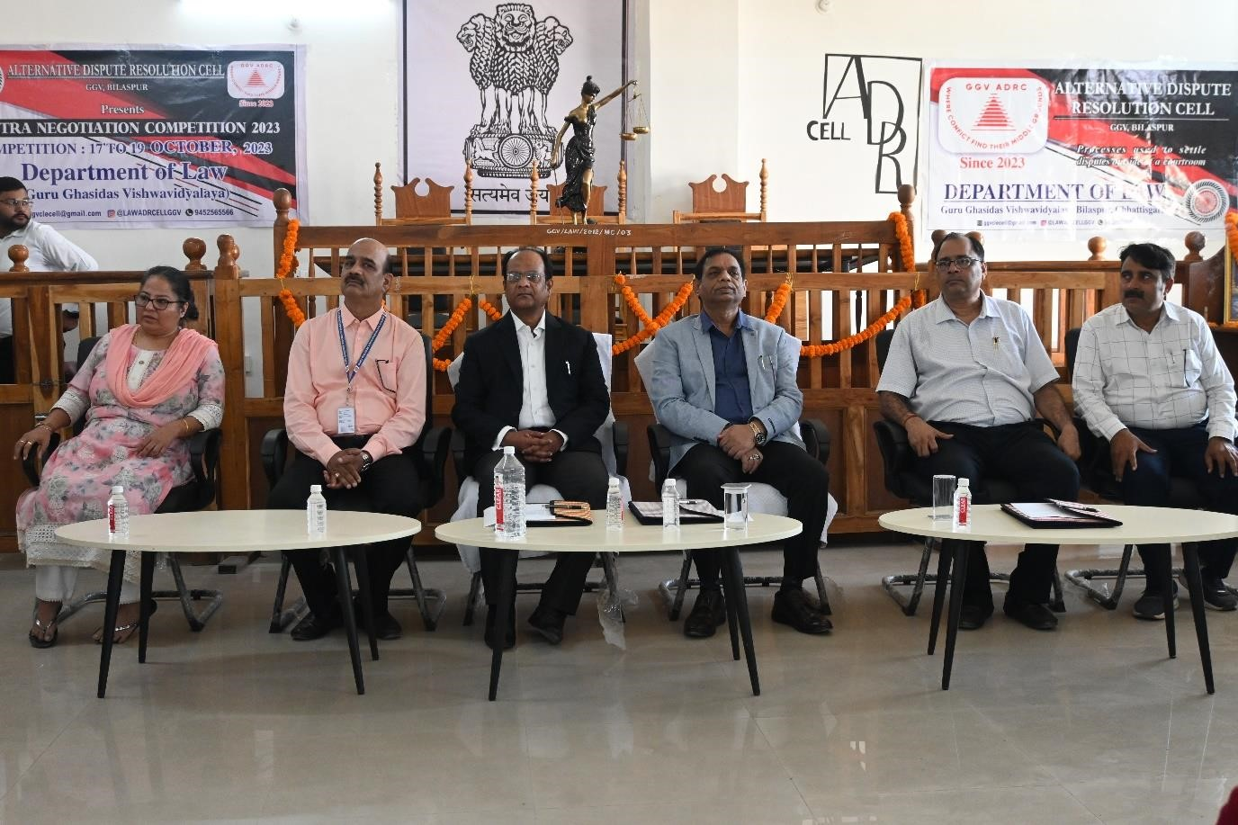

manage both study and get experience in field od law and according to him a law student has to research cases as much he/she can because it is important for a law student

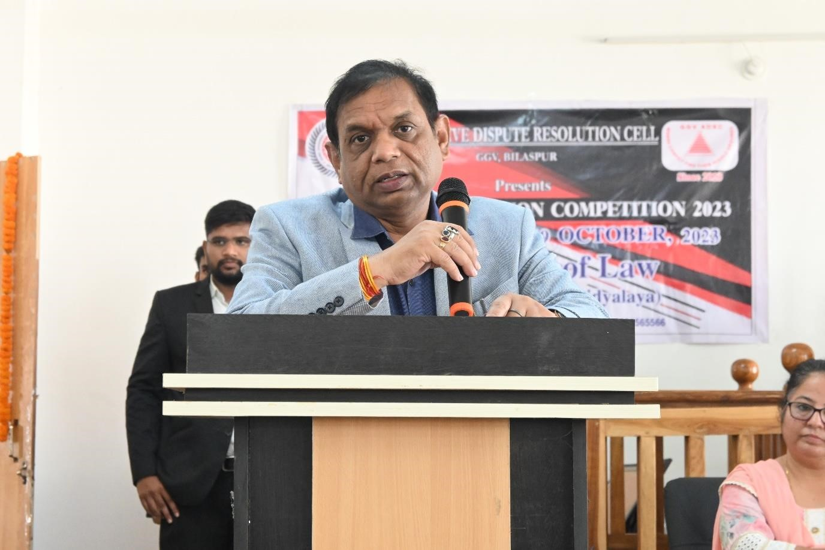

During the valedictory session, participants and the organizing team were recognized and awarded by Hon'ble Vice Chancellor Sir, which must have been a significant recognition of their efforts and achievements.

The valedictory session's success can be attributed to the invaluable mentorship provided by Professor (Dr.) M N Tripathy, the Dean of the School of Studies of Law. His guidance and support at every step played a pivotal role in ensuring that the session was both purposeful and successful.

The team, composed of the following students under different roles, emerged as the winners and each of them was honored with an Award and Certificate from the Honorable Vice Chancellor.

|  |  |  |  |  |  |  |
| --- | --- | --- | --- | --- | --- | --- |
| **Client 1** | **Client 2** | **Mediator** | **Chief Counsel** | **Assistant Counsel 1** | **Assistant Counsel 2** | **Coach** |
| Mahak Tolani | Anshi Nidhi Xalxo | Mh. Nakeeb | Azka Alam | Prashthi Shukla | Amisha Panjwani | Studyi Bisen |
| BCOMLL  B | BCOMLLB | BALLB | BCOMLLB | BALLB | BCOMLLB | BCOMLLB |
| 5TH | 5TH | 7TH | 9TH | 7TH | 9TH | 9TH |

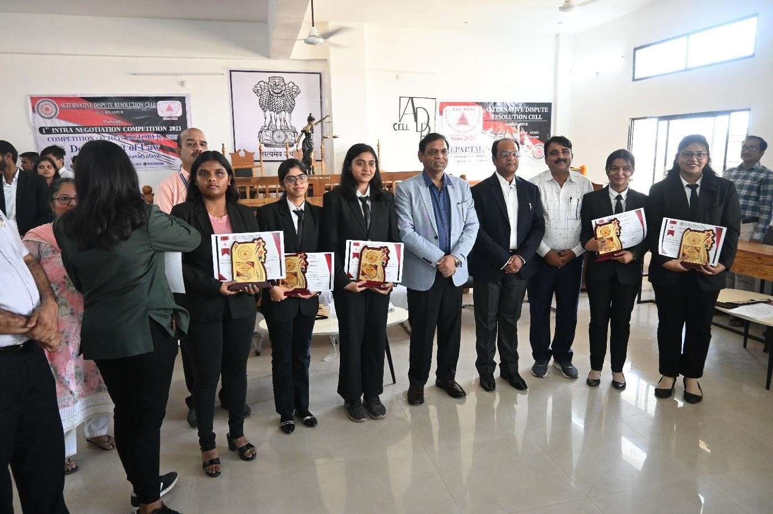

Similarly, the team, composed of the following students under different roles, secured the runner-up position and each of them also received an Award and Certificate from the Hon’ble Vice Chancellor.

|  |  |  |  |  |  |  |
| --- | --- | --- | --- | --- | --- | --- |
| **Client 1** | **Client 2** | **Mediator** | **Chief Counsel** | **Assistant Counsel 1** | **Assistant Counsel 2** | **Coach** |
| Jhalak Sachdev | Swati Ther | Priyanshu Ojha | Adarsh Patel | Gajendra  Prakash Sahu | Aditi Parakh | Shakshi Bhargav |

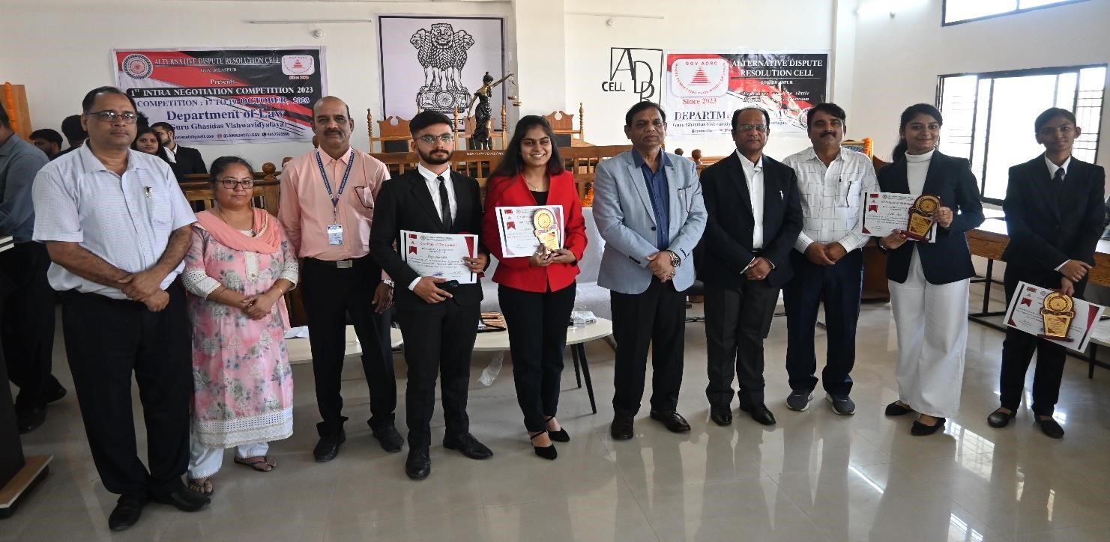

Moreover, among all the participants, certain individuals stood out with exceptional performances, capturing the attention of the ADR Cell. These outstanding participants were acknowledged with Certificates from the Dean of the School of Studies of Law, recognizing their exceptional distinction in their respective categories. Following are the list of such participants:

|  |  |  |  |  |  |  |  |
| --- | --- | --- | --- | --- | --- | --- | --- |
| **Best Negotiator** | **Best Client Counselling** | **Best**  **Communic ation Skill** | **Best**  **Conflict**  **Resolution** | **Best**  **Mediation**  **Excellence** | **Judges Choices** | **Best**  **Ethics**  **&**  **Professi onalism** | **Best Coach** |
| Prasshasti  Shukla  BALLB | Bhumika  Thakur  BALLB | Gautami  Deshmukh  BALLB | Aska  Alam  BCOMLLB | Ayushi  Pandey  BALLB | Ashutosh  Mishra  BCOML  LB | Shreyan sh  Srivasta va  BALLB | Shuba  &  Anmol  Gupta  BALLB |
| 7TH Sem | 9TH Sem | 9TH Sem | 9TH Sem | 7TH Sem | 5TH Sem | 7TH Sem | 9TH Sem |

The success of this negotiation competition was made possible through the dedicated efforts of a group of students who played a vital role in organizing the event. Their contributions deserve special recognition. Here is a list of those students who worked behind the scenes, but whose active involvement was instrumental in making this event a success.

|  |  |  |  |
| --- | --- | --- | --- |
|  | **List of Executive Committee** | |  |
| **Name** | **Designation** | **Course** | **Semester** |
| Apurva Nande | Co-ordinator | BCOMLLB | 9TH |
| Shekhar Gupta | Co-ordinator | BCOMLLB | 9TH |
| Chaina Kashyap | Co-ordinator | BCOMLLB | 9TH |
| Sheetal Gope | Co-ordinator | BALLB | 9TH |
| Nivbhrit Mishra | Co-ordinator | BCOMLLB | 9TH |
| Nidhi Tiwari | Deputy Event Coordinator | BALLB | 7TH |
|  | **List of Heads of Committee** | |  |
| Suman Srivastava | Media & Promotion | BALLB | 7TH |
| Satish Singh | Training Officer | BALLB | 7TH |
| Rajeev Ranjan Bharti | Registration Coordinator | BCOMLLB | 7TH |
| Harim Om Pandey &  Anubhav Singh | Volunteers Coordinator | BCOMLLB | 7TH |
| Harshit Tiwari | Logistic Coordinator | BCOMLLB | 7TH |
| Anand Bajaj | I.T. Coordinator | BALLB | 7TH |
| Arushi Singh | Anchoring | BALLB | 7TH |

Hon’ble Vice Chancellor, did not hesitate to appraise their hard labour, and also awarded them with Certificate of Appreciation.

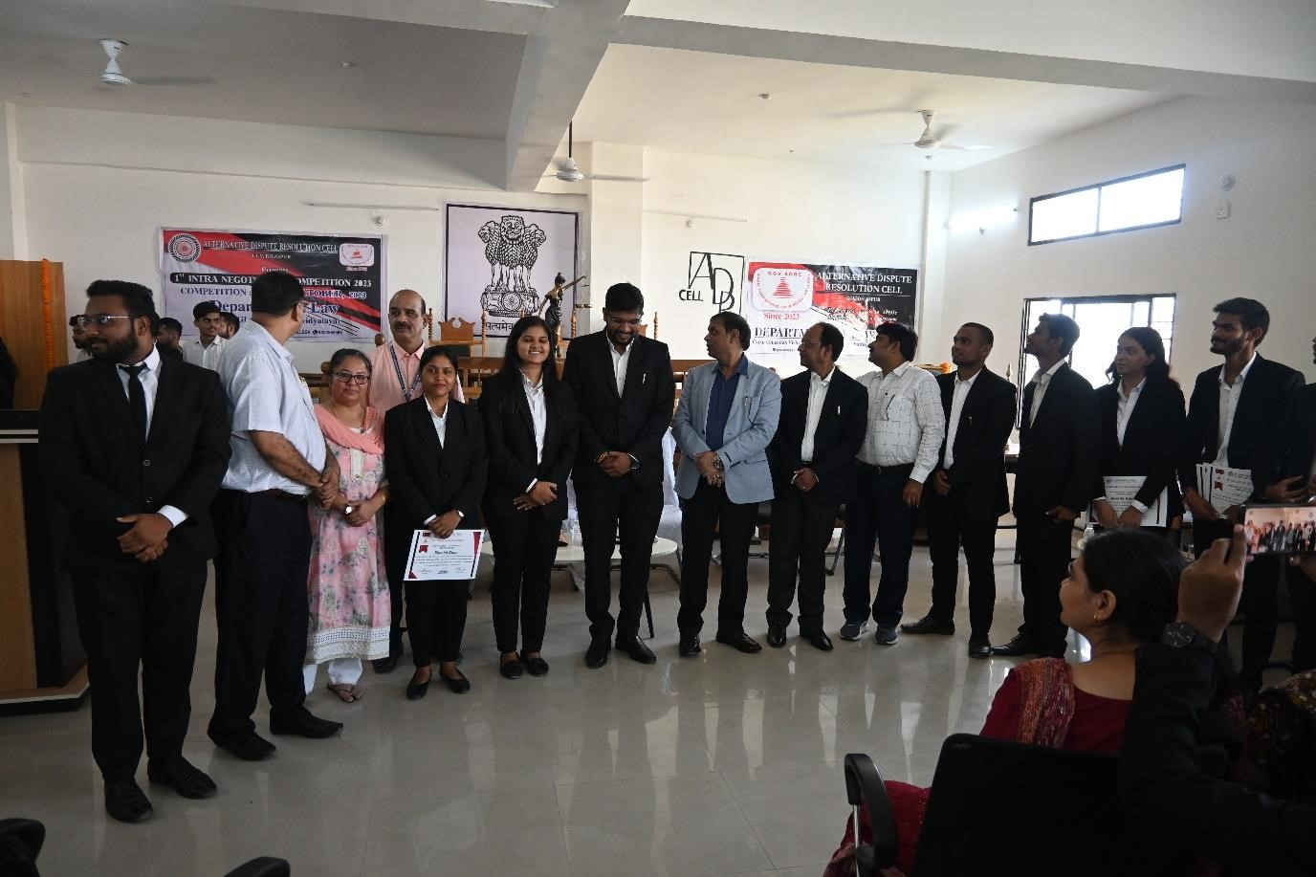

The department also recognized the role of volunteer student members whose hard labour made the event successful. Following volunteer members were awarded with certificate of appreciation by the hand of Head of Department:

|  |  |  |  |
| --- | --- | --- | --- |
| **S. No.** | **Name of the Volunteers** | **Course** | **Semester** |
| 1. | ADARSH MANCHANDA | B.Com LL.B | 2nd |
| 2. | ADARSH PANDEY | B.Com LL.B | 2nd |
| 3. | ALOK KUMAR DEWANGAN | B.Com LL.B | 2nd |
| 4. | AMAN KUMAR SAHU | B.Com LL.B | 2nd |
| 5. | ANANYA DUBEY | B.Com LL.B | 2nd |
| 6. | ANSHUM TIWARI | B.Com LL.B | 2nd |
| 7. | ARPIT UPADHYAY | B.Com LL.B | 2nd |
| 8. | AYUSH SAHU | B.Com LL.B | 2nd |
| 9. | AAYUSH YADAV | B.Com LL.B | 2nd |
| 10. | DEEPALI SINGH | B.Com LL.B | 2nd |
| 11. | PRATIK DUTT MISHRA | B.Com LL.B | 2nd |
| 12. | RUCHI RAO | B.Com LL.B | 2nd |
| 13. | SAKSHI CHOUBEY | B.Com LL.B | 2nd |
| 14. | SHRINIDHI KASHYAP | B.Com LL.B | 2nd |
| 15. | KHUSHANK YADU | B.Com LL.B | 2nd |
| 16. | KHUSAGRA GUPTA | B.A LL.B | 2nd |
| 17. | KHYATI KUPATKAR | B.A LL.B | 2nd |
| 18. | AJIT GHOSH | B.A LL.B | 2nd |
| 19. | SADHANA | B.A LL.B | 2nd |
| 20. | PRANIDHI TIWARI | B.A LL.B | 2nd |
| 21. | PRIYESH JAISWAL | B.A LL.B | 2nd |
| 22. | RADHIKA KUMARI | B.A LL.B | 2nd |
| 23. | SAMRIDH VISHWAS | B.A LL.B | 2nd |
| 24. | V.K. RADHAKRISHNA | B.A LL.B | 2nd |
| 25. | SRIJAN DIXIT | B.A LL.B | 2nd |
| 26. | RIMSHA AMBER | B.A LL.B | 2nd |
| 27. | SHUBHAGI PANDEY | B.A LL.B | 2nd |
| 28. | SUNIDHI SINGH | B.Com LL.B | 2nd |
| 29. | GAURAV GAIKWAD | B.Com LL.B | 7th |
| 30. | MAITILY JHA | B.Com LL.B | 7th |
| 31. | ISHA HARBANSH | B.Com LL.B | 7th |

Summarising the points, it can be said that, this First Intra Negotiation Competition witnessed the power of negotiation, diplomacy, and the determination of participants. The department witnessed immense growth, and there is no doubt that the skills developed here in the competition will serve them well in their future endeavours.

The feedback from participants and attendees was overwhelmingly positive. Participants appreciated the well-structured competition and the opportunity to apply their legal knowledge in practical scenarios. They also found the workshops and discussions informative and insightful.

**Report Prepared by:**

Dr. Sagar Kumar Jaiswal

Assistant Professor

Department of Law

Guru Ghasidas Vishwavidyalaya

Koni, Bilaspur, Chhattisgarh

***