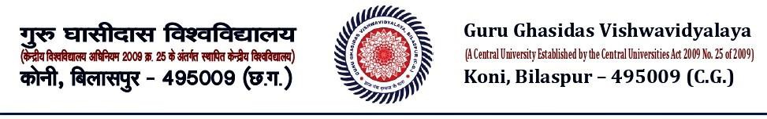

List of Students Admitted Against Reserved Category

|  |  |  |  |  |  |  |  |  |  |  |  |
| --- | --- | --- | --- | --- | --- | --- | --- | --- | --- | --- | --- |
| **Department : *Hindi*** | | | | | | | | | | | |
| ***Academic Year : 2020-21*** | | | | | | | | | | | |
| **Category** | | **SC** | **ST** | | | **OBC** | **DIVYANGJAN** | | **GEN** | **OTHERS** | **TOTAL** |
| **Seat**  **Reserved** | | 12 | 5 | | | 22 | 0 | | 41 | 20 | **100** |
| **Students Admitted** | | 9 | 1 | | | 12 | 0 | | 10 | 0 | **32** |
| ***Category : SC*** | | | | | | | | |  |  | |
| ***Total Number of Students Admitted : 9*** | | | | | | | |  |
| **Sr. No.** | **Enrollment No.** | | | **Name of the Student** | | | | | **Gender** | **Course** | |
| 01. | GGV/20/00203 | | | Aditya Joshi | | | | | Male | B. A. (Hons) | |
| 02. | GGV/20/00204 | | | Aditya Sonche | | | | | Male | B. A. (Hons) | |
| 03. | GGV/20/00213 | | | Priti | | | | | Female | B.A. (Hons) | |
| 04. | GGV/20/00215 | | | Ranjeeta Suryavanshi | | | | | Female | B.A. (Hons) | |
| 05. | GGV/20/00216 | | | Sanjay Kumar Khare | | | | | Male | B.A. (Hons) | |
| 06. | GGV/20/00218 | | | Suraj Prakash | | | | | Male | B.A. (Hons) | |
| 07. | GGV/20/00222 | | | Vikas Kesar | | | | | Male | B.A. (Hons) | |
| 08. | GGV/17/6067 | | | Minalee | | | | | Female | M.A. Hindi | |
| 09. | GGV/17/0132 | | | Tekchand | | | | | Male | M.A. Hindi | |
| ***Category : ST*** | | | | |  | | | | |  | |
|  | | | | | | | | | |
| ***Total Number of Students Admitted : 1*** | | | | | | | |  | |
| **Sr. No.** | **Enrollment No.** | | | **Name of the Student** | | | | | **Gender** | **Course** | |
| 1. | GGV/17/0041 | | | Ignatius Toppo | | | | | Male | MA Hindi | |
| ***Category : OBC*** | | | | |  | | | |
|  | | | | | | | | |
| ***Total Number of Students Admitted : 12*** | | | | | | | |  |
| **Sr. No.** | **Enrollment No.** | | | **Name of the Student** | | | | | **Gender** | **Course** | |
| 01. | GGV/20/00205 | | | Bhumika Patel | | | | | Female | B.A. (Hons) | |
| 02. | GGV/20/02052 | | | Gagan Dehari | | | | | Male | B.A. (Hons) | |
| 03. | GGV/20/00207 | | | Harshraj | | | | | Male | B.A. (Hons) | |
| 04. | GGV/20/00210 | | | Nshikant Patel | | | | | Female | B.A. (Hons) | |
| 05. | GGV/20/00212 | | | Padamajyoti | | | | | Female | B.A. (Hons) | |



|  |  |  |  |  |  |  |  |
| --- | --- | --- | --- | --- | --- | --- | --- |
| 06. | | GGV/20/00223 | Pratik Manikpuri | | | Male | B.A. (Hons) |
| 07. | | GGV/20/00219 | Sushmita Barik | | | Female | B.A. (Hons) |
| 08. | | GGV/20/00221 | Tuleshwar Shau | | | Male | B.A. (Hons) |
| 09. | | GGV/20/00306 | Harshit Kumar Shau | | | Male | M.A. Hindi |
| 10. | | GGV/20/00303 | Jyotirmayi Pradhan | | | Female | M.A. Hindi |
| 11. | | GGV/20/00304 | Manoj Kumar | | | Male | M.A. Hindi |
| 12. | | GGV/17/0092 | Preeti | | | Female | M.A. Hindi |
| ***Category : DIVYANGJAN*** | | | |  | |  |  |
|  | | | | | |
| ***Total Number of Students Admitted : 0*** | | | | |  |
| **Sr. No.** | | **Enrollment No.** | **Name of the Student** | | | **Gender** | **Course** |
|  | |  |  | | |  |  |
| ***Category : GENERAL*** | | | | | |  |  |
| ***Total Number of Students Admitted : 10*** | | | | |  |
| **Sr. No.** | **Enrollment No.** | | **Name of the Student** | | | **Gender** | **Course** |
| 01. | GGV/20/00201 | | Adarsh Mishra | | | Male | B.A. (Hons) |
| 02. | GGV/20/00209 | | Nisha | | | Female | B.A. (Hons) |
| 03. | GGV/20/00211 | | Om Panda | | | Male | B.A. (Hons) |
| 04. | GGV/20/00220 | | Swasti Sharma | | | Female | B.A. (Hons) |
| 05. | GGV/20/00301 | | Arti Singh Thakur | | | Female | M.A. Hindi |
| 06. | GGV/20/00302 | | Dharitri Thakur | | | Female | M.A. Hindi |
| 07. | GGV/20/00305 | | Mau Ray | | | Female | M.A. Hindi |
| 08. | GGV/17/0089 | | Pragya Singh | | | Female | M.A. Hindi |
| 09. | GGV/17/0004 | | Aakansha Tiwari | | | Female | M.A. Hindi |
| 10. | GGV/17/0122 | | Sweta Joshi | | | Female | M.A. Hindi |
| ***Category : EWS*** | | | | | |  |  |
| ***Total Number of Students Admitted : 0*** | | | | |  |
| **Sr. No.** | | **Enrollment No.** | **Name of the Student** | | | **Gender** | **Course** |
|  | |  |  | | |  |  |

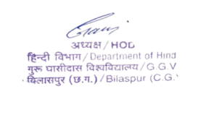

Signature & Seal of HoD