Table of Contents

Subject Name: | Internet of Things Lab
Subject Code: | CSUCLT1

S.N. | Name of Experiments | QR Code
01. | Do hands-on based on ARDUINO API structure and its Installation. | 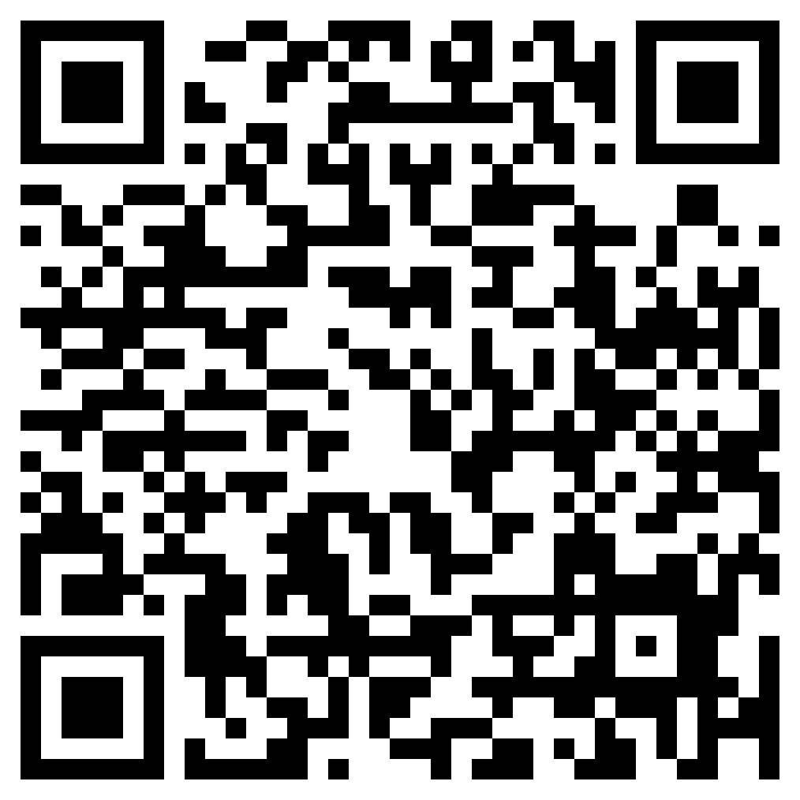
02. | Create program for Simple LED blinking program and Interface proximity sensor with Arduino. | 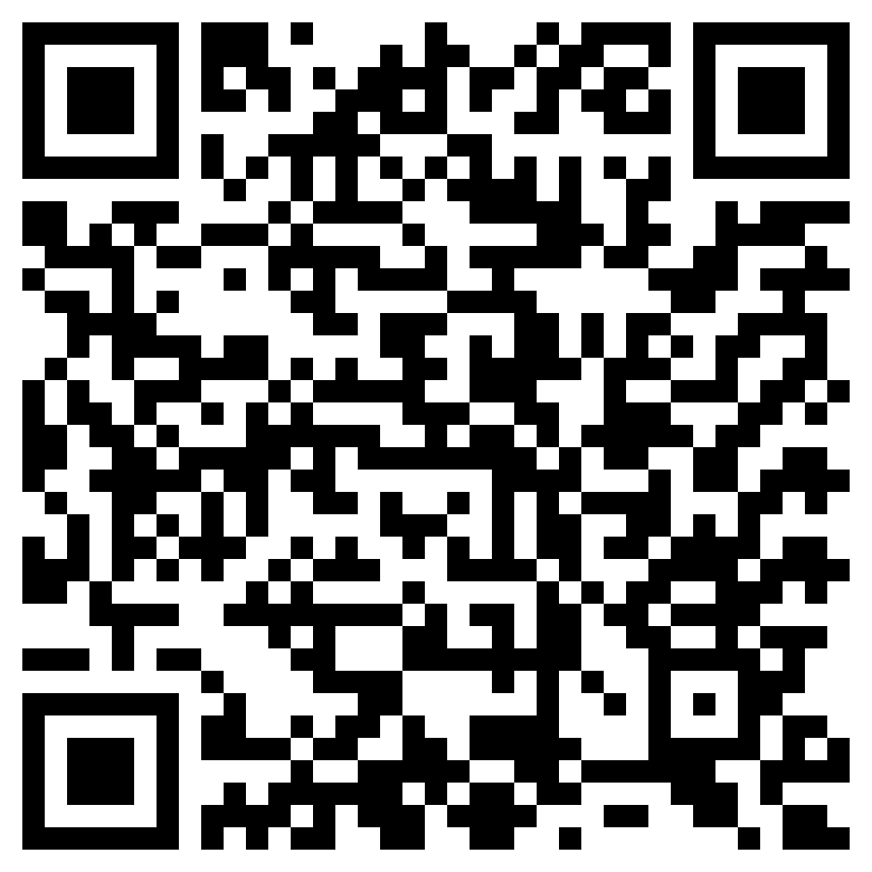
03. | Make a program and execute to program for interface of temperature sensor with Arduino. | 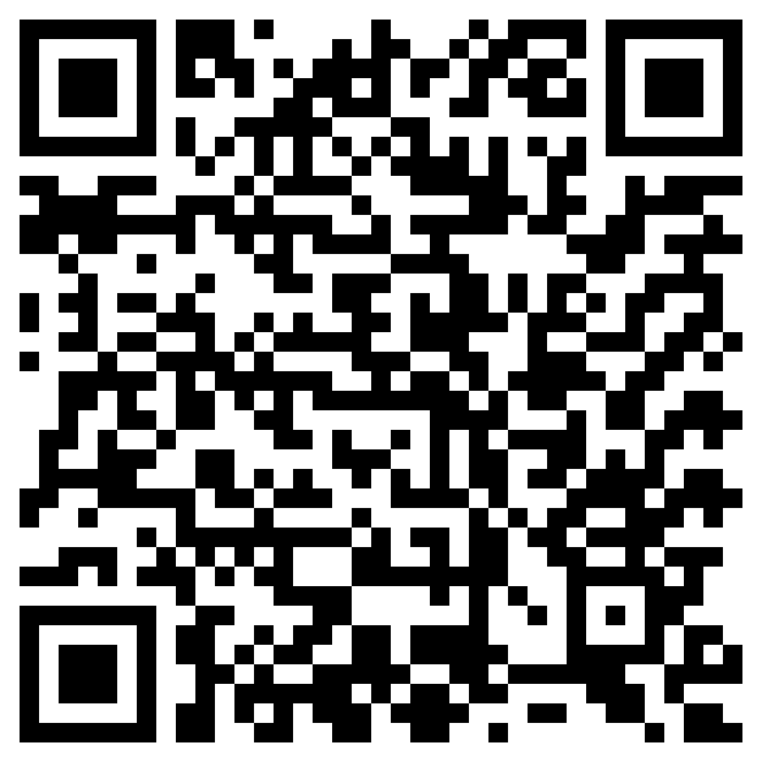
04. | Create program to display of real-time sensor data of ultra-sonic sensors with Arduino. | 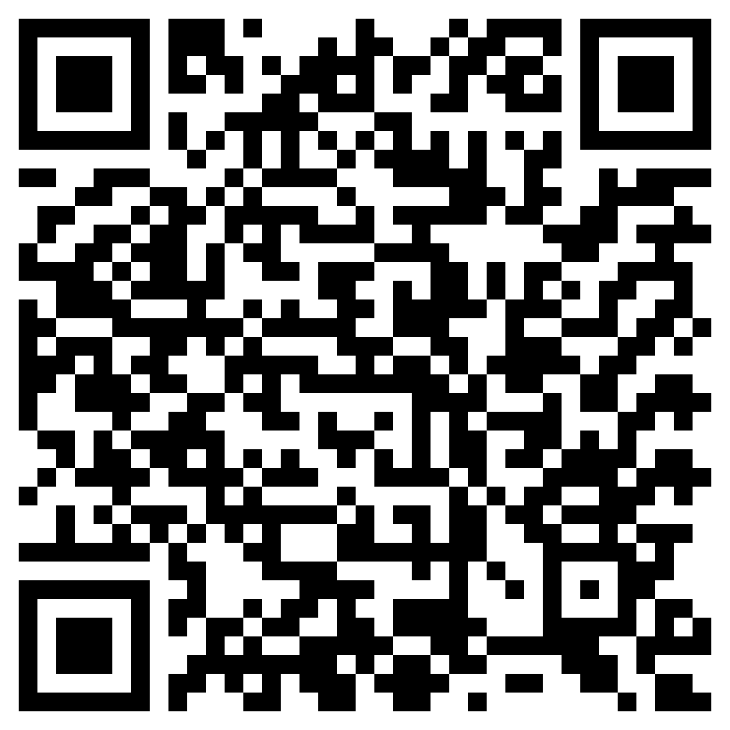
05. | Create live project and implementation on Arduino boards with different sensors. | 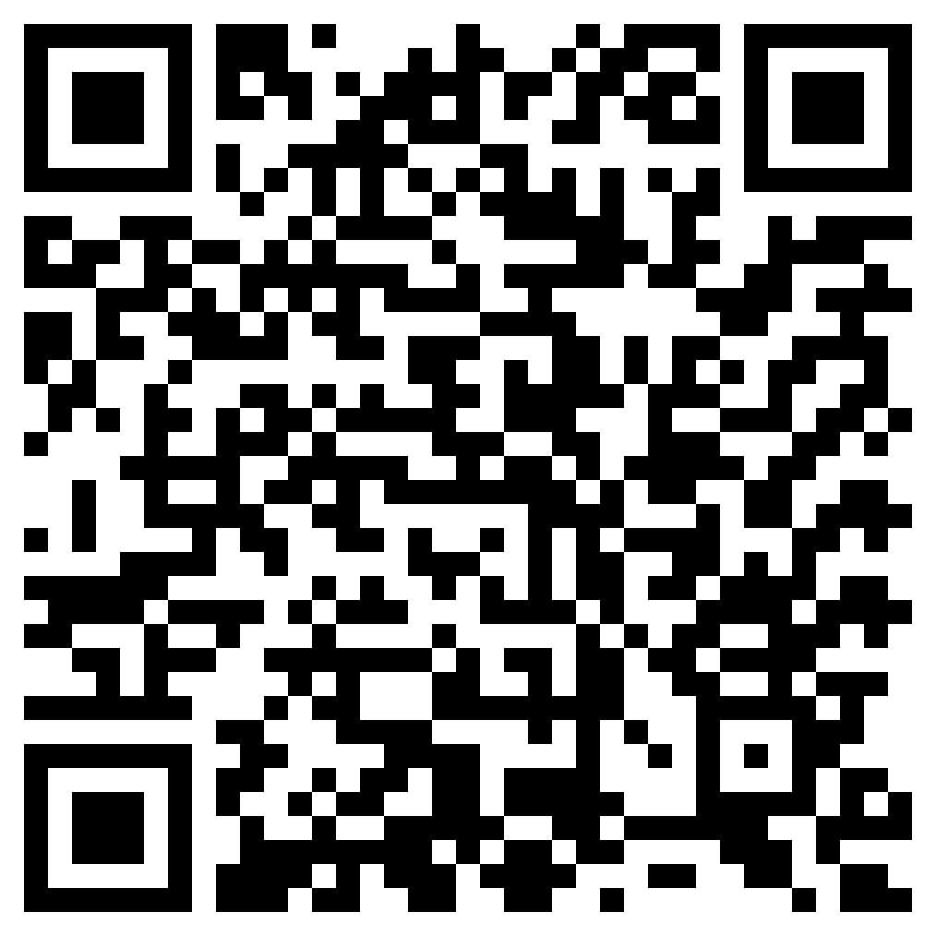
06. | Setup of Node MCU ESP8266 Board in Arduino IDE. | 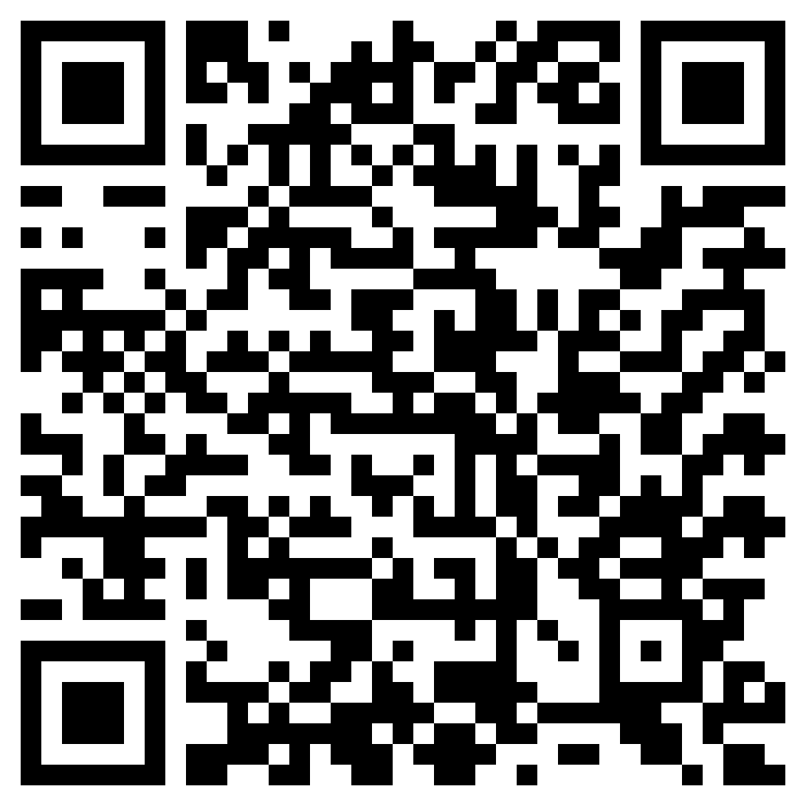
07. | Create program to generating the data of DHT sensor and controlling the LED with Node MCU ESP8266. | 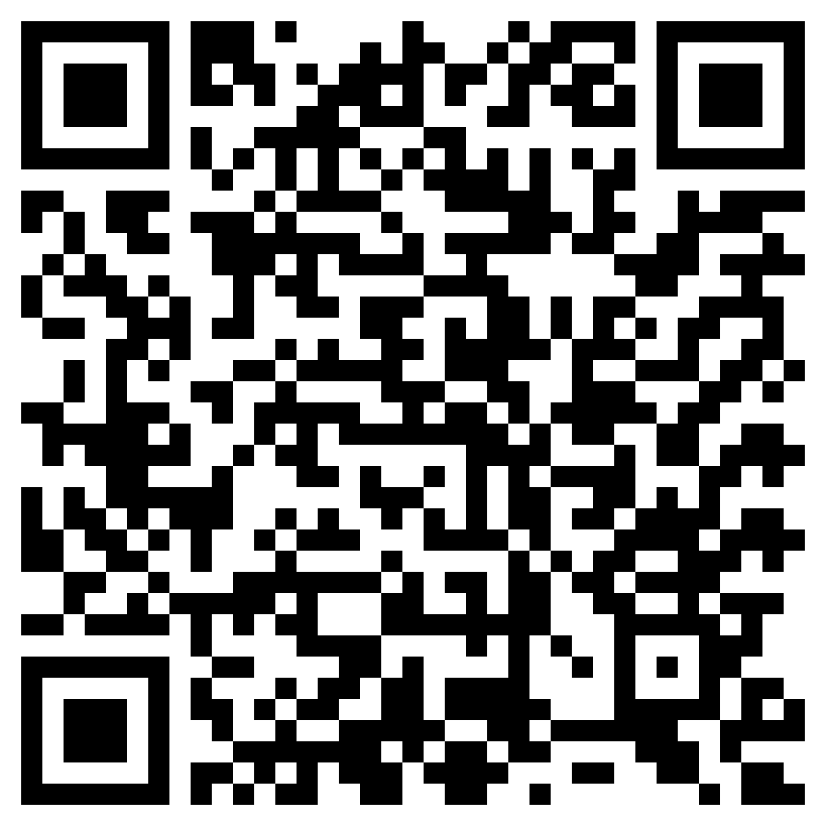
08. | Create program to connect Node MCU with the WiFi networks and connect with Thingspeak cloud environment & uploading sensor data to thingspeak. | 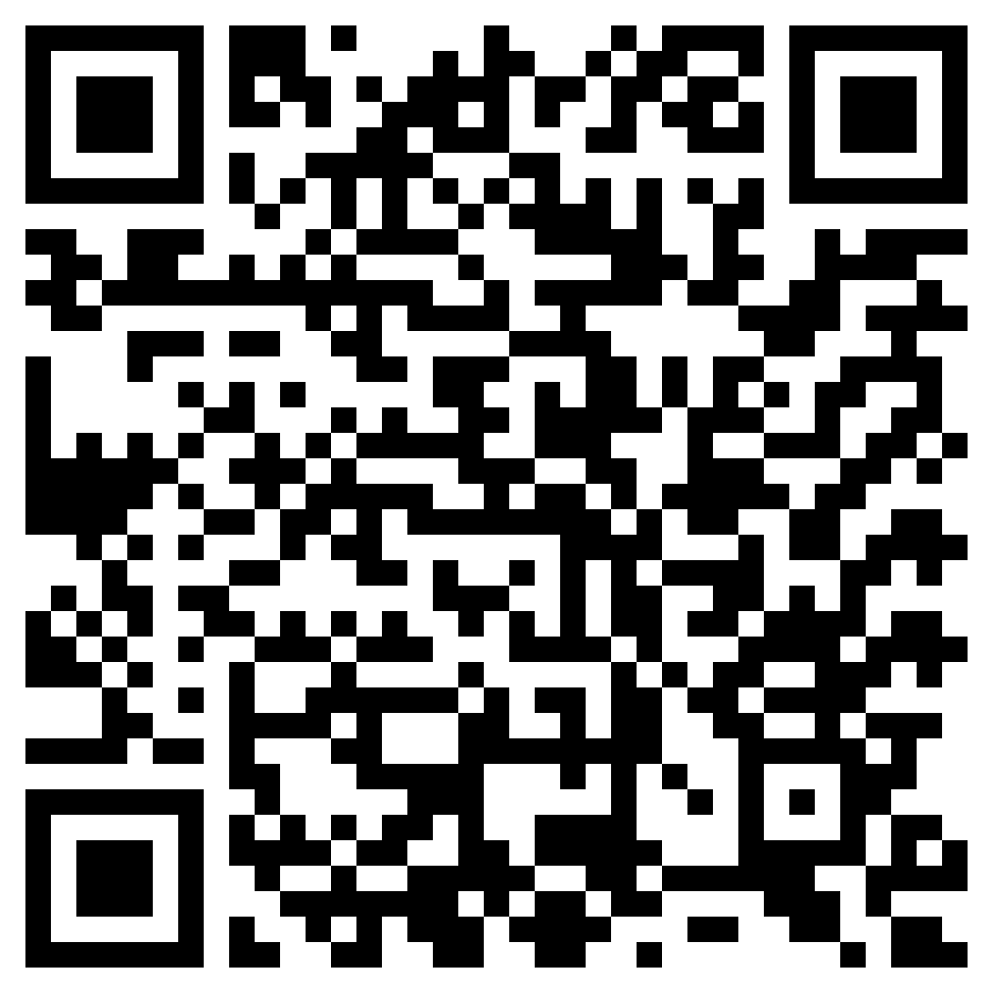
09. | Create program to connect Node MCU with the Google Firebase cloud and upload and download the sensors data to and from the Google Firebase cloud. | 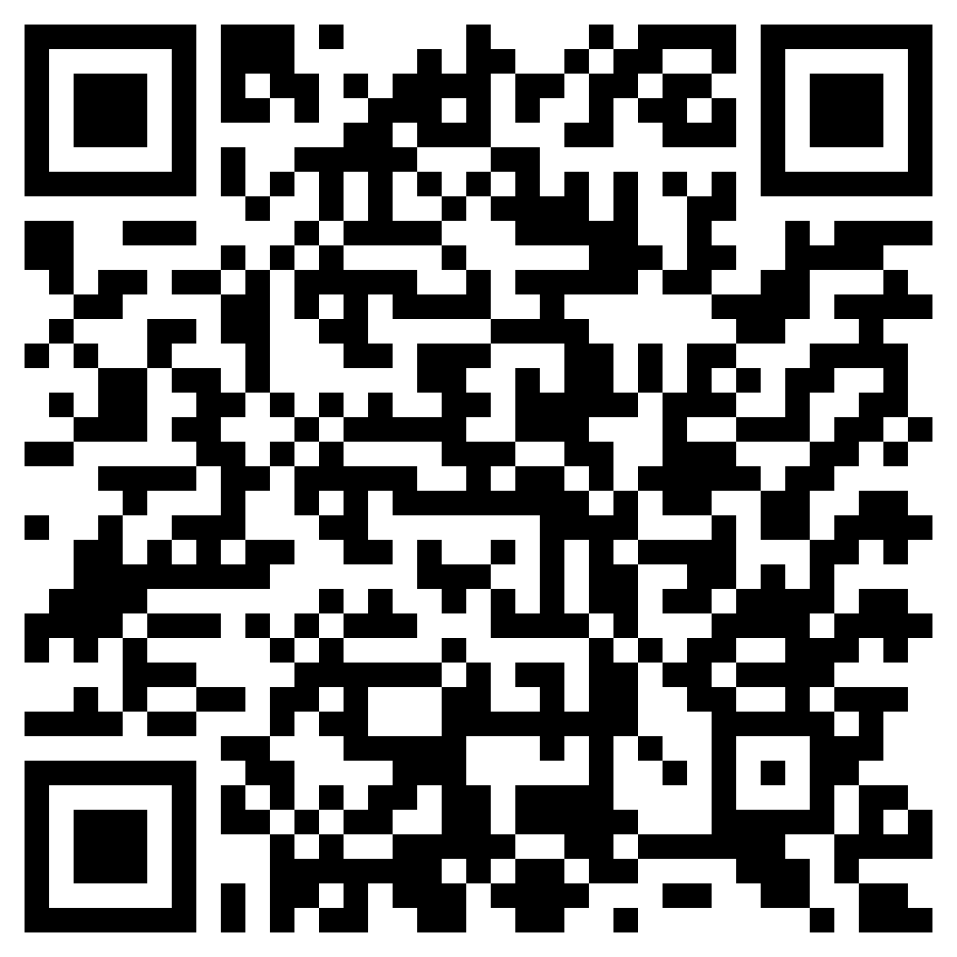
10. | Create program to develop Android App for the WiFi connection with Node MCU and monitor sensor data using Node MCU. | 