List of Programme(s)
Department:
List of Programmes having Components of field projects/research projects/internships
Sr. No. | Programme Code | Programme Name | Academic Year
01. | DSE4 | M.LIB.I.SC | 2021-22

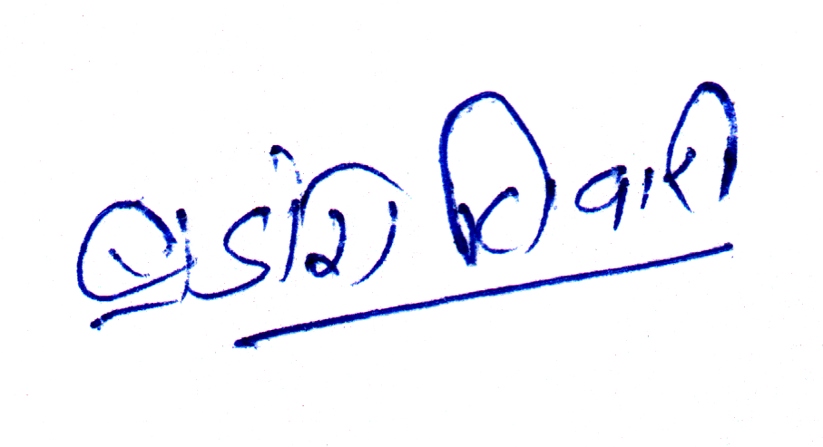
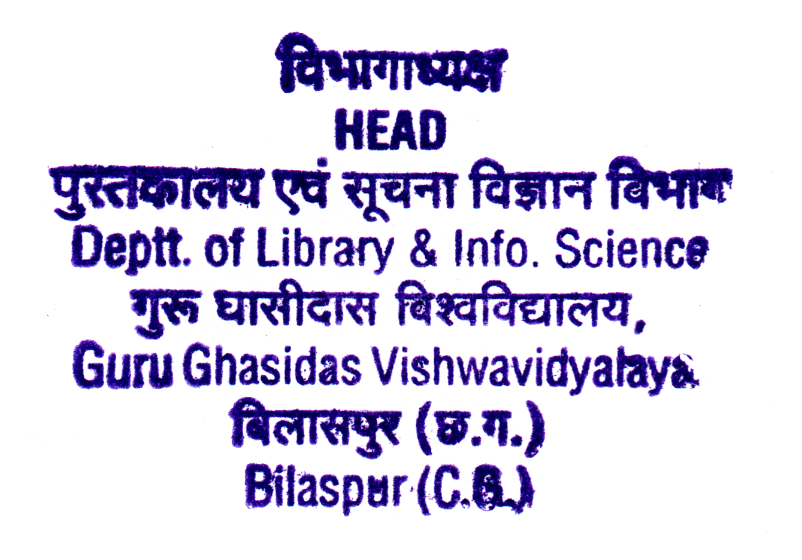

Minutes of Meetings (MoM) of Board of Studies (BoS)
Academic Year : 2021-22
School : School of Studies of Arts
Department : Library and Information Science

Programme Name : M. Lib. I. Sc.
Date and Time : October 29, 2021, 12: 00 Noon
Venue : UTD Wing B, Room No. 74
The scheduled meeting of member of Board of Studies (BoS) of Department of Library and Information Science, School of Studies of Arts, Guru Ghasidas Vishwavidyalaya, Bilaspur was held to design and discuss the B.Lib.I.Sc. and M.Lib.I.Sc. scheme and syllabi.
The following members were present in the meeting:
- Dr. Brajesh Tiwari (HOD, Associate Prof., Dept. of Lib. & Info. Science.-cum Chairman, BOS)
- Prof. Maya Verma , PRSU , Raipur was attend through online mode.
Following points were discussed during the meeting
- Revision of B.Lib. I.Sc. Syllabus for the session 2021-22 onwards;
- Revision of M.Lib. I.Sc. Syllabus for the session 2021-22 onwards;
The committee discussed and approved the scheme and syllabi. The revised courses are as follows:
B.lib.I.Sc.
C1 Foundation of Library and Information Science
C2 Knowledge Organization- Classification (Theory)
C3 Knowledge Organization- Cataloguing (Theory)
C4 Basics of Information and Communication Technology (Theory)
C5 Information Sources , Systems and services
C6 Library Management
C7 Knowledge Organization- Classification (Practice)
C8 Knowledge Organization-Cataloguing (Practice)
C9 Basics of Information and Communication Technology (Practice)
DSE1 School Library and Media Center
DSE2 Public Library and Information Systems
DSE3 Special Library and Information Systems
M.Lib.I.Sc.
C1 Knowledge Society
C2 Information Storage and Retrieval (Theory)
C3 Information Communication Technology for Libraries (Theory)
C4 Information Storage and Retrieval (Practice)
C6 Information Source , System and Programme
C7 Managements of Libraries and Information Centers/ Institutions
C8 Research Methods and Statistical Techniques
C9 Information Communication Technology for Libraries (Practice)
AECC1 Information Analysis, Repackaging, and Consolidation
DSE1 Academic Information System
GE2 Preservation and Conservation of Library Materials
GE3 Media and Information Literacy

The new courses introduced are as follows:
B.Lib.I.Sc.
GE 2 | Digital Library : Fundamental
C7 | Knowledge Organization – Classification (Practice)
C8 | Knowledge Organization – Cataloguing (Practice)
Project | Project work (In lieu of DSE)
M.Lib.I.Sc.
C5 | Library Use and User Studies
GE1 | Webometrics, Infomatics, & Scientometrics
Project | Project work (In lieu of DSE)
- CBCS system was already adopted in the above courses from session 2015-16
- Prof. Jaydeep Sharma, IGNOU, New Delhi who could not attend the meeting however send his consent about the newly prepared syllabus.
- Advices from the faculty members present as well as ex faculties were also consider the CBCS/ECS courses adequately endorse in the design and development of syllabus.

Scheme
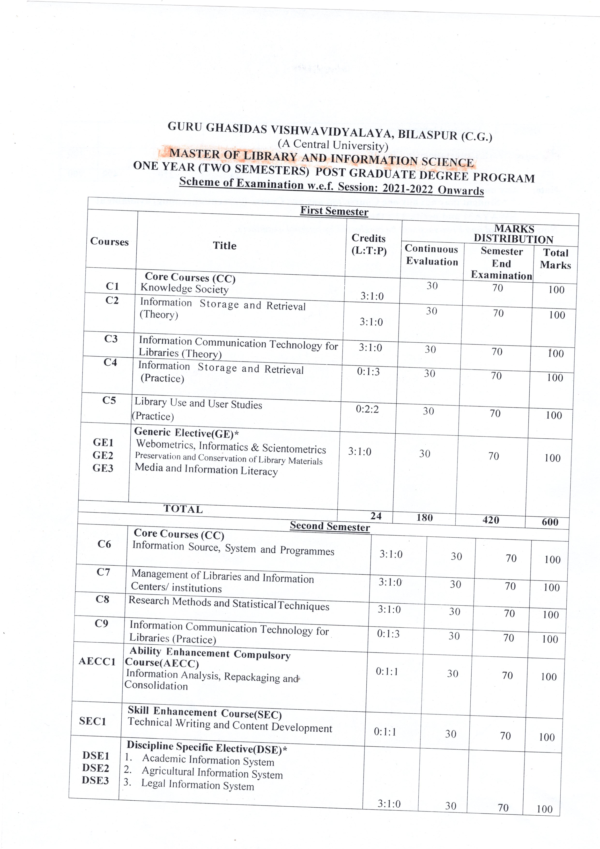
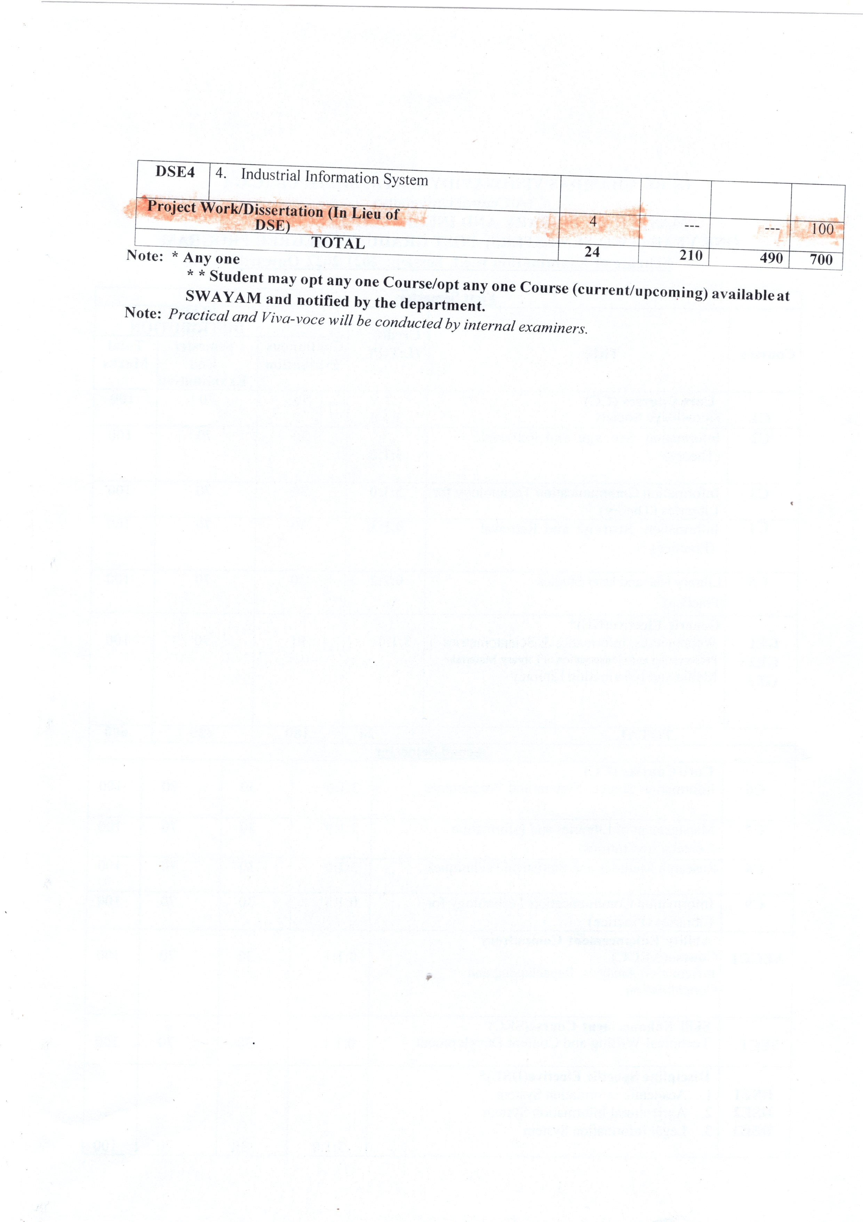

List of students undertaking Field Projects/Projects / Internships
Sr. No. | Programme Name | Name of the Student |  | Link of Certificate
01. | M.LIB.I.SC | ANILKANT SAHU |  | http://new.ggu.ac.in/attachments/attachments/department/03282023030008_project_1..pdf
02. | M.LIB.I.SC | ANSHU SAHU
03. | M.LIB.I.SC | GAYTREE KALSE
04. | M.LIB.I.SC | RAJESHWARI SAHU
05. | M.LIB.I.SC | RENU
06. | M.LIB.I.SC | ANITA MEHER
07. | M.LIB.I.SC | DILESHWAR YADAW
08. | M.LIB.I.SC | MOSES SUNA
09. | M.LIB.I.SC | RUCHI DUBEY
10. | M.LIB.I.SC | SHOBHA KASHYAP
11. | M.LIB.I.SC | BHUPENDRA KHUNTE
12. | M.LIB.I.SC | DONA KHAMARI
13. | M.LIB.I.SC | PREETAM PANDEY
14. | M.LIB.I.SC | SIPUN KUMAR BEHRA
15. | M.LIB.I.SC | SUNIL KUMAR SAHU
16. | M.LIB.I.SC | ANSHIKA SHARMA
17. | M.LIB.I.SC | ANKITA GAUTAM
18. | M.LIB.I.SC | MANJU MATHUR
19. | M.LIB.I.SC | NIHAR RANJAN
20. | M.LIB.I.SC | URMILA THAKUR
21. | M.LIB.I.SC | SUSHANT KESHRI
22. | M.LIB.I.SC | SADHANA MIRI
23. | M.LIB.I.SC | PRIYANKA
24. | M.LIB.I.SC | MUKESH
25. | M.LIB.I.SC | VINAY KUMAR
26. | M.LIB.I.SC | SANGEETA TANDIA
27. | M.LIB.I.SC | RANJEET SINGH
28. | M.LIB.I.SC | LILI BARIK
29. | M.LIB.I.SC | BIDYA SHREE PRADHAN
30. | M.LIB.I.SC | ASMITA LAL
31. | M.LIB.I.SC | CHANDRIKA BHOI
32. | M.LIB.I.SC | DIVYA CHAURSIYA
33. | M.LIB.I.SC | GANGA SAMRAT
34. | M.LIB.I.SC | PINTU MANDAL
35. | M.LIB.I.SC | SABINA
36. | M.LIB.I.SC | MEENA
37. | M.LIB.I.SC | MUSKAN
38. | M.LIB.I.SC | BIRENDRA
39. | M.LIB.I.SC | PUSHPRAJ
40. | M.LIB.I.SC | ABHISHEK EKKA
41. | M.LIB.I.SC | M. VEERASWAMY
42. | M.LIB.I.SC | SWETA
43. | M.LIB.I.SC | SUNEET KUMAR
44. | M.LIB.I.SC | TWINKLE BHANGE
45. | M.LIB.I.SC | ANUPAM JUSTIN
46. | M.LIB.I.SC | DAMINI
47. | M.LIB.I.SC | DEBASHISH
48. | M.LIB.I.SC | DIVYA JAISWAL
49. | M.LIB.I.SC | NAVEEN

