Value Added Courses Offered
SIX WEEKS CERTIFICATE COURSE ON YOGIC SCIENCE
School: Education
Department : Physical Education, Yoga and Sports Science

Academic Year : 2022-23
Sr. No. | Course Code | Name of the Course
01. | CPY101 | Yogic Science Paper-1
02. | CPY102 | Practical Theory Paper- II
03. | CPY103 | Performance Evaluation
04. | CPY104 | Teaching Skill

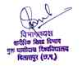

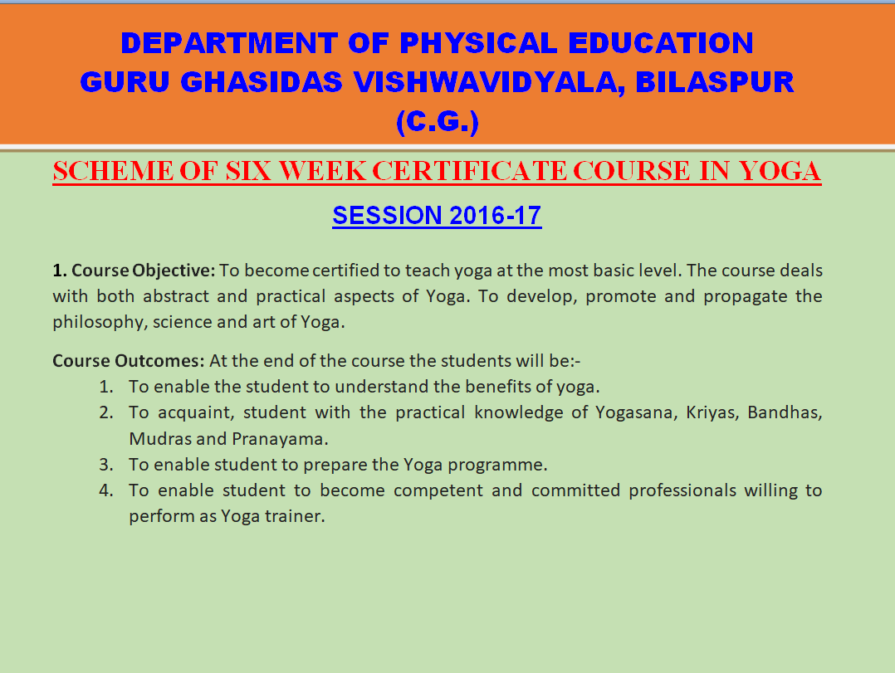
Session 2023-24

