Minutes of Meetings (MoM) of Board of Studies (BoS)
The scheduled meeting of member of Board of Studies (BoS) of Department of Forestry, Wildlife and Environmental Sciences, School of Studies of Natural Resources, Guru Ghasidas Vishwavidyalaya, Bilaspur was held on dated 26.07.2018 at 11:00 am for academic session 2018-19 to design and discuss the B. Sc (Forestry) Four Years Degree Program and syllabi.
The following members were present in the meeting:
1. Prof. Lalji Singh (External Expert Member BoS, Dept. of Agroforestry, IGKV, Raipur)
2. Prof. S. S. Singh (Member BoS, Dept. of Forestry, Wildlife and Environmental Sciences)
3. Dr. S. C. Tiwari (HOD, Associate Prof., Dept. of Forestry, Wildlife and Environmental Sciences -cum Chairman, BOS)
4. Dr S. S. Dhuria (Member BoS, Associate Professor, Dept. of Forestry, Wildlife and Environmental Sciences)
5. Dr. Gunjan Patil (Member BoS, Assistant Professor, Dept. of Forestry, Wildlife and Environmental Sciences)
Following points were discussed during the meeting
- The syllabus of B. Sc. Forestry (4 years/ 8 Semesters) framed as per the guidelines of CBCS pattern recommended by UGC has been discussed thoroughly and was passed by the committee for the implementation from academic session 2018-19.
- The course curriculum of M. Sc Forestry and Environmental Sciences was discussed and it was resolved that this course is well framed and contemporary with the course curriculum of other forestry institution in the country. Since it is at Forestry, Wildlife and Environmental Sciences at par with the needs of the current scenario so presently needs no revision.
- The committee also resolved that the syllabus of M. Sc. Forestry and Environmental Sciences will be the syllabus for VRET examination of PhD program in forestry.
The following new courses were introduced in the of B. Sc. (Forestry) Four-year degree program:
1.NR/FR/SC/03/01/L | Nursery Practices and Plantation Management
2. NR/FR/CR/04/10/L | Fundamentals of Wood Science
3.NR/FR/CR/04/12/L | Application of Remote Sensing and GIS in Forest and Watershed Management
4. Summer internship | Swayam Swachhta/NSS/Industrial visit/UBA/ Others
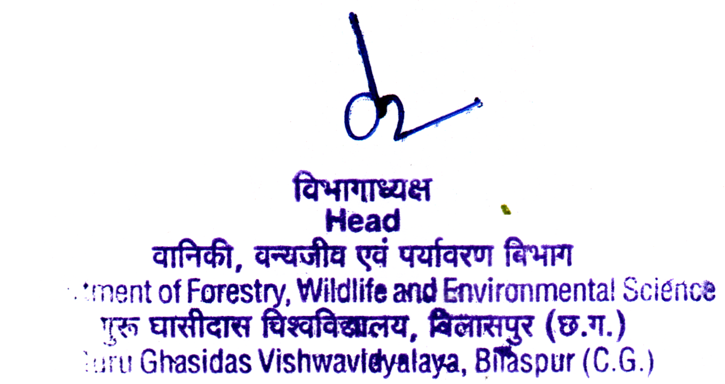
Signature & Seal of HoD

Scheme and Syllabus

