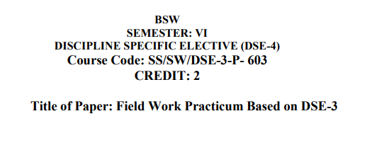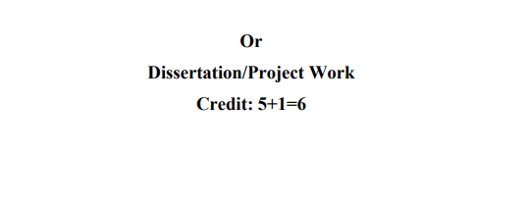

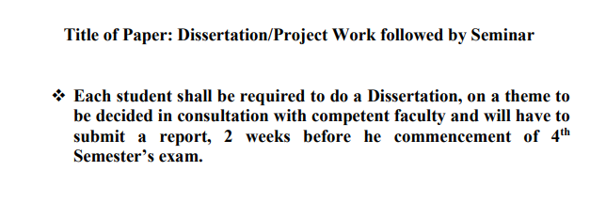

The following Student has done the project in **BSW**.

|  |  |  |  |
| --- | --- | --- | --- |
| **S.No.** | **Student Name** | **Enrollment No.** | **Certificates** |
| 1 | Anjali | GGV/21/08602 | <http://164.100.113.105/attachments/attachments/department/FEILD_WORK_CERTIFICATE_-_Compile_Copy.pdf> |
| 2 | Avinash Ray | GGV/21/08605 |
| 3 | Sandhya Bakshi | GGV/21/08622 |
| 4 | Hitesh Kumar | GGV/21/08614 |
| 5 | Gurudev Singh | GGV/21/08612 |
| 6 | Hitesh Kumar Gond | GGV/21/08615 |
| 7 | Ravi Kumar Dhurve | GGV/21/08620 |
| 8 | Atishu Kashyap | GGV/21/08604 |
| 9 | Chanchal | GGV/21/08608 |
| 10 | Gulshan Kumar Nawik | GGV/21/08611 |
| 11 | Kshama Sahu | GGV/21/08616 |
| 12 | Priyanshu Yadav | GGV/21/08617 |
| 13 | Pushpendra Mahant | GGV/21/08618 |
| 14 | Sameer Mahant | GGV/21/08618 |
| 15 | Unnati Sahu | GGV/21/08632 |
| 16 | Anjali Rathour | GGV/21/08603 |
| 17 | Saraswati | GGV/21/08624 |
| 18 | Awanti Shyam | GGV/21/08606 |
| 19 | Azimuddin | GGV/21/08607 |
| 20 | Diksha Singh | GGV/21/08609 |
| 21 | Geetika Nitam | GGV/21/08610 |
| 22 | Himashu H Chahande | GGV/21/08613 |
| 23 | Raksha Mishra | GGV/21/08619 |
| 24 | Satyam Sharma | GGV/21/08625 |
| 25 | Sheetal Bala | GGV/21/08626 |
| 26 | Shivam Sidar | GGV/21/08627 |
| 27 | Shivani | GGV/21/08628 |
| 28 | Shreya Sarkar | GGV/21/08629 |
| 29 | Shubham Tirkey | GGV/21/08630 |
| 30 | Supriya Rajput | GGV/21/08631 |
| 31 | Yuvraj Singh | GGV/21/08633 |
| 32 | Sareer Fayaz Bhatt | GGV/21/08623 |
| 33 | Adil Manzoor Mir | GGV/21/08601 |

