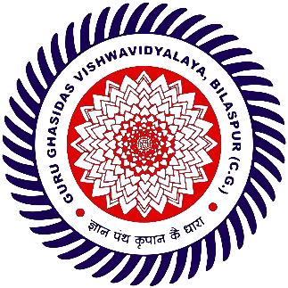



ID-MCC REPORT

2024

6th INTRA DEPARTMENT MOOT COURT COMPETITION

School of Law

Guru Ghasidas Vishwavidyalaya

Bilaspur, (C.G.) – 495009

(A Central University)

Contents

MESSAGE FROM HEAD OF DEPARTMENT 3

1. INTRODUCTION : 4

2. EVENT OVERVIEW : 5

2.1 Analysis of The Event 5

2.2 Unique Aspects of the Competition 6

2.3 Objectives of the Event: 7

3. CASE STUDY : 8

3.1 Synopsis of The Moot Court Proposition: 8

3.2 Relevant Legal Issues Discussed: 8

3.3 Importance of the Case in Legal Practice: 9

4. COMPETITION STRUCTURE & ACHIEVEMENTS : 10

4.2 FINAL 12

4.3 WINNERS 12

4.3.1 Feedback 13

4.4 RUNNER-UP : 13

4.4.1 Feedback 13

**4.5 BEST SPEAKER 13**

**4.6 BEST RESEARCHER 13**

1. **PANELISTS 14**
   1. **Panelists for Preliminary Round: 14**
   2. **Panelists for Quarter and semi-finals Round: 14**

#### 5.3 Panelists for Finals: 14

1. **EVENT ORGANIZERS 15**
2. **CONCLUSION : 16**

# 

# MESSAGE FROM HEAD OF DEPARTMENT

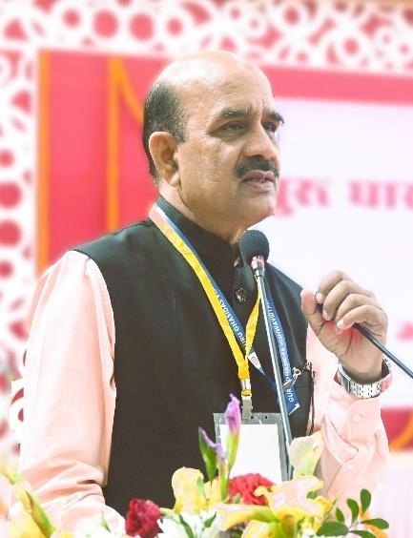Dear students and participants, it gives me immense pleasure to extend my heartfelt gratitude to each and every one of you for your invaluable contributions to the resounding success of the 6th Intra-Department Moot Court Competition 2024. Under the auspices of our dynamic all-women organising committee, this event stands as a beacon of gender empowerment, aligning with the ethos of International Women’s Day. In the wake of three days brimming with fervent debates, unyielding resolve, and insightful discussions, we stand united to rejoice in the extraordinary triumph of this event. With immense pride, we contemplate the strides

we have made, the wisdom we have shared, and the camaraderie we have forged. Throughout the competition, we witnessed the extraordinary dedication and prowess exhibited by our esteemed participants, whose fervent arguments and insightful analyses illuminated every courtroom, instilling inspiration in all who were privileged to attend. I extend my commendations to each team for their tireless endeavours and commendable performances, which undeniably elevated the standard of legal advocacy at our university. I would be remiss if I did not express my deepest appreciation to our faculty members and all those who worked tirelessly behind the scenes to ensure the smooth execution of this event. Your support and dedication have been instrumental in making this competition a resounding success.

As we look towards the future, let us carry forward the lessons learned and the connections forged during this competition. May we continue to strive for excellence, uphold the principles of justice and equality, and work towards creating a brighter future for all. Thank you once again for your unwavering support and commitment. Until we meet again at the next intra-department moot court competition, I bid you farewell with the fondest of memories and the highest hopes for the future.

Warm regards,

**Dr. Sudhanshu Ranjan Mohapatra**

Head Of Department

School of Law

**1. INTRODUCTION** :

Moot court tournaments stand as pillars of legal education, offering students a priceless stage to hone their advocacy skills, deepen their understanding of legal principles, and engage in spirited debates on pressing legal issues. Rooted in the tradition of simulated court proceedings, moot court competitions provide participants with invaluable practical experience, allowing them to develop critical thinking, oral advocacy, and legal research skills in a controlled yet dynamic environment. Intra-department moot court competitions bear a special significance within scholastic establishments, serving as crucibles wherein students may put theory into practice and assay their mettle amidst their academic cohorts. These competitions offer an unparalleled occasion for students to engage in genial rivalry, garner insightful critique from seasoned judges and mentors, and gain confidence in their abilities as future legal professionals.

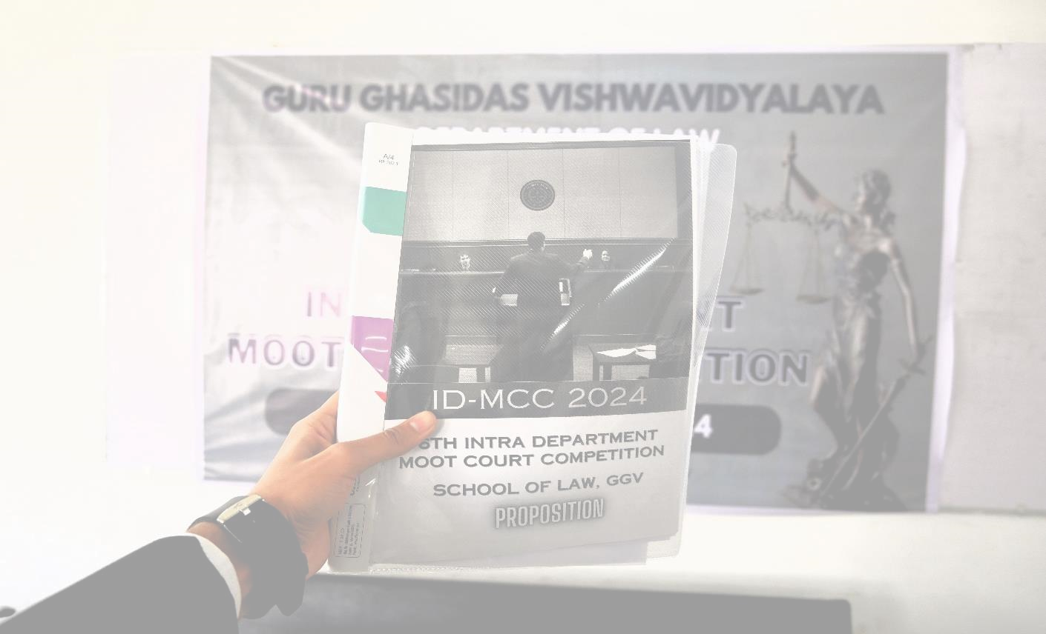

Furthermore, intra-department competitions engender a sense of camaraderie and fellowship within the academic enclave, as students come together to bolster and provoke each other in the pursuit of excellence. By encouraging participation from students across different levels of study, these competitions promote inclusivity and collaboration, cultivating a culture of academic excellence and mutual respect. In Summation, intra-department moot court competitions play a vital role in shaping the next generation of legal professionals, endowing them with the skills, knowledge, and confidence requisite for triumph in their forthcoming vocations. As we embark upon this odyssey of enlightenment and erudition, let us embrace the challenges and opportunities

that lie ahead, and may this competition serve as a catalyst for growth, innovation, and excellence in legal education.

# 

# 2. EVENT OVERVIEW :

## 2.1 Analysis of The Event

This inaugural event marked a significant milestone as the first of its kind to grace the annals of our esteemed institution. The organizers spared no effort in ensuring the event's success, **offering invaluable workshops** tailored to equip first-time participants with the requisite skills and knowledge essential for navigating the intricacies of moot court proceedings. With a commendable response, a total of **24 teams** enthusiastically enrolled to test their legal acumen and advocacy prowess.

The event commenced with a **ceremonious inauguration** on *March 11* graced by the distinguished presence of our **female faculty members** alongside the esteemed **spouses** of our male counterparts. Such a collective display of support underscored the inclusive spirit and commitment to fostering gender parity within our academic community.

Spanning across *four* intellectually charged days *(i.e. March 11, 18, 22 & 23)*:

* **March 11** - **Inauguration and Workshop**
* **March 18** - **Preliminary Rounds** (08 Teams out of 24, Qualified)
* **March 22** - **Quarter and Semi-Final Round** (4 Teams Qualified for Quarter Final and further our Two Qualified finalists were announced.
* **March 23** - **Final Round** (Both the finalist engaged the Moot Court Room with their factual and legal reasonings and based on the grades by respected jury, the winning team of Intra Moot Court Competition was declared.)

Throughout the competition, participants were not only treated to intellectually stimulating debates but were also provided with sustenance in the form of **lunch facilities**, fostering camaraderie and conviviality among contestants.

The **venue** was the Department of Law itself, where various Court rooms were set up for the event and the final was held in our **Moot Court Room.**

## 

## 2.2 Unique Aspects of the Competition

This Intra-Moot Court Competition distinguished itself through several unique aspects that contributed to its success and Impact.

1. **All-women Organizing Committee:** This competition stood out notably due to its orchestration by an all-women committee, highlighting the university’s unwavering dedication and commitment to promoting gender equality and empowering women in the legal profession. This Pioneering step not only provided leadership opportunities for women but also served as a vibrant celebration of their remarkable contributions to the realm of law, notably timed with the commemoration of international women’s Day.
2. **Inclusive Workshops for First-Timers:** Recognizing the importance of inclusivity, the organizing committee conducted workshops specifically for firsttime participants. These sessions equipped newcomers with the necessary skills and knowledge to navigate the intricacies of moot court advocacy, fostering a supportive learning environment and active participation in the competition.
3. **Varied Backgrounds of Jurors:** The competition featured a diverse panel of jurors comprising alumni of the Department of Law with backgrounds ranging from high court advocates to judicial officers, faculty members, and legal researchers. This diversity ensured a multiplicity of perspectives in evaluating participants' performances, enriching the adjudication process and providing valuable feedback to contestants.
4. **Faculty and Spousal Inauguration:** The inauguration ceremony, graced by female faculty members and wives of male faculties, underscored the university's commitment to inclusivity and collaboration across genders. By involving both faculty and their spouses in the opening ceremony, the event symbolized a collective commitment to supporting and encouraging students endeavours in moot court advocacy**.**
5. **Simulation of National-Level Competition Environment:** By creating a professional and competitive atmosphere the competition sought to replicate the ambiance and rigors of a national-level moot court competition, also offering participants lunch facilities and other amenities commonly found in such events.

## 

## 2.3 Objectives of the Event:

1. Equipping students with hands-on experience in moot court advocacy.
2. Cultivating critical thinking, legal reasoning, and oral advocacy skills among contenders.
3. Promoting collaboration, professionalism, and ethical conduct amidst a competitive backdrop.
4. Facilitating networking opportunities and fostering collaboration among students, faculty, and legal practitioners.
5. Commemorating the achievements and contributions of women in the legal realm, in alignment with the spirit of International women’s Day.



# 3. CASE STUDY :

## 3.1 Synopsis of The Moot Court Proposition:

The crux of the case revolves around a surrogacy agreement involving Aviraj and Piya Chaudhary, a married couple facing infertility issues, and Kriti Singh, the chosen Surrogate. Tragically, fate intervenes as Aviraj and Piya meet an untimely demise before the birth of their anticipated child, leaving behind a newborn in their wake. From this unfortunate circumstance springs a contentious dispute over the custody of the child, the enforcement of the surrogacy agreement, and the rightful claim to compensation, igniting a legal showdown between Kriti and the bereaved Chaudhary

family. The case delves into the complexities of surrogacy laws, contractual obligations, parental rights, and the welfare of the child.

## 3.2 Relevant Legal Issues Discussed:

1. **Enforceability of the Surrogacy Agreement**: The primary issue lies in the enforceability of the surrogacy agreement amidst the unforeseen demise of the intending parents. This raises questions regarding the legal status of the agreement and Kriti’s entitlement to any parental rights or compensation.
2. **Custody of the Child:** An additional critical concern revolves around the legal custody of the child conceived through surrogacy. With no explicit provisions within the agreement or a specified legal guardian, the question of who rightfully assumes custody becomes paramount. This necessitates the invocation of principles surrounding guardianship and the paramount consideration of the child's welfare in determining the suitable custodian.
3. **Entitlement to Compensation:** The dispute extends to Kriti's entitlement to the agreed compensation amount stipulated in the surrogacy agreement. The circumstances surrounding the death of the intending parents and subsequent events influence the enforceability and fulfilment of this contractual obligation.
4. **Inheritance Rights of the Child:** The case also explores the potential inheritance rights of the child born through surrogacy within the Chaudhary family's estate. Legal considerations regarding succession laws and the status of the child as a potential heir are examined in light of the familial relationship and contractual arrangements.
5. **Verbal Intent of the grandfather:** Additionally, the legal weight of the grandfather's verbal intent to transfer property among his grandchildren, contingent upon the birth of Aviraj's child, emerges as a pertinent issue. This raises questions about the validity and enforceability of verbal agreements in matters of succession and property transfer.

## 3.3 Importance of the Case in Legal Practice:

The case underscores the intricate legal complexities surrounding surrogacy agreements, parental rights, and child custody in the event of unforeseen circumstances such as the death of the intending parents. It serves as a significant precedent for legal practitioners, highlighting the need for comprehensive contractual frameworks, clarity in guardianship arrangements, and adherence to relevant laws governing surrogacy and familial relationships. Moreover, the case underscores the evolving nature of family law and the imperative for judicial intervention to safeguard the best interests of children born through assisted reproductive technologies. As such, it holds

profound importance in shaping legal practice and policy concerning surrogacy arrangements and parental responsibilities.



# 4. COMPETITION STRUCTURE & ACHIEVEMENTS :

#### PRELIMINARY ROUND

**ROUND 1**  **ROUND 2**

**TOP 8 QUALIFYING TEAMS**

|  |  |  |  |
| --- | --- | --- | --- |
| **TEAM CODE** | **RESEARCHER** | **SPEAKER 1** | **SPEAKER 2** |
| **TC 04** | ADITYA SHANKAR AACHARYA | DEEKSHANT VERMA | RUCHI RAO |
| **TC 06** | ANKITA MAURYA | AAROHI SHUKLA | JAGRITI DWIVEDI |
| **TC 20** | ARYA | KRIPA AGRAWAL | RIMSHA AMBER |
| **TC 26** | MAHAK TOLANI | MAHAK TOLANI | MOHAMMAD NAQEEB |
| **TC 30** | AAYUSHI MINJ | POOJA CHOWDHARY | ANUGRAH KURRE |
| **TC 32** | ASHUTOSH PANDAY | KUMARI DEEPTI LAHARE | ANANYA PANDEY |
| **TC 38** | HARSH PATRE | SAURAV KUMAR | RAGHAV SHARMA |
| **TC 42** | PRAGYA SINGH | Y. SAKSHI CHOUDHARY | VEDANSH SHASTRI |

**QUARTER FINALS**

|  |  |  |
| --- | --- | --- |
|  | **COURT** | **ROOM 1** |
| PETITIONER |  | TC 04 |
| RESPONDENT |  | TC 42 |
| **QUALYFING TEAM** |  | **TC 42** |

|  |  |  |  |  |
| --- | --- | --- | --- | --- |
|  | **COURT ROOM 2** | |  |  |
| PETITIONER |  |  |  | TC 38 |
| RESPONDENT |  |  |  | TC 32 |
| **QUALYFING TEAM** |  |  |  | **TC 32** |

|  |  |  |  |  |
| --- | --- | --- | --- | --- |
|  | **COURT ROOM 3** | |  |  |
| PETITIONER |  |  |  | TC 06 |
| RESPONDENT |  |  |  | TC 30 |
| **QUALYFING TEAM** |  |  |  | **TC 06** |

|  |  |  |  |  |
| --- | --- | --- | --- | --- |
|  | **COURT ROOM 1** | |  |  |
| PETITIONER |  |  |  | TC 26 |
| RESPONDENT |  |  |  | TC 20 |
| **QUALYFING TEAM** |  |  |  | **TC 26** |

**SEMI FINALS**

|  |  |  |  |  |
| --- | --- | --- | --- | --- |
|  | **ROUND 1** | |  |  |
| PETITIONER |  |  |  | TC 32 |
| RESPONDENT |  |  |  | TC 06 |
| **QUALYFING TEAM** |  |  |  | **TC 06** |

|  |  |  |  |  |
| --- | --- | --- | --- | --- |
|  | **ROUND 2** | |  |  |
| PETITIONER |  |  |  | TC 42 |
| RESPONDENT |  |  |  | TC 26 |
| **QUALYFING TEAM** |  |  |  | **TC 26** |

## 4.2 FINAL

TC 06

PETITIONER

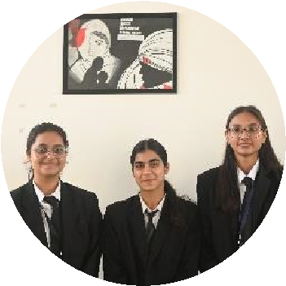

VS

TC 26

RESPONDENT

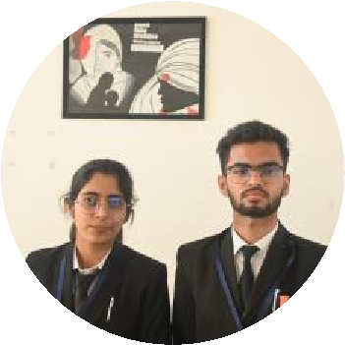

## 4.3 WINNERS

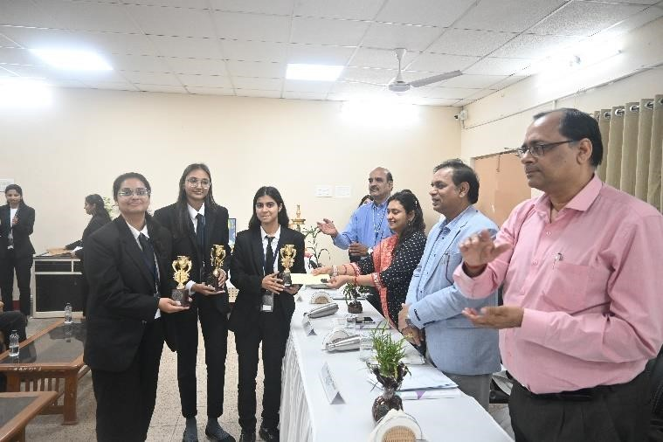

|  |  |  |  |
| --- | --- | --- | --- |
| **TEAM CODE** | **RESEARCHER** | **SPEAKER 1** | **SPEAKER 2** |
| **TC 06** | ANKITA MAURYA | AAROHI SHUKLA | JAGRITI DWIVEDI |

### 4.3.1 Feedback

*“Mooting is one of the pivotal parts of law school, and the 6th Intra-Departmental Moot Court Competition has given me the most enriching experience. The interaction with the judges and other teams had helped me to hone my research and advocacy skills. I would like to thank the organising committee for conducting such an enriching event, and we are all looking forward to more such fun and enlightening opportunities.”-* ***Ankita Maurya****.*

*“Participating in moot court gave me a glimpse of the anxiety and pressure one faces in a real courtroom. If I felt this intensity during a simulated competition, I could only imagine the challenges real lawyers encounter daily. The rigorous research, late-night preparations, and the need to perform flawlessly provided valuable insights into the legal profession. Additionally, receiving feedback from practicing lawyers and facing sharp competition from opposing teams highlighted the importance of having a worthy opponent. This experience deepened my respect for the dedication, skill, and resilience required in the legal field.” –* ***Aarohi Shukla***

*“Participating in the 6th Intra-Departmental Moot Court Competition, which was my inaugural moot court, was truly enriching. And to win at such an infant stage has boosted our confidence and empowered us to participate in more such events and excel. The rigorous cross-questioning from the judges sharpened my skills. Immersive research and improved presence of mind as a speaker were invaluable lessons that I'm going to take away from this experience. Also, witnessing our college alumni, who came as judges, excel in their respective fields, fuelled our competitive spirit. Gratitude to the organising committee for this opportunity. We look forward to more enriching experiences like this”-* ***Jagriti Dwivedi***

## 

## 4.4 RUNNER-UP :

### 4.4.1 Feedback

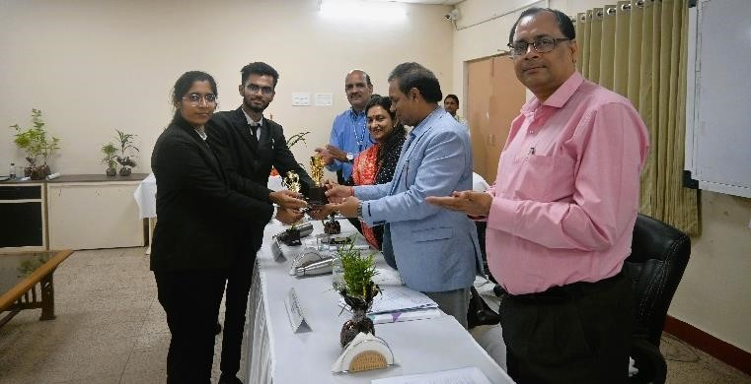*“The ID-MCC is a great initiative that should be taken. Such kinds of events should happen in the department more often. It was nice that a mock session was held, and even the foods were given to the participants. But the OC's need to be more attentive.” –* ***Mahak Tolani***

“*Mooting is not new to me, but every moot competition is unique in itself and teaches us a lot. Winning and losing are part of the journey, but it's all about getting better. Taking notes on what the jury says helps us*

*improve.” –* ***Mohammad Naqeeb*** **TC 26**

|  |  |
| --- | --- |
| **4.5 BEST SPEAKER** | **4.6 BEST RESEARCHER** |
|  |  |
| **TC 42 - Y. Sakshi Choudhary** | **TC 16 - Shreenidhi Kashyap** |

**PANELISTS**

**5.1 Panelists for Preliminary Round:**

|  |  |  |
| --- | --- | --- |
| **NAME** | **POST** | **PHOTO** |
| Mr. Arjit Tiwari | Alumni |  |
| Mr. Anmol Verma | Alumni |
| Ms. Juhi Anguria | Alumni |
| Ms. Apoorva Pandey | Alumni |
| Mr. Rishabh Singh | Alumni |
| Mr. Pranjal Singh | Alumni |
| Ms. Soumya Sharma | Alumni |
| Ms. Anuja Sharma | Alumni |
| Mr. Rahul Agarwal | Alumni |

**5.2 Panelists for Quarter and semi-finals Round:**

|  |  |  |
| --- | --- | --- |
| **NAME** | **POST** | **PHOTO** |
| Mr. Pranjal Agarwal | Alumni |  |
| Mr. Saurabh Sahu | Alumni |
| Mr. Ayushman Tripathi | Alumni |
| Mr. Sudhir Sharma | Alumni |
| Mr. Aditya Verma | Alumni |

**5.3 Panelists for Finals:**

|  |  |  |
| --- | --- | --- |
| **NAME** | **POST** | **PHOTO** |
| Mr. Sabyasachi Bhaduri | HNLU Alumni |  |
| Mr. Arjit Tiwari | Alumni |
| Mr. Harah Dave | Alumni |

**EVENT ORGANIZERS**

|  |
| --- |
| **MS. VIDHI JAIN**  BALLB 8th SEMESTER  (EVENT CO-ORDINATOR) |

**MS. NIDHI SANDAL**

ASSOCIATE PROFESSOR

(

EVENT CONVENER

)

**MS. ARUSHI SINGH**

BALLB

8

th

SEMESTER

(

EVENT CO

-

ORDINATOR

)



|  |  |  |  |  |  |  |  |
| --- | --- | --- | --- | --- | --- | --- | --- |
| |  | | --- | | **MS. SHARMISHTHA RATHORE**  BALLB 8th SEMESTER  (EVENT ORGANISING COMMITTEE) | |  | |  | | --- | | **MS. ASTHA PATEL**  BALLB 8th SEMESTER  (EVENT ORGANISING COMMITTEE) | |  | |  | | --- | | **MS. AYUSHI PANDEY**  BALLB 8th SEMESTER  (EVENT ORGANISING COMMITTEE) | |

|  |  |  |  |  |  |  |  |
| --- | --- | --- | --- | --- | --- | --- | --- |
| |  | | --- | | **MS. NIKITA DUBEY**  BALLB 8th SEMESTER  (EVENT ORGANISING COMMITTEE) | |  | |  | | --- | | **MS. PRASHASTI SHUKLA**  BALLB 8th SEMESTER  (EVENT ORGANISING COMMITTEE) | |  | |  | | --- | | **MS. SUMAN SRIVASTAVA**  BALLB 8th SEMESTER  (EVENT ORGANISING COMMITTEE) | |

**MS.**

**AMISHA RAJWADE**

BCOMLLB 8

th

SEMESTER

EVENT

(

ORGANISING COMMITTEE

)

**MS.**

**MAHIMA SAHU**

BALLB 8

th

SEMESTER

EVENT

(

ORGANISING COMMITTEE

)

**MS.**

**UPASANA**

**SEWTE**

BALLB 8

th

SEMESTER

(

EVENT

ORGANISING COMMITTEE

)

**MS.**

**GAURI BHASKAR**

BCOMLLB 8

th

SEMESTER

(

EVENT

ORGANISING COMMITTEE

)

**MS.**

**AS**

**THA PANDEY**

BCOMLLB 8

th

SEMESTER

EVENT

(

ORGANISING COMMITTEE

)

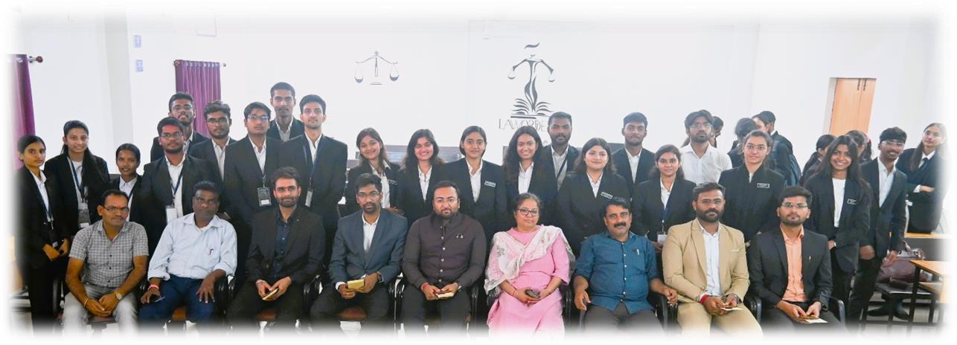

**CONCLUSION :**

As the curtains fall on the 6th Intra-Department Moot Court Competition, we extend our heartfelt gratitude to all participants, organizers, and sponsors who contributed to the success of this event. Your dedication, hard work, and enthusiasm have truly made this competition a memorable and enriching experience for all involved. To our esteemed participants, we commend your exemplary advocacy skills, legal acumen, and professionalism displayed throughout the competition. Your passion for the law and commitment to excellence have set a high standard for future endeavours in the legal field. We congratulate each of you on your achievements and look forward to witnessing your continued growth and success in your legal careers.

We would also like to express our sincere appreciation to the organizing committee for their tireless efforts in planning and executing this event. Your dedication, attention to detail, and innovative approach have been instrumental in creating a stimulating and rewarding experience for all participants. Additionally, we extend our gratitude to our sponsors for their generous support and commitment to advancing legal education and advocacy. Your contributions have helped make this event possible and have greatly enriched the experience for all involved. As we conclude this competition, we extend an invitation to all participants to stay engaged with future events and initiatives within our department. We are committed to fostering a vibrant and supportive legal community, and we welcome your continued involvement and participation in our future endeavours.

Lastly, we would like to extend a special thanks to the volunteers whose selfless efforts and unwavering commitment behind the scenes made this event possible. Your dedication to ensuring the smooth operation of every aspect of the competition, from logistics to support, has not gone unnoticed. It is your hard work and passion for the legal profession that truly embody the spirit of community and collaboration we strive for within our department. Your contributions have undoubtedly played a significant role in the success of this event, and for that, we are immensely grateful. Thank you for your invaluable support and for being an integral part of our Moot Court family.

For further inquiries, please feel free to contact us. We value your feedback and suggestions and look forward to hearing from you. Once again, thank you to everyone who contributed to the

success of the 6th Intra-Department Moot Court Competition. Your passion, dedication, and collaboration have truly made a difference, and we look forward to future opportunities to continue our shared journey in the pursuit of legal excellence.