**List of Students Admitted Against Reserved Category**

|  |  |  |  |  |  |  |  |  |  |  |
| --- | --- | --- | --- | --- | --- | --- | --- | --- | --- | --- |
| **Department : *Commerce*** | | | | | | | | | | |
|  | | | | | | | | | | |
| ***Academic Year: 2022-23*** | | | | | | | | | | |
|  | | | | | | | | | | |
| **Category** | **SC** | **ST** | | **OBC** | **DIVYANGJAN** | | | **GEN** | **OTHERS** | **TOTAL** |
| **Seat Reserved** | 46 | 22 | | 84 | * | | | 140 | 32 | **324** |
| **Students Admitted** | 44 | 22 | | 84 | 05 | | | 125 | 32 | **312** |
| **\*As per GoI Norms** | | | | | | | | | | |
| ***Category : SC*** | | |  | | |  | | |  | |
|  | | | | | | | | | | |
| ***Total Number of Students Admitted : 44*** | | | | | | |  | | | |
|  | | | | | | |  | | | |

|  |  |  |  |  |  |
| --- | --- | --- | --- | --- | --- |
| Sr. No. | Enrollment No. | Name of the Student | Gender | Course | |
|  | GGV/22/04001 | AAKANKASHA KUMARI | FEMALE | B.Com |
|  | GGV/22/04002 | AAKARSH KUMAR JHARIYA | MALE | B.Com |
|  | GGV/22/04004 | AANCHAL SONWANI | FEMALE | B.Com |
|  | GGV/22/04008 | ADITYA RAJ | MALE | B.Com |
|  | GGV/22/04018 | AMAN KUMAR KURREY | MALE | B.Com |
|  | GGV/22/04020 | AMIT ANANT | MALE | B.Com |
|  | GGV/22/04033 | ANSHU BAITHA | FEMALE | B.Com |
|  | GGV/22/04038 | ARCHANA AHIRWAR | FEMALE | B.Com |
|  | GGV/22/04041 | ARPITA KHARE | FEMALE | B.Com |
|  | GGV/22/04043 | ARUN JANGDE | MALE | B.Com |
|  | GGV/22/04058 | CHANDANI NAWARANG | FEMALE | B.Com |
|  | GGV/22/04059 | CHHAYA CHATURE | FEMALE | B.Com |
|  | GGV/22/04092 | HARSHWARDHAN BANJARE | MALE | B.Com |
|  | GGV/22/04101 | HIMANSHU KUMAR SONCHE | MALE | B.Com |
|  | GGV/22/04106 | KABIRAJ MADHUKAR | MALE | B.Com |
|  | GGV/22/04112 | KHILENDRA DAHIRE | MALE | B.Com |
|  | GGV/22/04125 | KRITIKA KANT | FEMALE | B.Com |
|  | GGV/22/04139 | MILIND XAVIER DAHARIYA | MALE | B.Com |
|  | GGV/22/04143 | OMPRAKASH | MALE | B.Com |
|  | GGV/22/04156 | PANKAJ KUMAR TONDEY | MALE | B.Com |
|  | GGV/22/04157 | PRIYA DHIRHE | FEMALE | B.Com |
|  | GGV/22/04162 | PRIYA JANGDE | FEMALE | B.Com |
|  | GGV/22/04165 | PRIYARANJAN RATREY | MALE | B.Com |
|  | GGV/22/04169 | RAJKAMAL CHAUHAN | MALE | B.Com |
|  | GGV/22/04172 | RAKHI KHANDEY | FEMALE | B.Com |
|  | GGV/22/04175 | SACHIN KUMAR ARYA | MALE | B.Com |
|  | GGV/22/04176 | SAKSHI CHANDRAVANSHI | FEMALE | B.Com |
|  | GGV/22/04179 | SAKSHI KUMARI | FEMALE | B.Com |
|  | GGV/22/04193 | SAKSHI TENDUWE | FEMALE | B.Com |
|  | GGV/22/04197 | SHIVAM KURREY | MALE | B.Com |
|  | GGV/22/04205 | SHREYANSH CHOUHAN | MALE | B.Com |
|  | GGV/22/04216 | SUDHANSHI KHUNTE | FEMALE | B.Com |
|  | GGV/22/04227 | TANUSHREE BORKAR | FEMALE | B.Com |
|  | GGV/22/04019 | URVARSHI RAIKAR | FEMALE | B.Com |
|  | GGV/22/04513 | PARAG JHARIA | MALE | M.Com |
|  | GGV/22/04516 | RAJA JAYAPURIA | MALE | M.Com |
|  | GGV/22/04517 | RASHI PATLEY | FEMALE | M.Com |
|  | GGV/22/04520 | ROSHNI GANDA | FEMALE | M.Com |
|  | GGV/19/4165 | SAMAR GEDAM | MALE | M.Com |
|  | GGV/22/04527 | TANU SONTEKE | FEMALE | M.Com |
|  | GGV/22/04529 | VENKATESH JANGDE | MALE | M.Com |
|  | GGV/14/4018 | AISHWARYA | FEMALE | Pre. Ph.D. |
|  | GGV/22/11413 | PRIYA | FEMALE | Pre. Ph.D. |
|  | GGV/22/11415 | R ALBERT TANDI | MALE | Pre. Ph.D. |

|  |  |  |  |  |  |  |  |  |  |
| --- | --- | --- | --- | --- | --- | --- | --- | --- | --- |
| *Category : ST* | | |  |  | | |  | | |
|  | | | | | | | | | |
| *Total Number of Students Admitted : 22* | | | | |  | | | | |
|  | | | | |  | | | | |
| Sr. No. | **Enrollment No.** | **Name of the Student** | | | | **Gender** | | **Course** |
|  | GGV/22/04036 | | ANURAG BECK | | | MALE | | B.Com |
|  | GGV/22/04055 | | BISHAKHA MARAVI | | | FEMALE | | B.Com |
|  | GGV/22/04064 | | DEVINDRA MARKAM | | | MALE | | B.Com |
|  | GGV/22/04068 | | DIKESHWARI SIDAR | | | FEMALE | | B.Com |
|  | GGV/22/04094 | | HIMANI L KANWAR | | | FEMALE | | B.Com |
|  | GGV/22/04095 | | HRISHIKA SAI PAINKRA | | | FEMALE | | B.Com |
|  | GGV/22/04126 | | ISHITA KHESS | | | FEMALE | | B.Com |
|  | GGV/22/04147 | | MINAKSHI ADALI | | | FEMALE | | B.Com |
|  | GGV/22/04149 | | PRACHI TIGGA | | | FEMALE | | B.Com |
|  | GGV/22/04191 | | PRADEEP KUMAR SIDAR | | | MALE | | B.Com |
|  | GGV/22/04209 | | SHESHNARAYAN THAKUR | | | MALE | | B.Com |
|  | GGV/22/04213 | | SURAJ KUMAR | | | MALE | | B.Com |
|  | GGV/22/04215 | | SWATI KANWAR | | | FEMALE | | B.Com |
|  | GGV/22/04228 | | TAMANNA KUJUR | | | FEMALE | | B.Com |
|  | GGV/22/04232 | | VAIBHAV SINGH | | | MALE | | B.Com |
|  | GGV/22/04237 | | VARTIKA SALLAM | | | FEMALE | | B.Com |
|  | GGV/22/04240 | | VINAY KUMAR | | | MALE | | B.Com |
|  | GGV/22/04001 | | VINEE NETAM | | | FEMALE | | B.Com |
|  | GGV/19/4013 | | AKSHAY KUMAR RAJ | | | MALE | | M.Com |
|  | GGV/22/04514 | | PRIYANSHU BHAGAT | | | MALE | | M.Com |
|  | GGV/22/04528 | | UPHAR KERKETTA | | | MALE | | M.Com |
|  | GGV/22/11409 | | NANG RINI LONGKENG | | | FEMALE | | Pre. Ph.D. |

|  |  |  |  |  |  |  |  |  |  |
| --- | --- | --- | --- | --- | --- | --- | --- | --- | --- |
| *Category : OBC* | | |  |  | | |  | | |
|  | | | | | | | | | |
| *Total Number of Students Admitted : 84* | | | | |  | | | | |
|  | | | | |  | | | | |
| Sr. No. | **Enrollment No.** | **Name of the Student** | | | | **Gender** | | **Course** |
|  | GGV/22/04012 | AKANSHU SHRIWAS | | | | MALE | | B.Com |
|  | GGV/22/04013 | AKASH KUMAR GUPTA | | | | MALE | | B.Com |
|  | GGV/22/04017 | AMAN KUMAR CHANDRAVANSHI | | | | MALE | | B.Com |
|  | GGV/22/04019 | AMAR SONI | | | | MALE | | B.Com |
|  | GGV/22/04021 | ANCHAL YADAV | | | | FEMALE | | B.Com |
|  | GGV/22/04023 | ANJALI | | | | FEMALE | | B.Com |
|  | GGV/22/04025 | ANJALI YADAV | | | | FEMALE | | B.Com |
|  | GGV/22/04026 | ANKIT DEWANGAN | | | | MALE | | B.Com |
|  | GGV/22/04035 | ANSHU VISHWAKARMA | | | | MALE | | B.Com |
|  | GGV/22/04037 | ANURAG PRADHAN | | | | MALE | | B.Com |
|  | GGV/22/04042 | ARSHLAN ALI | | | | MALE | | B.Com |
|  | GGV/22/04046 | ASHISH PATEL | | | | MALE | | B.Com |
|  | GGV/22/04049 | AYUSH YADAV | | | | MALE | | B.Com |
|  | GGV/22/04051 | BALKRISHNA SAHU | | | | MALE | | B.Com |
|  | GGV/22/04052 | BHAVDEEP SAHU | | | | MALE | | B.Com |
|  | GGV/22/04056 | BRIJESH DAS MANIKPURI | | | | MALE | | B.Com |
|  | GGV/22/04057 | CHAMAN BHOI | | | | MALE | | B.Com |
|  | GGV/22/04063 | DEVESH DEWANGAN | | | | MALE | | B.Com |
|  | GGV/22/04065 | DHANENDRA SAHU | | | | MALE | | B.Com |
|  | GGV/22/04066 | DIKESHWARI SAHU | | | | FEMALE | | B.Com |
|  | GGV/22/04073 | DUSHYANT SAHU | | | | MALE | | B.Com |
|  | GGV/22/04079 | GOPESH VERMA | | | | MALE | | B.Com |
|  | GGV/22/04080 | GYAN SHANKER VERMA | | | | MALE | | B.Com |
|  | GGV/22/04096 | HARSHITA SAO | | | | FEMALE | | B.Com |
|  | GGV/22/04099 | JASLEEN KAUR | | | | FEMALE | | B.Com |
|  | GGV/22/04100 | JEETESH PATEL | | | | MALE | | B.Com |
|  | GGV/22/04104 | JUHI YADAV | | | | FEMALE | | B.Com |
|  | GGV/22/04105 | KARAN SINGH | | | | MALE | | B.Com |
|  | GGV/22/04107 | KEDAR PATEL | | | | MALE | | B.Com |
|  | GGV/22/04108 | KHILESH YADAV | | | | MALE | | B.Com |
|  | GGV/22/04114 | KHUSHBOO NAYAK | | | | FEMALE | | B.Com |
|  | GGV/22/04116 | KUNAL CHAUHAN | | | | MALE | | B.Com |
|  | GGV/22/04117 | KUSHAL PATEL | | | | MALE | | B.Com |
|  | GGV/22/04120 | LAXMIKANT PATEL | | | | MALE | | B.Com |
|  | GGV/22/04124 | MANORANJAN MANDAL | | | | MALE | | B.Com |
|  | GGV/22/04131 | MICKEY LAL RAJWADE | | | | MALE | | B.Com |
|  | GGV/22/04135 | NIKHIL RATHORE | | | | MALE | | B.Com |
|  | GGV/22/04137 | NITIN PATEL | | | | MALE | | B.Com |
|  | GGV/22/04140 | NOHAR SINGH VERMA | | | | MALE | | B.Com |
|  | GGV/22/04141 | PALAK TAMRAKAR | | | | FEMALE | | B.Com |
|  | GGV/22/04142 | PALLAVI KAIWART | | | | FEMALE | | B.Com |
|  | GGV/22/04146 | PALLAVI PATEL | | | | FEMALE | | B.Com |
|  | GGV/22/04148 | PIYUSH SHRIVAS | | | | MALE | | B.Com |
|  | GGV/22/04150 | PRADEEP KUMAR PAL | | | | MALE | | B.Com |
|  | GGV/22/04154 | PRAKHAR SAHU | | | | MALE | | B.Com |
|  | GGV/22/04155 | PRATEEK RAI | | | | MALE | | B.Com |
|  | GGV/22/04158 | PREM KUMAR RAJPUT | | | | MALE | | B.Com |
|  | GGV/22/04159 | PRIYA YADAV | | | | FEMALE | | B.Com |
|  | GGV/22/04160 | PRIYA YADAV | | | | FEMALE | | B.Com |
|  | GGV/22/04170 | PRIYANKA DAS | | | | FEMALE | | B.Com |
|  | GGV/22/04171 | RASHMI RAJAK | | | | FEMALE | | B.Com |
|  | GGV/22/04183 | ROSHAN SHARMA | | | | MALE | | B.Com |
|  | GGV/22/04185 | SANDEEP SHARMA | | | | MALE | | B.Com |
|  | GGV/22/04189 | SAPNA MANJHI | | | | FEMALE | | B.Com |
|  | GGV/22/04190 | SHARAD NAIK | | | | MALE | | B.Com |
|  | GGV/22/04192 | SHASHIKANT SAHU | | | | MALE | | B.Com |
|  | GGV/22/04196 | SHIKHA SONI | | | | FEMALE | | B.Com |
|  | GGV/22/04207 | SHREYA SARAF | | | | FEMALE | | B.Com |
|  | GGV/22/04219 | SUMIT SEN | | | | MALE | | B.Com |
|  | GGV/22/04221 | TARUN NIRMALKAR | | | | MALE | | B.Com |
|  | GGV/22/04223 | TOOLIKA VERMA | | | | FEMALE | | B.Com |
|  | GGV/22/04226 | TRIPTI SAHU | | | | FEMALE | | B.Com |
|  | GGV/22/04234 | UDIT NAYAK | | | | MALE | | B.Com |
|  | GGV/22/04003 | VASU SAHU | | | | MALE | | B.Com |
|  | GGV/22/04501 | ANCHAL GUPTA | | | | FEMALE | | M.Com |
|  | GGV/22/04503 | BHAVNA DEVANGAN | | | | FEMALE | | M.Com |
|  | GGV/22/04504 | DEVYANI PRADHAN | | | | FEMALE | | M.Com |
|  | GGV/22/04505 | GOVARDHAN RATHOR | | | | MALE | | M.Com |
|  | GGV/22/04508 | KONAL DEWANGAN | | | | MALE | | M.Com |
|  | GGV/22/04509 | KRITI YADAV | | | | FEMALE | | M.Com |
|  | GGV/19/4082 | LAV SINGH RATHORE | | | | MALE | | M.Com |
|  | GGV/22/04511 | MAYANK KUMAR | | | | MALE | | M.Com |
|  | GGV/22/04512 | NANDLAL SONI | | | | MALE | | M.Com |
|  | GGV/19/4134 | PRIYA PATEL | | | | FEMALE | | M.Com |
|  | GGV/22/04515 | RAHUL DEVANGAN | | | | MALE | | M.Com |
|  | GGV/22/04518 | RENUKA MAHTO | | | | FEMALE | | M.Com |
|  | GGV/22/04521 | SADHNA YADAV | | | | FEMALE | | M.Com |
|  | GGV/22/04522 | SAROJ KUMAR | | | | MALE | | M.Com |
|  | GGV/22/04525 | SONALI NAMDEO | | | | FEMALE | | M.Com |
|  | GGV/19/4204 | VARSHA SAHU | | | | FEMALE | | M.Com |
|  | GGV/19/4052 | HEMKIRAN SAHU | | | | FEMALE | | Pre Ph.D. |
|  | GGV/22/11406 | HIMANSHU KOLTE | | | | MALE | | Pre Ph.D. |
|  | GGV/22/11407 | ISH KUMAR KEWAT | | | | MALE | | Pre Ph.D. |
|  | GGV/22/11408 | JITENDRA PATEL | | | | MALE | | Pre Ph.D. |

|  |  |  |  |  |  |  |  |  |
| --- | --- | --- | --- | --- | --- | --- | --- | --- |
| *Category : DIVYANGJAN* | | |  | | |  | | |
|  | | | | | | | | |
| *Total Number of Students Admitted : 05* | | | |  | | | | |
|  | | | |  | | | | |
| Sr. No. | **Enrollment No.** | **Name of the Student** | | | **Gender** | | **Course** |
| 01. | GGV/22/04030 | ANNAPURNA SINGH | | | FEMALE | | B.Com |
| 02. | GGV/22/04032 | ANSHIL KUMAR | | | MALE | | B.Com |
| 03. | GGV/22/04062 | DEEPESH SAW | | | MALE | | B.Com |
| 04. | GGV/22/04074 | FAIZAN HUSSAIN | | | MALE | | B.Com |
| 05. | GGV/22/04130 | NICKY BHARDWAJ | | | FEMALE | | B.Com |

|  |  |  |  |  |  |  |  |  |  |
| --- | --- | --- | --- | --- | --- | --- | --- | --- | --- |
| *Category : GENERAL* | | |  |  | | |  | | |
|  | | | | | | | | | |
| *Total Number of Students Admitted :125* | | | | |  | | | | |
|  | | | | |  | | | | |
| Sr. No. | **Enrollment No.** | **Name of the Student** | | | | **Gender** | | **Course** |
|  | GGV/22/04003 | AANCHAL SHUKLA | | | | FEMALE | | B.Com |
|  | GGV/22/04005 | AASTHA KUMARI | | | | FEMALE | | B.Com |
|  | GGV/22/04009 | ADITYA SHARMA | | | | MALE | | B.Com |
|  | GGV/22/04010 | AISHWARYA NAIR | | | | FEMALE | | B.Com |
|  | GGV/22/04011 | AKANKSHA SAHU | | | | FEMALE | | B.Com |
|  | GGV/22/04014 | AKASH SINGH | | | | MALE | | B.Com |
|  | GGV/22/04015 | AKASH SINGH | | | | MALE | | B.Com |
|  | GGV/22/04016 | ALISHA KESHARWANI | | | | FEMALE | | B.Com |
|  | GGV/22/04022 | ANIKA KHASKALAM | | | | FEMALE | | B.Com |
|  | GGV/22/04024 | ANJALI JAISWAL | | | | FEMALE | | B.Com |
|  | GGV/22/04031 | ANSARI IRFAN | | | | MALE | | B.Com |
|  | GGV/22/04034 | ANSHU GUPTA | | | | MALE | | B.Com |
|  | GGV/22/04039 | ARMAN SAHU | | | | MALE | | B.Com |
|  | GGV/22/04044 | ARYAN DANSENA | | | | MALE | | B.Com |
|  | GGV/22/04047 | ATUL PANDEY | | | | MALE | | B.Com |
|  | GGV/22/04048 | AYUSH DUBEY | | | | MALE | | B.Com |
|  | GGV/22/04050 | AYUSHI KASHYAP | | | | FEMALE | | B.Com |
|  | GGV/22/04053 | BHOOMIKA AGRAWAL | | | | FEMALE | | B.Com |
|  | GGV/22/04054 | BHUVAN KUMAR GUPTA | | | | MALE | | B.Com |
|  | GGV/22/04060 | DEEPANJALI PARESHWAR | | | | FEMALE | | B.Com |
|  | GGV/22/04069 | DISHA SAHU | | | | FEMALE | | B.Com |
|  | GGV/22/04070 | DIVAKAR KUMAR | | | | MALE | | B.Com |
|  | GGV/22/04071 | DIVYA SMRITI SINGH | | | | FEMALE | | B.Com |
|  | GGV/22/04072 | DIYA SHAHANI | | | | FEMALE | | B.Com |
|  | GGV/22/04075 | FALESHWAR PRASAD RATHIA | | | | MALE | | B.Com |
|  | GGV/22/04076 | G VANSHIKA REDDY | | | | FEMALE | | B.Com |
|  | GGV/22/04077 | GARIMA LOKHANDE | | | | FEMALE | | B.Com |
|  | GGV/22/04078 | GAURAV NAGPURE | | | | MALE | | B.Com |
|  | GGV/22/04081 | HARI NARAYAN DWIVEDI | | | | MALE | | B.Com |
|  | GGV/22/04082 | HARSH BHAGAT | | | | MALE | | B.Com |
|  | GGV/22/04084 | HARSH KUMAR | | | | MALE | | B.Com |
|  | GGV/22/04085 | HARSH SHARMA | | | | MALE | | B.Com |
|  | GGV/22/04088 | HARSH VARDHAN RATHORE | | | | MALE | | B.Com |
|  | GGV/22/04089 | HEMANT KUMAR SAHU | | | | MALE | | B.Com |
|  | GGV/22/04091 | HEMANT PATEL | | | | MALE | | B.Com |
|  | GGV/22/04093 | HIMANSHU DADSENA | | | | MALE | | B.Com |
|  | GGV/22/04097 | HIMANSHU SHEKHAR | | | | MALE | | B.Com |
|  | GGV/22/04102 | JASPREET KAUR MUNDI | | | | FEMALE | | B.Com |
|  | GGV/22/04103 | KALYAN SINGH RATHIA | | | | MALE | | B.Com |
|  | GGV/22/04109 | KARAN DODWANI | | | | MALE | | B.Com |
|  | GGV/22/04110 | KHUSHI ADWANI | | | | FEMALE | | B.Com |
|  | GGV/22/04111 | KHUSHI PANDEY | | | | FEMALE | | B.Com |
|  | GGV/22/04113 | KHUSHI SINGH | | | | FEMALE | | B.Com |
|  | GGV/22/04115 | KUMKUM BATHRI | | | | FEMALE | | B.Com |
|  | GGV/22/04118 | KUNAL PATEL | | | | MALE | | B.Com |
|  | GGV/22/04119 | LEKHRAJ PATEL | | | | MALE | | B.Com |
|  | GGV/22/04121 | MAHAK CHAWLA | | | | FEMALE | | B.Com |
|  | GGV/22/04122 | MAYUR SONI | | | | MALE | | B.Com |
|  | GGV/22/04123 | MEGHA TOLANI | | | | FEMALE | | B.Com |
|  | GGV/22/04127 | MEHAK SHARMA | | | | FEMALE | | B.Com |
|  | GGV/22/04128 | MOHAMMED HAROON RIZVI | | | | MALE | | B.Com |
|  | GGV/22/04129 | NAVNISH KUMAR RAY | | | | MALE | | B.Com |
|  | GGV/22/04132 | NIDHI MSHRA | | | | FEMALE | | B.Com |
|  | GGV/22/04133 | NILESH RAI | | | | MALE | | B.Com |
|  | GGV/22/04134 | NITESH KUMAR GUPTA | | | | MALE | | B.Com |
|  | GGV/22/04136 | NITESH KURAHE | | | | MALE | | B.Com |
|  | GGV/22/04138 | NITIN SONI | | | | MALE | | B.Com |
|  | GGV/22/04151 | NURUNNISHA | | | | FEMALE | | B.Com |
|  | GGV/22/04153 | PRAKRITI YADAV | | | | FEMALE | | B.Com |
|  | GGV/22/04163 | PRASHANSHA SAHU | | | | FEMALE | | B.Com |
|  | GGV/22/04164 | RAHUL SAHU | | | | MALE | | B.Com |
|  | GGV/22/04166 | RAJ VIKASH PRAJAPATI | | | | MALE | | B.Com |
|  | GGV/22/04167 | RAJNIKANT PATHAK | | | | MALE | | B.Com |
|  | GGV/22/04168 | RAHUL BAJPAI | | | | MALE | | B.Com |
|  | GGV/22/04174 | RAJVEER | | | | MALE | | B.Com |
|  | GGV/22/04177 | SAHIL TIRKEY | | | | MALE | | B.Com |
|  | GGV/22/04178 | SAKSHI SINHA | | | | FEMALE | | B.Com |
|  | GGV/22/04180 | SAKSHI TEKCHANDANI | | | | FEMALE | | B.Com |
|  | GGV/22/04181 | SAKSHI VERMA | | | | FEMALE | | B.Com |
|  | GGV/22/04182 | SAMARTH SHRIVASTAVA | | | | MALE | | B.Com |
|  | GGV/22/04188 | SAMEER VERMA | | | | MALE | | B.Com |
|  | GGV/22/04194 | SHAHANA PARVEEN | | | | FEMALE | | B.Com |
|  | GGV/22/04198 | SHIVANGI PRIYA | | | | FEMALE | | B.Com |
|  | GGV/22/04200 | SHRUTI DIXIT | | | | FEMALE | | B.Com |
|  | GGV/22/04201 | SHRYANSH JAIN | | | | MALE | | B.Com |
|  | GGV/22/04203 | SIMRAN SINGH | | | | FEMALE | | B.Com |
|  | GGV/22/04206 | SOMU BERA | | | | MALE | | B.Com |
|  | GGV/22/04208 | SUHANI SINGH | | | | FEMALE | | B.Com |
|  | GGV/22/04210 | SUMITRA SIDAR | | | | FEMALE | | B.Com |
|  | GGV/22/04211 | SURAJ SINGH CHOUHAN | | | | MALE | | B.Com |
|  | GGV/22/04212 | SUYASH GUPTA | | | | MALE | | B.Com |
|  | GGV/22/04217 | SUYASH SAHU | | | | MALE | | B.Com |
|  | GGV/22/04218 | TANYA SAHU | | | | FEMALE | | B.Com |
|  | GGV/22/04220 | TANYA VISHWAKARMA | | | | FEMALE | | B.Com |
|  | GGV/22/04222 | THANENDRA KUMAR VERMA | | | | MALE | | B.Com |
|  | GGV/22/04225 | TRIPTI DEWANGAN | | | | FEMALE | | B.Com |
|  | GGV/22/04229 | TWINKAL DEWANGAN | | | | FEMALE | | B.Com |
|  | GGV/22/04230 | VAIBHAVEE DEWANGAN | | | | FEMALE | | B.Com |
|  | GGV/22/04233 | VANSHIKA ADWANI | | | | FEMALE | | B.Com |
|  | GGV/22/04236 | VARUN SENGAR | | | | MALE | | B.Com |
|  | GGV/22/04238 | VIGHNESH KEDIA | | | | MALE | | B.Com |
|  | GGV/22/04241 | VINAY VERMA | | | | MALE | | B.Com |
|  | GGV/22/04242 | VINIT KUMAR THAWRANI | | | | MALE | | B.Com |
|  | GGV/22/04243 | VISHAL KUMAR SINGH | | | | MALE | | B.Com |
|  | GGV/22/04244 | VISHWA SHARMA | | | | MALE | | B.Com |
|  | GGV/22/04002 | SNEHA SINGH | | | | FEMALE | | B.Com |
|  | GGV/19/4016 | AMARTYA VERMA | | | | MALE | | M.Com |
|  | GGV/22/04502 | ANKITA Tiwari | | | | FEMALE | | M.Com |
|  | GGV/19/4028 | AYUSH KUMAR | | | | MALE | | M.Com |
|  | GGV/22/04507 | JANHAVI KAR | | | | FEMALE | | M.Com |
|  | GGV/22/04510 | MADHURI JHA | | | | FEMALE | | M.Com |
|  | GGV/19/4111 | NITISH AILANI | | | | MALE | | M.Com |
|  | GGV/22/04519 | RIDDHI AHUJA | | | | FEMALE | | M.Com |
|  | GGV/22/04523 | SIDDHI AHUJA | | | | FEMALE | | M.Com |
|  | GGV/22/04524 | SONALI KUMARI | | | | FEMALE | | M.Com |
|  | GGV/19/4190 | TANISHKA GUPTA | | | | FEMALE | | M.Com |
|  | GGV/22/11401 | ABHISHEK KUMAR UPADHYAY | | | | MALE | | Pre Ph.D. |
|  | GGV/22/11402 | AISHWARYA SINGH | | | | FEMALE | | Pre Ph.D. |
|  | GGV/22/11403 | AMAR YADAV | | | | MALE | | Pre Ph.D. |
|  | GC/09/252 | DEEPIKA DADSENA | | | | FEMALE | | Pre Ph.D. |
|  | GGV/22/11404 | DEVENDRA PRATAP SINGH | | | | MALE | | Pre Ph.D. |
|  | GGV/22/11405 | DHARAM SHILA | | | | FEMALE | | Pre Ph.D. |
|  | GGV/22/11410 | NEHA PATHAK | | | | FEMALE | | Pre Ph.D. |
|  | GGV/22/11411 | NIDHI PANDEY | | | | FEMALE | | Pre Ph.D. |
|  | GGV/22/11412 | POOJA PATEL | | | | FEMALE | | Pre Ph.D. |
|  | GGV/22/11414 | PURNENDU KUMAR | | | | MALE | | Pre Ph.D. |
|  | GGV/22/11416 | RAHUL KUMAR | | | | MALE | | Pre Ph.D. |
|  | GGV/22/11417 | RASHMI TIWARI | | | | FEMALE | | Pre Ph.D. |
|  | GGV/22/11418 | SHALINI KUSHWAHA | | | | FEMALE | | Pre Ph.D. |
|  | GGV/22/11419 | SHUBHANKAR CHATTERJEE | | | | MALE | | Pre Ph.D. |
|  | GGV/22/11421 | SOURABH KUMAR PANDEY | | | | MALE | | Pre Ph.D. |
|  | GGV/22/11422 | SUJEET KUMAR GAUR | | | | MALE | | Pre Ph.D. |
|  | GGV/22/11424 | VANSHIKA THAKUR | | | | FEMALE | | Pre Ph.D. |
|  | GGV/22/11425 | VIVEK | | | | MALE | | Pre Ph.D. |
|  | GGV/22/11426 | YASHWANT KUMAR | | | | MALE | | Pre Ph.D. |

|  |  |  |  |  |  |
| --- | --- | --- | --- | --- | --- |
| *Category : OTHERS (EWS+J&K+EQ)* | | |  | | |
| *Total Number of Students Admitted : 32* | | | |
|  | | | |
| Sr. No. | **Enrollment No.** | **Name of the Student** | | | **Gender** | | **Course** |
|  | GGV/22/04006 | AAYUSH TIWARI | | | MALE | | B.Com |
|  | GGV/22/04007 | ADITYA KUMAR | | | MALE | | B.Com |
|  | GGV/22/04027 | ANKITA GOURHA | | | FEMALE | | B.Com |
|  | GGV/22/04028 | ANMOL GUPTA | | | MALE | | B.Com |
|  | GGV/22/04029 | ANMOL SHARMA | | | MALE | | B.Com |
|  | GGV/22/04040 | ARNAV MISHRA | | | MALE | | B.Com |
|  | GGV/22/04061 | DEEPANSHI RAJPOOT | | | FEMALE | | B.Com |
|  | GGV/22/04067 | DINESH PANJWANI | | | MALE | | B.Com |
|  | GGV/22/04144 | JAYESH SHRIVASTAVA | | | MALE | | B.Com |
|  | GGV/22/04145 | PAPIYA BISWAS | | | FEMALE | | B.Com |
|  | GGV/22/04152 | PIYUSH KUMAR | | | MALE | | B.Com |
|  | GGV/22/04161 | PRANSHU SHARMA | | | MALE | | B.Com |
|  | GGV/22/04173 | PRIYANSHU GHOSH | | | MALE | | B.Com |
|  | GGV/22/04187 | SAGAR MISHRA | | | MALE | | B.Com |
|  | GGV/22/04195 | SARVESH AGRAWAL | | | MALE | | B.Com |
|  | GGV/22/04199 | SHIVANSH SHUKLA | | | MALE | | B.Com |
|  | GGV/22/04202 | SHRUTI SINGH | | | FEMALE | | B.Com |
|  | GGV/22/04204 | SNEHA KARN | | | FEMALE | | B.Com |
|  | GGV/22/04214 | SOUMYA SHARMA | | | MALE | | B.Com |
|  | GGV/22/04224 | SWAYAM MISHRA | | | MALE | | B.Com |
|  | GGV/22/04231 | TUSHAR PANDEY | | | MALE | | B.Com |
|  | GGV/22/04235 | VARTIKA MISHRA | | | FEMALE | | B.Com |
|  | GGV/22/04009 | VEDANT KUNDU | | | MALE | | B.Com |
|  | GGV/22/04506 | IPSITA PRADHAN | | | FEMALE | | M.Com |
|  | GGV/19/4103 | NEETYA KHATRI | | | FEMALE | | M.Com |
|  | GGV/19/4172 | SHIVAM GUPTA | | | MALE | | M.Com |
|  | GGV/22/11420 | SOHIT KUMAR PANDEY | | | MALE | | M.Com |
|  | GGV/22/11423 | TAI SHAGUFTA | | | FEMALE | | M.Com |
|  | GGV/22/04045 | ASHISH KUMAR SINGH | | | MALE | | B.Com |
|  | GGV/22/04001 | SHARAD KUMAR | | | MALE | | B.Com |
|  | GGV/22/04239 | SANIDHYA PATHAK | | | MALE | | B.Com |
|  | GGV/22/04000 | VINAYAK KAUSHIK | | | MALE | | B.Com |

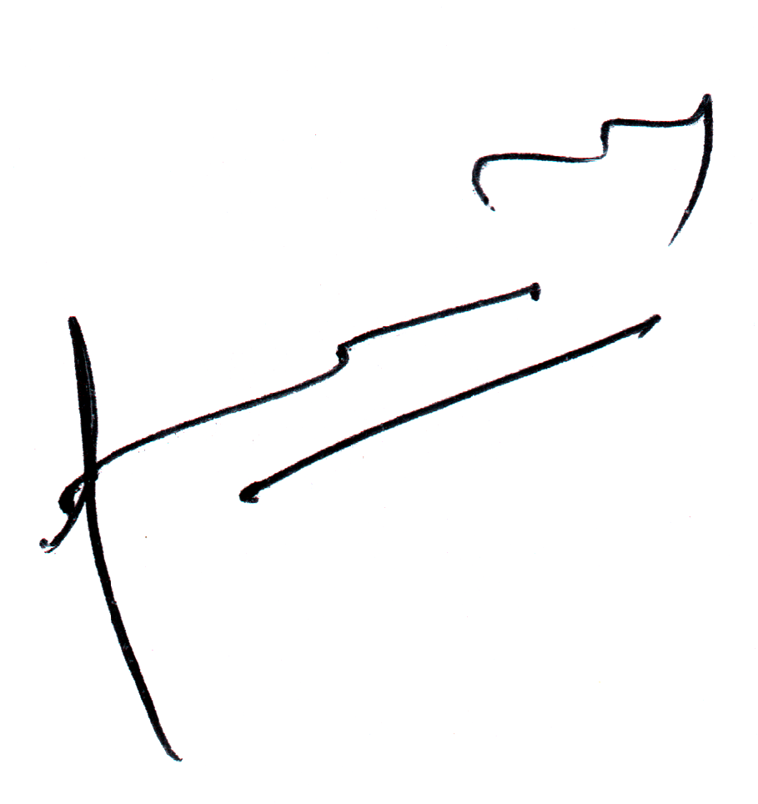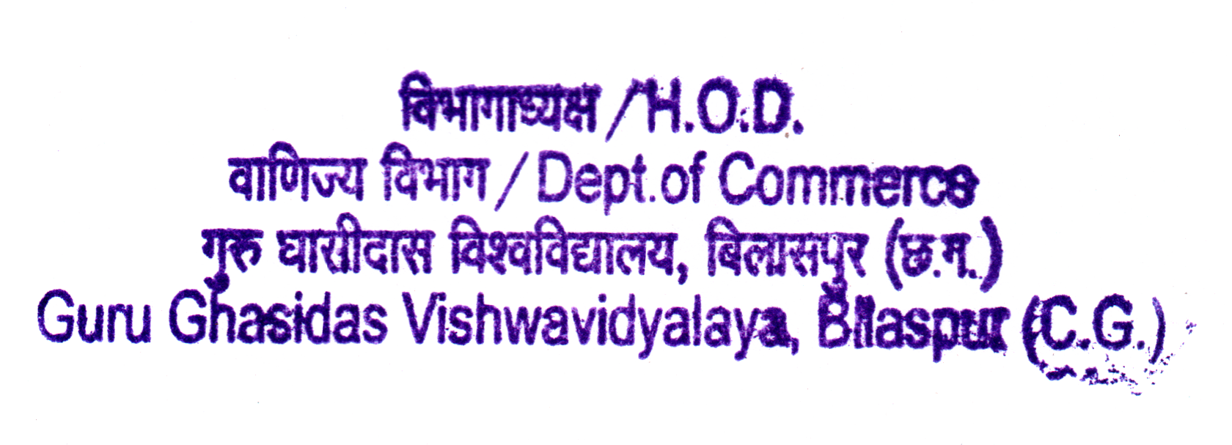

Signature & Seal of HoD