List of Students Admitted Against Reserved Category
Department : Journalism & Mass Communication

Academic Year : 2022-23
Category |  | SC | ST |  |  | OBC | DIVYANGJAN |  |  | Unreserved |  |  | OTHERS (EWS) | TOTAL
Seat Reserved |  | 21 | 08 |  |  | 31 | -- |  |  | 44 |  |  | 11 | 115
Students Admitted |  | 08 | 06 |  |  | 30 | -- |  |  | 42 |  |  | 07 | 93
Category : SC
Total Number of Students Admitted : 07
Sr. No. | Enrollment No. |  |  | Name of the Student |  |  |  |  |  |  | Gender |  | Course
01. | GGV/22/00402 |  |  | Aakansha Sahare |  |  |  |  |  |  | Female |  | B.A. J.M.C. Semester-Ist
02 | GGV/22/00410 |  |  | Arun Kumar |  |  |  |  |  |  | Male |  | B.A. J.M.C. Semester-Ist
03 | GGV/22/00415 |  |  | Dolly Suryavanshi |  |  |  |  |  |  | Female |  | B.A. J.M.C. Semester-Ist
04 | GGV/22/00422 |  |  | Heena Khande |  |  |  |  |  |  | Female |  | B.A. J.M.C. Semester-Ist
05 | GGV/22/00425 |  |  | Lav Kumar Ranjan |  |  |  |  |  |  | Male |  | B.A. J.M.C. Semester-Ist
06 | GGV/22/00449 |  |  | Soumya Warde |  |  |  |  |  |  | Female |  | B.A. J.M.C. Semester-Ist
07. | GGV/22/11203 |  |  | Priyanka Sarkar |  |  |  |  |  |  | Female |  | Pre-Ph.D

Category : ST
Total Number of Students Admitted : 06
Sr. No. | Enrollment No. | Name of the Student |  |  |  | Gender |  | Course
01. | GGV/22/00411 | Annanya Naik |  |  |  | Female |  | B.A. J.M.C. Semester-Ist
02 | GGV/22/00439 | Durga Singh Gond |  |  |  | Female |  | B.A. J.M.C. Semester-Ist
03. | GGV/22/00435 | Priyanjali Ekka |  |  |  | Female |  | B.A. J.M.C. Semester-Ist
04. | GGV/22/00437 | Saini Bara |  |  |  | Female |  | B.A. J.M.C. Semester-Ist
05. | GGV/22/00507 | Harshika Netam |  |  |  | Female |  | M.A.J.M.C. Semester- Ist
06. | GGV/22/0302 | Shahil Xalxo |  |  |  | Female |  | M.A.J.M.C. Semester- Ist

Category : OBC
Total Number of Students Admitted : 31
Sr. No. | Enrollment No. | Name of the Student |  |  |  | Gender |  | Course
01. | GGV/22/00403 | Aastha Gupta |  |  |  | Female |  | B.A. J.M.C. Semester-Ist
02. | GGV/22/00415 | Akansha Raj |  |  |  | Female |  | B.A. J.M.C. Semester-Ist
03. | GGV/22/00413 | Chetan Sahu |  |  |  | Male |  | B.A. J.M.C. Semester-Ist
04. | GGV/22/00418 | Gayeshwer Verma |  |  |  | Male |  | B.A. J.M.C. Semester-Ist
05. | GGV/22/00418 | Gudivada Srivivekanand |  |  |  | Male |  | B.A. J.M.C. Semester-Ist
06. | GGV/22/00421 | Harsha Sonbersha |  |  |  | Female |  | B.A. J.M.C. Semester-Ist
07. | GGV/22/00423 | Kamna Patel |  |  |  | Female |  | B.A. J.M.C. Semester-Ist
08. | GGV/22/00504 | Nupur Verma |  |  |  | Female |  | B.A. J.M.C. Semester-Ist
09. | GGV/22/00434 | Piyush Kumar Maitry |  |  |  | Male |  | B.A. J.M.C. Semester-Ist
10. | GGV/22/00438 | Sakshi Naik |  |  |  | Female |  | B.A. J.M.C. Semester-Ist
11. | GGV/22/00440 | Shaista Praveen |  |  |  | Female |  | B.A. J.M.C. Semester-Ist
12. | GGV/22/00511 | Shreyansh Domne |  |  |  | Male |  | B.A. J.M.C. Semester-Ist
13. | GGV/22/00445 | Shrijana Yadev |  |  |  | Female |  | B.A. J.M.C. Semester-Ist
14. | GGV/22/00446 | Shubham Kumar |  |  |  | Male |  | B.A. J.M.C. Semester-Ist
15. | GGV/22/00452 | Umar Ahmad Raza |  |  |  | Male |  | B.A. J.M.C. Semester-Ist
16. | GGV/22/00454 | Velu Pula Tharun |  |  |  | Male |  | B.A. J.M.C. Semester-Ist
17. | GGV/22/00457 | Yash Bairagi |  |  |  | Male |  | B.A. J.M.C. Semester-Ist
18. | GGV/22/00501 | Akash Sahu |  |  |  | Male |  | M.A.J.M.C. Semester- Ist
19. | GGV/22/00506 | Gatum Rishi Sahu |  |  |  | Female |  | M.A.J.M.C. Semester- Ist
20. | GGV/22/0051 | Garav Sinha |  |  |  | Male |  | M.A.J.M.C. Semester- Ist
21. | GGV/22/00508 | Megha Soni |  |  |  | Female |  | M.A.J.M.C. Semester- Ist
28. | GGV/22/00509 | Pragya Pal |  |  |  | Female |  | M.A.J.M.C. Semester- Ist
29. | GGV/22/00512 | Shakshi |  |  |  | Female |  | M.A.J.M.C. Semester- Ist
30. | GGV/22/11205 | Shahid Ali |  |  |  | Male |  | Pre-Ph.D
31 | GGV/22/11201 | Limina Sahu |  |  |  | Female |  | Pre-Ph.D

Category : DIVYANGJAN

Total Number of Students Admitted : 00
Sr. No. | Enrollment No. | Name of the Student |  |  |  | Gender |  | Course

Category : Unreserved
Total Number of Students Admitted : 42
Sr. No. | Enrollment No. | Name of the Student |  |  |  | Gender |  | Course
01. | GGV/22/00401 | Aahanya Vaidya |  |  |  | Female |  | B.A. J.M.C. Semester-Ist
02. | GGV/22/00404 | Aayushi |  |  |  | Female |  | B.A. J.M.C. Semester-Ist
03. | GGV/22/00406 | Aniket Kesari |  |  |  | Male |  | B.A. (Hons.) J.M.C.-Ist
04. | GGV/ 22/ 00407 | Anjali Mishra |  |  |  | Female |  | B.A. J.M.C. Semester-Ist
05. | GGV/22/00409 | Anshita Mishra |  |  |  | Female |  | B.A. J.M.C. Semester-Ist
06. | GGV/22/00411 | Ayushi Tiwari |  |  |  | Female |  | B.A. J.M.C. Semester-Ist
07. | GGV/22/00412 | Balvir Singh |  |  |  | Male |  | B.A. J.M.C. Semester-Ist
08. | GGV/22/ 00414 | Deepika Mishra |  |  |  | Female |  | B.A. J.M.C. Semester-Ist
09. | GGV/22/00419 | Ghanishtha Dubey |  |  |  | Female |  | B.A. J.M.C. Semester-Ist
10. | GGV/22/00424 | Kshitij Singh |  |  |  | Male |  | B.A. J.M.C. Semester-Ist
11. | GGV/22/00426 | Mansha Tiwari |  |  |  | Female |  | B.A. J.M.C. Semester-Ist
12. | GGV/22/00412 | Mayank Singh Thakur |  |  |  | Male |  | B.A. J.M.C. Semester-Ist
13. | GGV/22/00413 | Moon Singh |  |  |  | Female |  | B.A. J.M.C. Semester-Ist
14. | GGV/22/00430 | Nikhil Krishna Dubey |  |  |  | Male |  | B.A. J.M.C. Semester-Ist
15. | GGV/22/00414 | Nupur Vishwakarma |  |  |  | Female |  | B.A. J.M.C. Semester-Ist
16. | GGV/22/00436 | Rekha Rani Patel |  |  |  | Female |  | B.A. J.M.C. Semester-Ist
17. | GGV/22/00439 | Sanghmitra Buddhist |  |  |  | Female |  | B.A. J.M.C. Semester-Ist
18. | GGV/22/00439 | Shivam Mishra |  |  |  | Male |  | B.A. J.M.C. Semester-Ist
19. | GGV22/00443 | Shreya Patel |  |  |  | Male |  | B.A. J.M.C. Semester-Ist
20. | GGV/22/00422 | Sneha Singh |  |  |  | Female |  | B.A. J.M.C. Semester-Ist
21. | GGV/22/00451 | Saurabhi Shukla |  |  |  | Female |  | B.A. J.M.C. Semester-Ist
22. | GGV/22/00453 | Vedant Pandey |  |  |  | Male |  | B.A. J.M.C. Semester-Ist
23. | GGV/22/00426 | Vigypat Singh |  |  |  | Male |  | B.A. J.M.C. Semester-Ist
24. | GGV/22/00501 | Akash Sahu |  |  |  | Male |  | M.A.J.M.C. Semester- Ist
30. | GGV/22/00502 | Adarsh Upadhay |  |  |  | Male |  | M.A.J.M.C. Semester- Ist
31. | GGV/22/00503 | Ankit Kumar |  |  |  | Male |  | M.A.J.M.C. Semester- Ist
32. | GGV/22/00504 | Anush Anand |  |  |  | Male |  | M.A.J.M.C. Semester- Ist
33. | GGV/19/0290 | Om Shukla |  |  |  | Male |  | M.A.J.M.C. Semester- Ist
34. | GGV/19/0294 | Prattun Saha |  |  |  | Male |  | M.A.J.M.C. Semester- Ist
35. | GGV/22/0510 | Rahul Srivastava |  |  |  | Male |  | M.A.J.M.C. Semester- Ist
36. | GGV/21/0626 | Ritik Shivhre |  |  |  | Male |  | M.A.J.M.C. Semester- Ist
37. | GGV/21/00511 | Riya Gupta |  |  |  | Female |  | M.A.J.M.C. Semester- Ist
38. | GGV/19/0303 | Shreya Jha |  |  |  | Female |  | M.A.J.M.C. Semester- Ist
39. | GGV/21/0303 | Supriya Upadhaya |  |  |  | Female |  | M.A.J.M.C. Semester- Ist
40. | GGV/19/514 | Chetana Vastrakar |  |  |  | Female |  | M.A.J.M.C. Semester- Ist
41. | GGV/19/514 | Secok Das Ghritlahre |  |  |  | Male |  | Pre-Ph.D.
42. | GGV/22/11202 | Nishant Tiwari |  |  |  | Male |  | Pre-Ph.D.
43. | GGV/22/11202 | Satyesh Bhatt |  |  |  | Male |  | Pre-Ph.D.

Category : OTHERS (EWS)
Total Number of Students Admitted : 07
Sr. No. | Enrollment No. | Name of the Student |  |  |  | Gender |  | Course
01. | GGV/22/00417 | Gauri Pushp |  |  |  | Female |  | B.A.(Hons.) J.M.C.-Ist
02. | GGV/22/0429 | Nidhi Chaudharay |  |  |  | Male |  | B.A.(Hons.) J.M.C.-Ist
03. | GGV/22/0431 | Nikhil Kumar Mishra |  |  |  | Male |  | B.A.(Hons.) J.M.C.-Ist
04. | GGV/22/0441 | Shalu Kumari |  |  |  | Female |  | B.A.(Hons.) J.M.C.-Ist
05. | GGV/22/0417 | Shubham Pathak |  |  |  | Male |  | B.A.(Hons.) J.M.C.-Ist
06. | GGV/22/0450 | Sunny Kumar |  |  |  | Male |  | B.A.(Hons.) J.M.C.-Ist
07. | GGV/22/0456 | Vishwadev Singh |  |  |  | Male |  | B.A.(Hons.) J.M.C.-Ist

Head of the Department

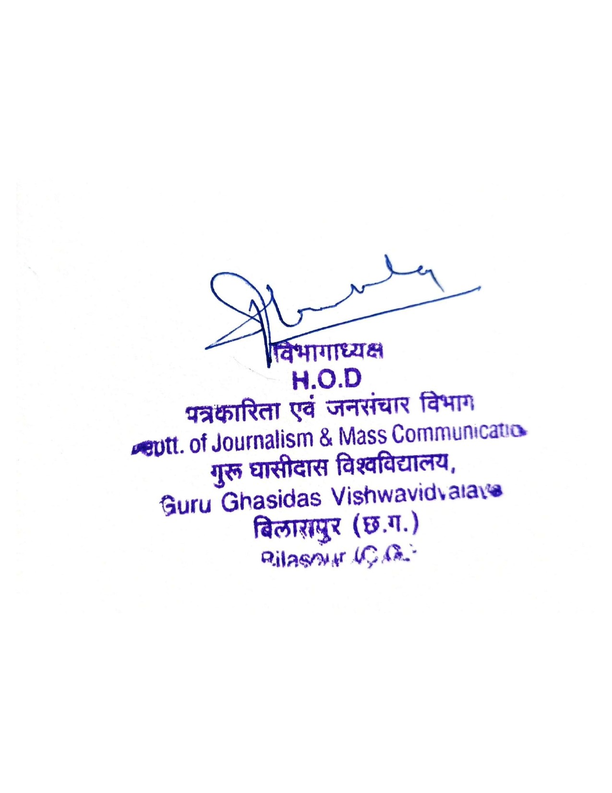
Seal of H.O.D.

