List of Courses which focuses on Professional Ethics, Gender, Human Values, Environment & Sustainability and other value framework
Department : Journalism and Mass Communication

Programme Name : M.A in JMC
Academic Year : 2022-23

Courses which focuses on Professional Ethics, Gender, Human Values, Environment & Sustainability and other value framework:
Sr. No. | Course Code | Name of the Course
01. | JJMUATT1 | Introduction to Journalism
02. | JMUATG1 | Basics of Journalism
03. | JMUATL2 | Media, Gender and Human Rights
04. | JMUBTT1 | Reporting and Editing for Print
05.
06.
07.
08.
09.
10.

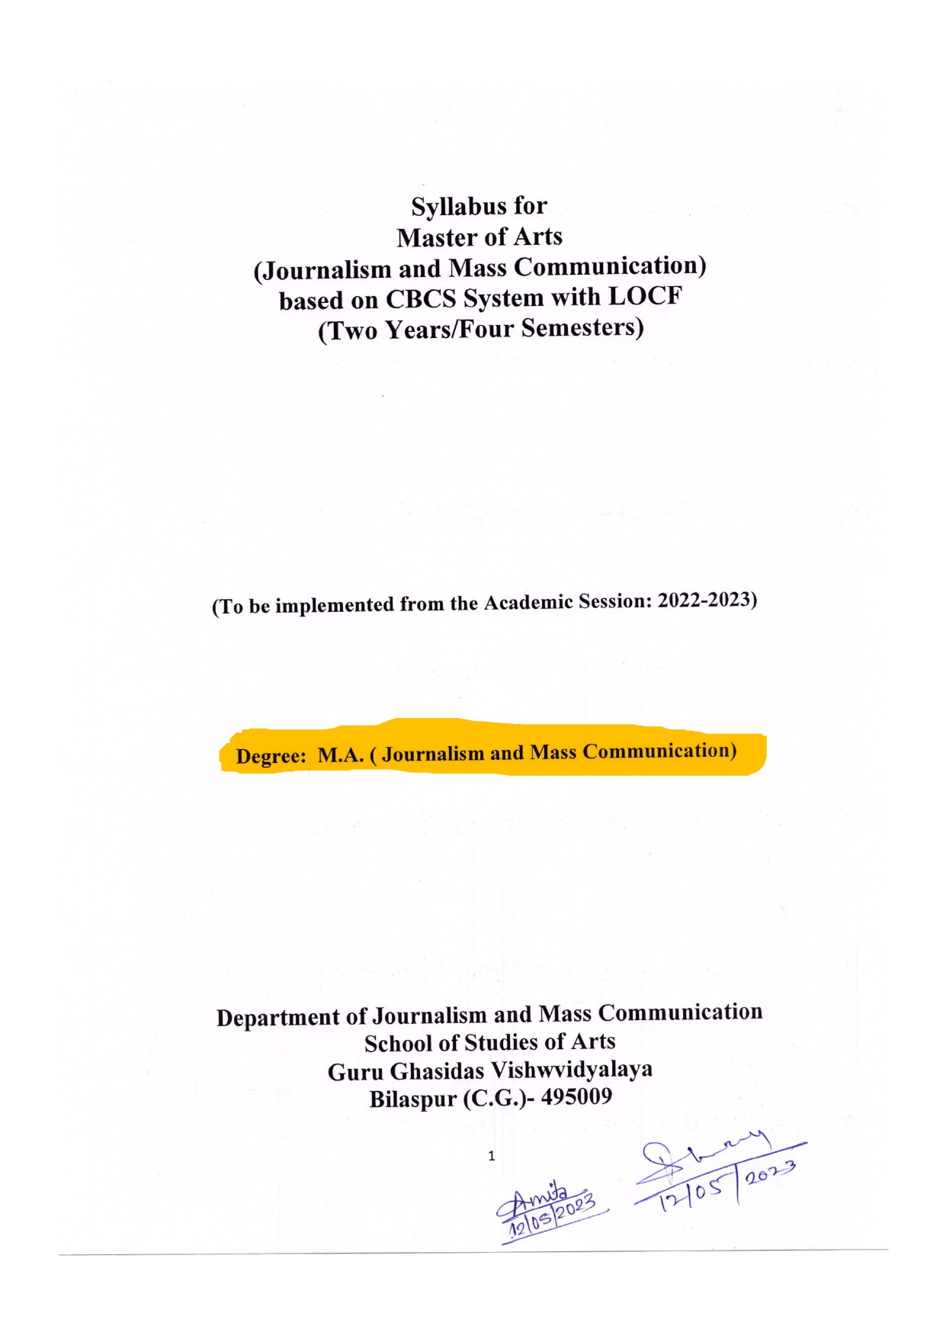
Scheme and Syllabus

