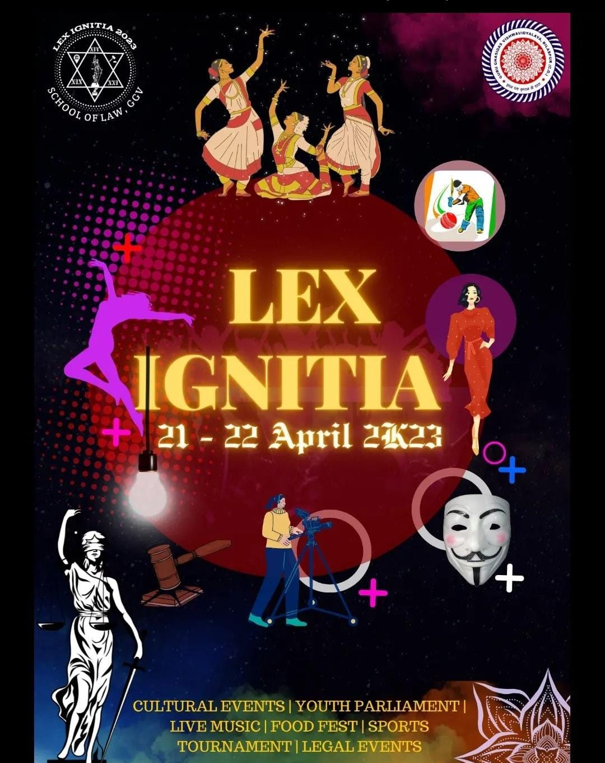

**Introduction**

Guru Ghasidas Vishwavidyala’s Department of Law organized its much-anticipated annual law fest, Lex Ignitia, on April 21-22, 2023, at the Bilaspur campus. This vibrant event brought together law students, faculty, and distinguished guests in a showcase of intellect, artistry, and athleticism, highlighting the multidimensional talents of the students. Lex Ignitia 2023 featured a diverse lineup of activities and competitions designed to provide a comprehensive platform for self-expression and skill development beyond academics.

**Program Highlights**

The two-day festival was packed with activities catering to a wide range of interests, allowing students to engage in intellectual, artistic, and physical challenges. Highlights from the event included:

**1. Talent Hunt**

The fest kicked off with a Talent Hunt, where students captivated the audience with their singing, dancing, and other unique talents. The performances added a lively atmosphere to the opening day, setting a celebratory tone for the fest.

**2. Fashion Parade**

Creativity took centre stage in the fashion parade, with students designing and modeling outfits inspired by themes of social awareness and cultural identity. This event allowed students to use fashion as a form of expression, conveying powerful messages through their attire.

**3. Physical Games**

A spirit of friendly competition filled the air as students took part in several physical games:

* **Cricket Match:** Students showcased their sportsmanship and teamwork in an exhilarating cricket match.
* **Arm Wrestling:** Competitors tested their strength and resilience in thrilling arm wrestling bouts.
* **Sack Race:** The sack race brought a sense of nostalgia and fun, with students hopping their way to victory.
* **Tug of War:** A test of teamwork and strategy, this classic game brought students together in a fun and intense competition.
* **Treasure Hunt:** Clues and riddles led students across the campus in a treasure hunt, challenging their wit and problem-solving skills.

**4. Youth Parliament Competition**

Future leaders showcased their understanding of parliamentary proceedings in a simulated Youth Parliament. This event featured debates on pressing issues through mock sessions of the Vidhan Sabha Committee and the All India Political Party Meet Committee. The competition honed students' public speaking, analytical thinking, and knowledge of legislative processes.

**5. Canvas Competition**

Artistic talents came to life in the Canvas Competition, transforming department corridors into a gallery of creativity. Students presented paintings, sketches, and other artwork, illustrating their perspectives on various social, cultural, and personal themes.

**6. Foodopia**

Adding a culinary dimension to the fest, Foodopia brought together food enthusiasts to present their best dishes. The mini food fest celebrated India's culinary diversity, with students sharing flavors from different regions and their own family recipes.

**7. Performances**

Each evening was punctuated by live performances, with highlights including:

* **Abhinartan Dance Club:** The university's renowned dance club, Abhinartan, captivated the audience with energetic and synchronized routines.
* **Tarang Music Band:** The official band, Tarang, filled the air with soulful melodies and energetic beats, leaving the audience mesmerized.

**Dignitaries and Chief Guests**

The fest was graced by the presence of esteemed guests and university officials, including:

* **Dr . Amit Saxena, In charge Vice Chancellor**
* **Dr . Nilambari Dave, Ex-Vice Chancellor, Shaurastra University, Gujarat**
* **Dr . Shailendra Kumar, Dean of Student Welfare**
* **P.K. Bajpai, IQAC Cell Head**
* **Prof. Manish Shrivastava, Registrar**
* **Dean M.N. Tripathi**
* **Dr . Ajay Kumar Singh, Head of the Law Department**

Their inspiring words underscored the importance of holistic education and the role of co-curricular activities in shaping well-rounded legal professionals.

**Conclusion**

Lex Ignitia 2023 was an inspiring and memorable event, giving students a stage to explore their talents, connect with their peers, and celebrate their diverse abilities beyond the classroom. This festival highlighted the Department of Law’s commitment to fostering a community where students can grow academically, creatively, and socially. As the fest came to a close, Lex Ignitia left a lasting legacy, reminding everyone that law students are not just scholars, but vibrant individuals with a multitude of talents, each contributing uniquely to the university's tapestry.

