**REPORT ON**

**LEGAL AID CELL, DEPARTMENT OF LAW,**

**GURU GHASIDAS VISHWAVIDYALAYA**

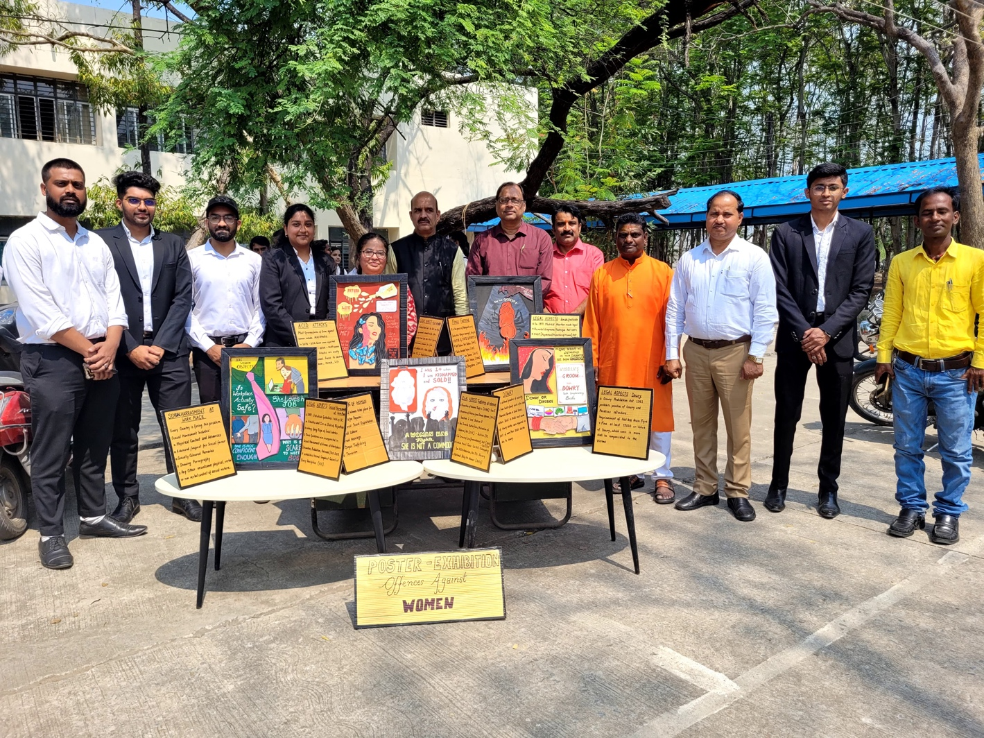

**Introduction**

The Legal Aid Cell of the Law Department at Guru Ghasidas Vishwavidyalaya (GGV) plays an instrumental role in promoting legal awareness, providing free legal services to underprivileged sections of society, and nurturing law students with practical knowledge. It embodies the institution's commitment to social justice and community outreach, in line with the fundamental goals of legal education in India.

**Objectives of the Legal Aid Cell**

The Legal Aid Cell is established with the following primary objectives:

1. **To Provide Legal Assistance**: To offer free legal aid and advice to people from economically disadvantaged and marginalized backgrounds who cannot afford legal representation.
2. **To Raise Legal Awareness**: To educate the public on their legal rights and responsibilities through awareness drives, seminars, and workshops.
3. **To Facilitate Practical Legal Training**: To provide law students with hands-on experience by involving them in real-life legal issues and cases.
4. **To Foster Social Responsibility**: To inculcate a sense of social responsibility among students and encourage them to work towards the betterment of society.

**Structure and Operations**

The Legal Aid Cell is typically structured under the guidance of the Law Department's faculty, who work closely with students to manage the cell’s activities. It comprises:

* **Faculty Coordinators**: Faculty members who oversee and guide the operations, activities, and student engagements within the cell.
* **Student Volunteers**: Law students who volunteer their time and skills to support the cell’s objectives. They participate in organizing legal awareness programs, research, and assisting in the provision of legal aid services.
* **Panel of Legal Advisors**: Often includes faculty with expertise in various areas of law and, at times, practicing lawyers associated with the university or local legal aid committees.

The Cell collaborates with local NGOs, community organizations, and legal aid committees to reach broader sections of society and ensure effective service delivery.

**Key Activities**

1. **Free Legal Aid Clinics**: These clinics provide a platform for people to approach the cell with their legal issues. Student volunteers, under the supervision of faculty, assist individuals in understanding their rights and legal remedies.
2. **Legal Awareness Camps**: The cell conducts outreach programs in rural and marginalized communities to educate them about fundamental rights, legal procedures, and government schemes.
3. **Workshops and Seminars**: Regular workshops, seminars, and guest lectures are organized to address topics like domestic violence, child rights, women’s rights, and labor laws.
4. **Legal Literacy Programs in Schools**: To foster awareness from a young age, the cell often organizes legal literacy programs in local schools, explaining basic legal concepts and rights.
5. **Mock Trials and Moot Courts**: The cell organizes mock trials and moot court competitions to train students in courtroom proceedings, legal drafting, and case analysis.

**Impact and Contributions**

The Legal Aid Cell of GGV’s Law Department has made significant contributions by:

* Assisting numerous individuals in understanding their legal rights, thus empowering them to take legal action when necessary.
* Building a sense of legal consciousness among the public and sensitizing students to societal issues.
* Providing students with practical exposure to handling cases, thereby bridging the gap between theoretical learning and practical implementation.

**Challenges Faced**

Despite its impactful activities, the Legal Aid Cell faces several challenges:

* **Resource Constraints**: Limited funding and resources restrict the scope and outreach of the cell’s activities.
* **Awareness and Accessibility**: Many potential beneficiaries remain unaware of the cell’s existence or are unable to reach it due to geographical limitations.
* **Complex Legal Issues**: Some cases presented to the cell involve complex legal questions that require specialized knowledge, sometimes beyond the current capacity of student volunteers.

**Conclusion and Recommendations**

The Legal Aid Cell at Guru Ghasidas Vishwavidyalaya serves as an essential bridge between academia and the community, fostering a culture of justice and equality. To enhance its effectiveness, the cell could consider:

* Increasing collaboration with local bar associations and legal professionals for technical support.
* Expanding outreach initiatives through digital platforms and social media to reach a broader audience.
* Securing additional funding through grants to support a wider range of services.

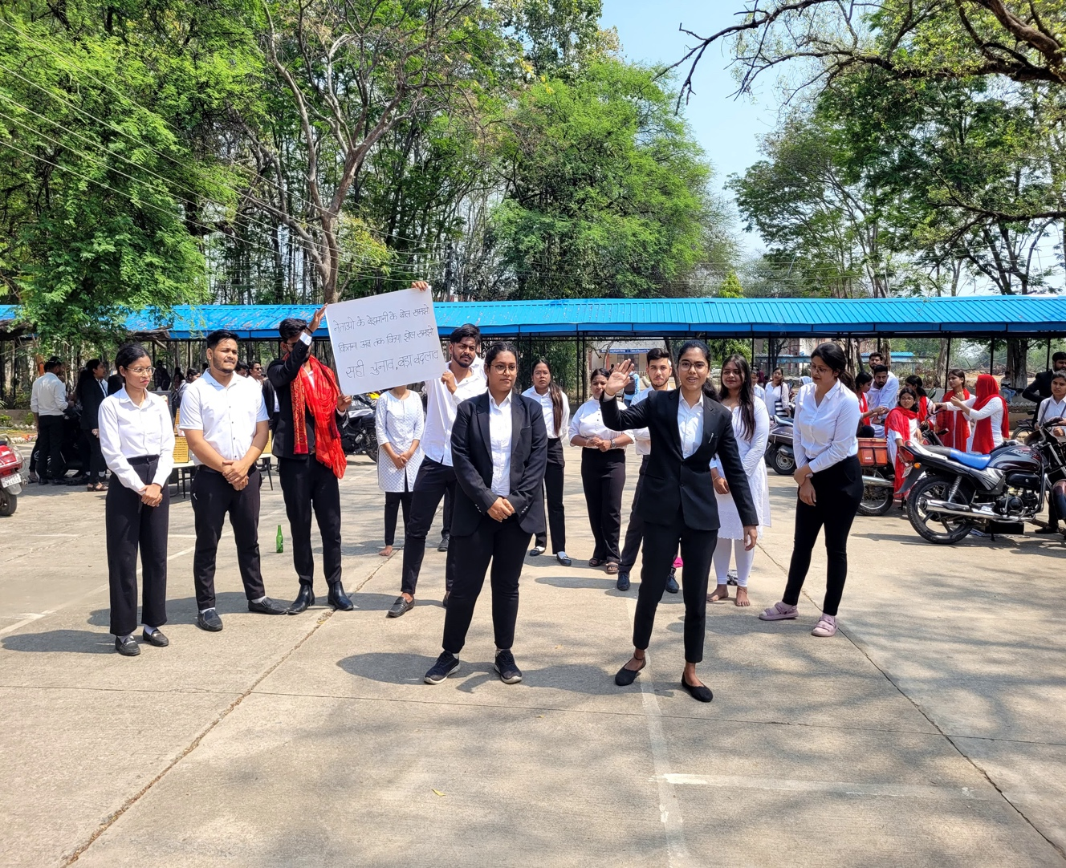In conclusion, the Legal Aid Cell of the Law Department at GGV stands as a beacon of social responsibility and professional development for law students, contributing meaningfully to both the legal profession and society at large.

