**SPEAKER’S FORUM**

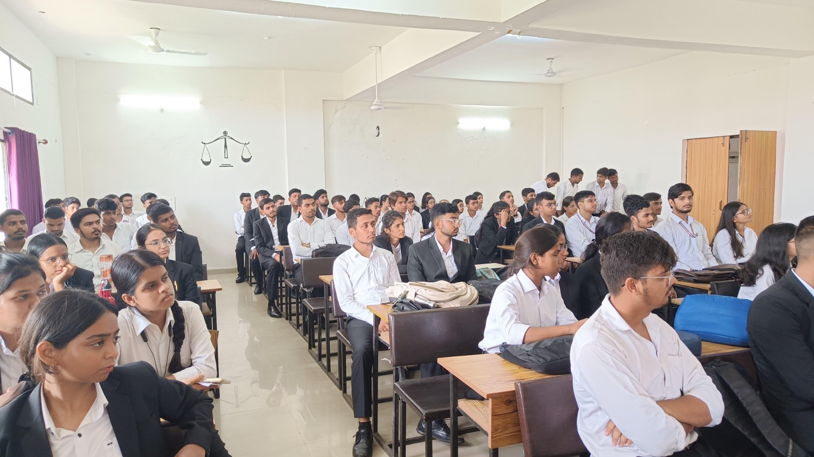

# Session Report

**Topic:**

**“Women Reservation Bill: Need of the hour or devious political strategy?"**

**Date: 06-10-2023**

**Index**

|  |  |
| --- | --- |
| **Acknowledgement** | 02 |
| **Introduction**  **About Speaker’s Forum**  **Objective of the Speaker’s Forum**  **Modes and Rules for The Debating sessions** | 03- 06 |
| **Session Report** | 07 – 11 |
| **Name of the participants** | 12-13 |
| **Photo of the session** | 14 |

**Acknowledgement**

The resounding success of our 5th Speaker's Forum session stands as a testament to unwavering dedication, astute leadership, and invaluable technical expertise.

This achievement would not have been possible without the unwavering support and guidance of the esteemed management of the Law Department. We extend our deepest gratitude to Dr. Ajay Singh, the Head of the Department of Law, whose wisdom and mentorship have been pivotal in our journey.

We take immense pleasure in acknowledging Dr. Sagar Kumar Jaiswal, the School's cultural coordinator, for his unwavering encouragement and support.

Under his tutelage, our Speaker's Forum tackled the challenging topic of the "Women Reservation Bill: Need of the hour or devious political strategy" with finesse. His provision of essential resources and guidance enhanced our understanding and enriched our learning. We will forever cherish the memories of this experience and remain committed to pushing our boundaries even further in the future.

Our heartfelt gratitude extends to the esteemed Sudhanshu Mahapatra Sir and Nidhi Mam, whose unwavering dedication and efforts merit our sincere appreciation. .

Our heartfelt appreciation extends to every member of the Speaker's Forum who generously contributed their time and attention to ensure the successful culmination of this session.

Lastly, but certainly not least, we extend our gratitude to all the participants and spectators. Your presence played a pivotal role in transforming this session into a truly remarkable and unforgettable experience. We eagerly look forward to your continued support in our upcoming sessions.

**Introduction**

## About Speaker’s Forum

The Speaker's Forum is a dynamic platform envisioned and crafted by the students of the esteemed Department of Law at Guru Ghasidas Central University in Chhattisgarh. Its purpose is to serve as a bastion for the organization of enlightening debate sessions and stimulating discussions, all under the guidance of the School of Law.

Within the Speaker's Forum, we proudly welcome participants and speakers hailing from the various echelons of our law program, encompassing students from all five academic years, including both B.A. LLB and B.Com LLB. Our primary objective revolves around the honing and nurturing of a fundamental legal skill - the art of debate. Recognizing its pivotal role in the early stages of legal education, our Forum has diligently committed itself to fostering and refining this vital ability.

In our modern political landscape, we firmly believe that democracy and debate are inseparable companions. Consequently, the Speaker's Forum is dedicated to orchestrating debates and discussions that serve to refine the speaking and research acumen of our participants. These sessions are meticulously curated, with topics rigorously researched and debated upon by our dedicated coordinators. Once approved by the department, these topics are unveiled to the entire Department of Law.

Our Forum is an open invitation to all law students who seek to partake in the rich tapestry of debate and discussion. We are acutely mindful of our students' academic commitments, ensuring that our sessions are thoughtfully scheduled on Fridays, conveniently following the conclusion of their classes. This way, our participants never have to choose between their academic pursuits and their engagement with the Speaker's Forum.

In essence, the Speaker's Forum stands as a beacon of intellectual growth and discourse within our academic community, where the art of debate is cultivated, and the spirit of democracy is celebrated

**Objective of the Speaker’s Forum:**

The art of skilled debate confers a multitude of invaluable advantages, encompassing the cultivation of research acumen, sharpening of logical faculties, and the refinement of eloquent public speaking abilities. Embracing the world of debating equips individuals with the tools to confront life's challenges, teaching them the art of crafting a compelling case, even in the face of personal disagreement, and the delicate precision of word selection. The Speaker's Forum, in its noble mission, seeks to immerse law students into the vibrant tapestry of debating culture. It stands as a staunch advocate for nurturing critical thinking, instilling civic responsibility, fostering exemplary etiquette, nurturing the art of thought organization, honing the skill of persuasion, and elevating the art of public speaking. As aspiring champions of justice within society, every law student is entrusted with the profound responsibility of developing their speaking prowess, amassing knowledge, and mastering the art of debate. This journey not only paves the path for their future livelihood but also bestows upon them the mantle of informed and responsible citizens of our great nation. Additionally, the Speaker's Forum endeavors to create a symbiotic relationship within the law school community. It envisions senior members of the institution imparting their wisdom and experience to their juniors, acting as torchbearers in the art of debate and the delicate art of embracing differing viewpoints. In doing so, it fosters an environment of learning intertwined with the joys of camaraderie, where seniors and juniors engage in a harmonious dance of intellectual exchange within the hallowed halls of our law school.

**Modes and Rules for The Debating sessions:**

The session unfolds in a meticulously structured manner, bifurcated into two distinct segments of intellectual discourse. The initial phase comprises the General Session, where participants deliver their overarching speeches. Subsequently, we transition into the Open Round, a more concise yet equally impactful segment.

Language knows no boundaries within this forum, as speeches are invited to embrace the multilingual tapestry of our nation. Here, participants are encouraged to weave their thoughts and ideas using a blend of Hindi and English, reflecting the rich linguistic diversity of our culture.

The dimension of time is a precious commodity, and as such, participants delivering General Speeches are granted a maximum of two minutes to articulate their perspectives. During the Open Round, brevity reigns supreme, with each participant allotted a concise one-minute window. In the spirit of interactive discourse, Points of Information may be raised, offering participants a brief ten-second interlude to engage in the exchange of ideas.

The substance of speeches is expected to be comprehensive and well researched. Participants are encouraged to draw from a broad spectrum of legal resources, incorporating foreign laws and statutes, foreign case precedents (if pertinent), Indian case law, Indian statutory provisions, and an array of research materials that extend beyond the confines of traditional sources. These encompass scholarly articles, blogs, and newspaper contributions from reputable online platforms (excluding Wikipedia, Mint, and Quint).

In the pursuit of intellectual enrichment, participants are invited to reference the wisdom of jurists and authors, drawing upon their books, quotes, legal maxims, and the reservoir of political thought. However, it is paramount to note that discussions within this forum are carefully directed away from frivolous tangents and meticulously avoid entanglement with political, religious, or caste matters. Instead, the focus remains firmly grounded in fostering profound legal and intellectual discourse.

**Session Report**

**5th Session of the Speaker’s Forum**

**Topic: “Women Reservation Bill: Need of the hour or devious political strategy”**

**What is women reservation bill 2023?**

**Women's Reservation Bill 2023** (*Nari Shakti Vandan Adhiniyam*), officially the **The Constitution (One Hundred and Twenty-Eighth Amendment) Bill 2023**, is a bill introduced in the Parliament of India. This Women's Reservation Bill was introduced in Lok Sabha on 19 September 2023 during the special session of Parliament.This legislation seeks to allocate 33 percent of the seats in the directly elected Lok Sabha and state legislative assemblies for women.

**Constitutional provisions**

Article 15, Article 16, Article 82, Article 330

### Progress

The bill is the possible culmination of a legislative debate that had been ongoing for 27 years, including the lapsed Women's Reservation Bill (2010), due to the lack of consensus among political parties. The bill was the first that was considered in the new parliament building. On 20 September 2023, Lok Sabha passed the bill with 454 votes in favour and two against. The Rajya Sabha passed the bill unanimously with 214 votes in favour and none against, on 21 September 2023. President Droupadi Murmu signed the bill on 29 September 2023, and the gazette notification was also published the same day, which made it clear that the reservation will come into force soon after the first delimitation.

### Judicial aspect

Article 15 of the Constitution provides for the prohibition of discrimination on grounds of religion, race, caste, sex or place of birth. At the same time, clause

(3) of Article 15 carves out space for “special provisions” being created for women and children.

Article 16 provides for “equality of opportunity in matters of public employment”, which has so far been the provision that underlies the reservation for Scheduled Castes, Scheduled Tribes, Other backward Castes and even the Economically Backward sections.

A nine-judge bench of the Supreme Court, in its judgment passed in November

1992 in the matter of ‘Indra Sawhney Vs Union of India' had observed that clause (4) of Article 16 speaks of “adequate representation and not of proportionate representation.”

At present, a number of petitions are pending before the Supreme Court regarding the validity of the reservations, the method of implementation and the need for a caste census to determine the actual representation of the SC/ST and OBCs in education, employment as well as local body election reservations.

### Cause of discussion

The 2023 composition of the Lok Sabha reveals underrepresentation of women Members of Parliament (MPs), constituting less than 15 percent of its members.

Similarly, this gender disparity is stronger in state assemblies including Andhra

Pradesh, Arunachal Pradesh, Assam, Goa, Gujarat, Himachal

Pradesh, Karnataka, Kerala, Madhya

Pradesh, Maharashtra, Manipur, Meghalaya, Odisha, Sikkim, Tamil Nadu, Telangana, Tripura and Puducherry, where the representation of women falls below 10 percent.

### Issue of Discussion

Critics of this legislation argue that the reservation of seats exclusively for women would primarily favour educated and urban women, consequently neglecting the underprivileged rural women belonging to marginalized castes. Conversely, proponents of this bill assert that the opposition from leaders of these political parties stems from patriarchal tendencies, as they apprehend a potential loss of power to women if a significant portion of seats is allocated to them.

Political parties; Congress, Samajwadi Party, and Rashtriya Janata Dal have criticised the bill as it does not have provision for reserved seats for OBC and Minorities women, which seeks to ensure equal representation for OBC and Minorities women. As the absence of quota for OBC and minorities would make it more difficult for the marginalised women to raise their voices in the Parliament.

### For the Motion

1. **Promoting Gender Equality:**

Proponents argue that the bill would be a significant step towards achieving gender equality in politics. Historically, women have been underrepresented in legislative bodies, which hampers their ability to influence policy decisions and advocate for issues affecting women. Reservation would provide a platform for women to participate actively in decision-making processes, ensuring their voices are heard.

1. **Empowering Women:**

Reservation can serve as a catalyst for empowering women and fostering leadership qualities among them. Increased representation would inspire more women to enter politics, encouraging them to take up leadership roles and contribute to governance. This empowerment can lead to better policies addressing gender-based discrimination, violence against women, and socioeconomic disparities.

1. **Diverse Perspectives and Inclusive Governance:**

Women bring unique perspectives and experiences to the table, enriching the decision-making process. Reservation would ensure that diverse viewpoints are represented, leading to more inclusive governance. It is argued that women tend to prioritize social welfare, education, healthcare, and other issues that directly impact families and marginalized communities.

1. **Promotion of Women's Issues:**

Women in politics often prioritize and advocate for issues that directly affect women, such as gender-based violence, women's health, education, and economic empowerment. Their presence can lead to the prioritization of these issues in policy discussions.

1. **Role Models:**

Women leaders in politics can serve as role models for young girls, encouraging them to aspire to leadership positions in various fields. Representation in politics can break stereotypes and inspire future generations.

### Against the Motion

1. **Merit-Based Selection:**

Reservation based solely on gender compromises the principle of meritocracy. They contend that political positions should be awarded based on an individual's capabilities, experience, and qualifications rather than their gender. Reservation may result in the selection of less qualified candidates, undermining the quality of governance and potentially perpetuating stereotypes.

1. **Tokenism and Marginalization:**

Reservation can lead to tokenism, where women are seen as mere placeholders rather than being recognized for their abilities. They argue that true empowerment should come from providing equal opportunities and creating an environment conducive to women's participation in politics, rather than relying on quotas. Reservation may also inadvertently marginalize other marginalized groups, such as lower caste women or women from economically disadvantaged backgrounds.

1. **Political Dynasties and Elite Capture:**

Reservation may inadvertently reinforce political dynasties, as influential families could dominate the reserved seats. This could limit the entry of new voices and perpetuate the concentration of power in the hands of a few. Critics also argue that elite capture is a significant concern, as privileged women from well-connected backgrounds may benefit more from reservation, while marginalized women continue to face barriers to political participation.

**Conclusion:**

The Woman Reservation Bill 2023 remains a subject of intense debate, reflecting the complexities surrounding gender equality and political representation. While proponents argue that reservation would lead to increased gender equality, empowerment, and inclusive governance, opponents highlight concerns related to meritocracy, tokenism, and potential elite capture. As society progresses towards gender parity, it is crucial to consider these arguments and find a balanced approach that ensures equal opportunities for women in politics while upholding principles of fairness and meritocracy.

# Participants

|  |  |  |
| --- | --- | --- |
| Name | Semester |  |
| Archana kumari Law | 2nd | For the motion |
| Kushagra Gupta | 2nd | For the motion |
| Shriya Dubey | 2nd | For the motion |
| Aayush Yadav | 2nd | For the motion |
| V k Radha Krishna | 2nd | For the motion |
| Harsh Mourya | 2nd | Against the motion |
| Manas Raj | 2nd | For the motion |
| Priyanka Arya | 2nd | For the motion |
| Sudhanshu Singh | 2nd | For the motion |
| Nayan Mishra | 2nd | For the motion |
| Nayan Mishra | 2nd | For the motion |
| Akash Tiwari | 2nd | Against the motion |
| Himanshee  Dewangan | 2nd | For the motion |
| Vibhay Chandravanshi | 5th | For the motion |
| Saurabh Singh | 2nd | For the motion |
| Ankush Gajanan  Khulge | 2nd | For the motion |
| Rahul Gupta | 2nd | For the motion |
| Radhika kumari | 2nd | For the motion |
| Radhika kumari | 2nd | For the motion |
| Pranidhi | 2nd | For the motion |
| Abhishek Kumar | 2nd | Against the motion |
| Ankita Saxena | 7th | For the motion |
| Snehil Thawait | 2nd | For the motion |
| Arya | 2nd | For the motion |
| Devesh Raj | 2nd | For the motion |
| Unnati Sahu | 2nd | For the motion |
| Vedansh shastri | 5th | For the motion |
| Amsha Sheikh | 2nd | For the motion |
| Ruchi Rao | 2nd | Against the motion |
| Pratiksha Bijore | 2nd | For the motion |
| Devek Raj | 2nd | Against the motion |
| Libance Bhagat | 2nd | Against the motion |
| Anshum Tiwari | 2nd | For the motion |
| Arpit Upadhyay | 2nd | For the motion |
| Sharmistha Rathore | 7th | Against the motion |
| Khushi Agrawal | 7th | For the motion |

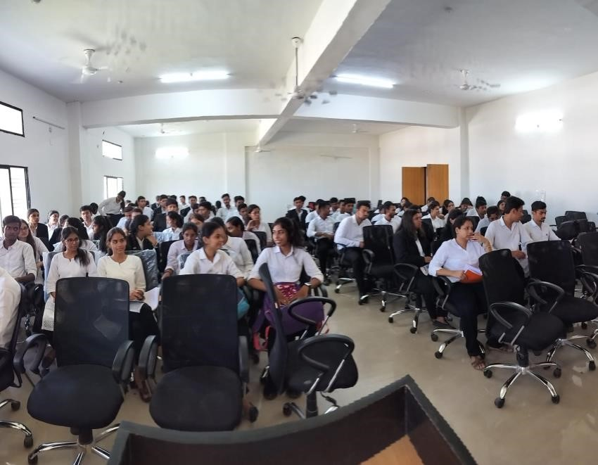 **Photos of the session**

