**Report on Annual Day Function of “Young Managers Club – BIHAAN 2025”**

**Event Name**: Annual Day Function of Young Managers Club – BIHAAN 2025  
**Date of the Event**: 4th April, 2025  
**Venue**: Rajat Jayanti Sabhagar - Hall No. 1  
**Number of Participating Students**:84  
**Convener**: Dr. B.B. Pandey  
**Co-convener**: Dr. Prem Shankar Diwedi

**Introduction**

The "Annual Day Function of Young Managers Club – BIHAAN 2025" was held on 4th April 2025 at Rajat Jayanti Sabhagar - Hall No. 1. The event was organized by the Department of Management Studies, GGV, with the aim of celebrating the achievements of students in academics, sports, and cultural activities. The event was a platform for students to showcase their creativity and talents while receiving recognition for their hard work and dedication. A total of 84 students participated in the event, which was made possible by the efforts of the organizers and faculty members.

**Inaugural Ceremony**

The programme commenced with the auspicious lighting of the ceremonial lamp by the dignitaries of the event. The esteemed guests who graced the occasion included:

* **Prof. Amit Kumar Saxena**, Acting VC, GGV
* **Prof. A.S. Randive**, Registrar, GGV
* **Prof. Shailendra Kumar**, Dean Student Welfare, GGV
* **Dr. B.D. Mishra**, Dean, School of Commerce and Management, GGV
* **Dr. Sanjay Pandey**, Head of the Department, Department of Management Studies, GGV

Their presence added great value to the event, symbolizing the importance of education, teamwork, and leadership.

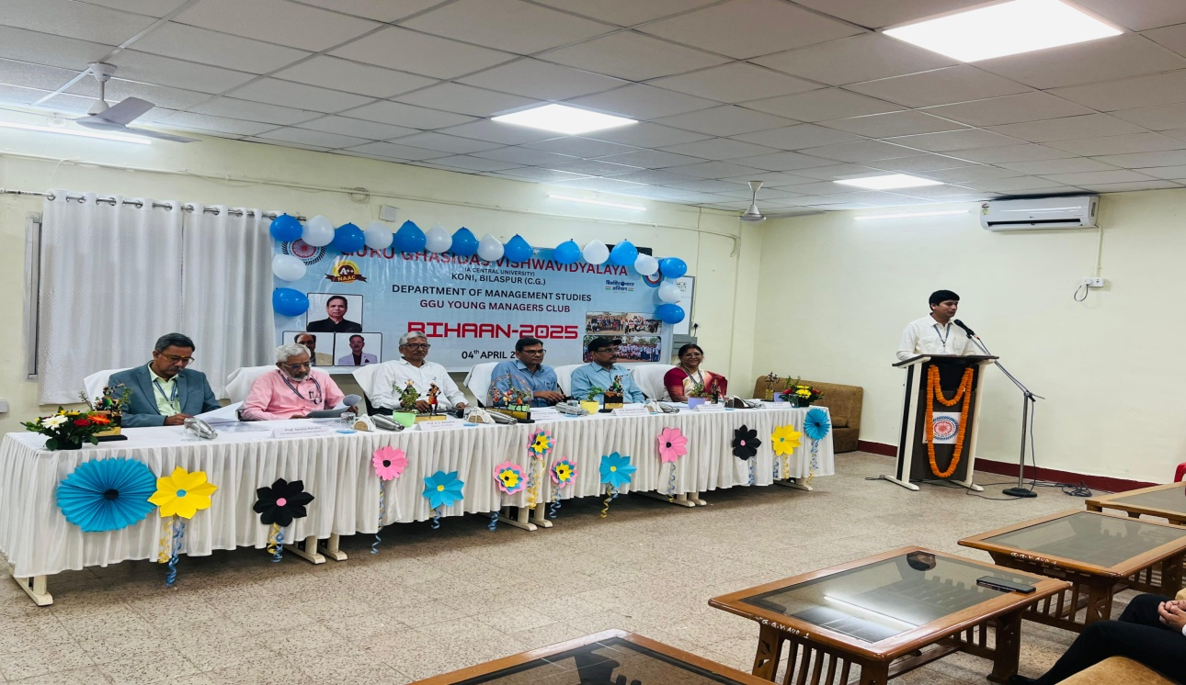

Dignitaries on the dias

**Purpose of the Young Managers Club**

The Young Managers Club was formed with the purpose of fostering the overall development of students, helping them discover and sharpen their unique talents and creativity. The club provides a platform for students to engage in a variety of academic, sports, and cultural activities, allowing them to grow as well-rounded individuals. The department of Management Studies organized several events, such as:

* **Academic Activities**: Essay Writing, Quiz Competitions, Extempore, Poster Making Competitions
* **Sports Activities**: Cricket, Badminton, Football, Carrom
* **Cultural Activities**: Singing Competitions, Painting, Rangoli Competitions

These events aimed to enhance students' abilities, encourage teamwork, and cultivate a spirit of healthy competition.

**Program Highlights**

1. **Welcome Address**

The event began with a **Sanskrit Shloka** and **Saraswati Vandana**, presented by the Co-convener and anchor of the event, **Dr. Prem Shankar Diwedi**. This was followed by the **welcome address** delivered by **Prof. Sanjay Pandey**, HOD, Department of Management Studies. In his speech, Prof. Pandey highlighted the achievements of the students and the importance of such events in fostering overall growth.

1. **Annual Report**

The **Annual Report** was read by the **Student President**, Ayush Shrivastav, of the Young Managers Club. The report provided an overview of the activities, achievements, and progress made by the club over the past year.

1. **Awards and Recognition**

The Annual Day Celebration served as a platform to recognize the academic and extracurricular accomplishments of the students. Prizes, certificates, and awards were distributed to students who excelled in various subjects and activities. Special recognition was given to the **Student of the Year**, a prestigious award that highlighted exceptional all-round performance.

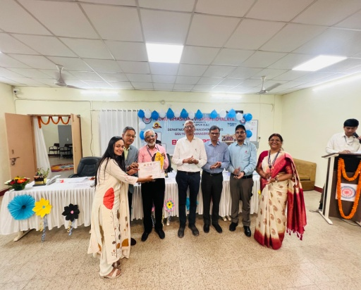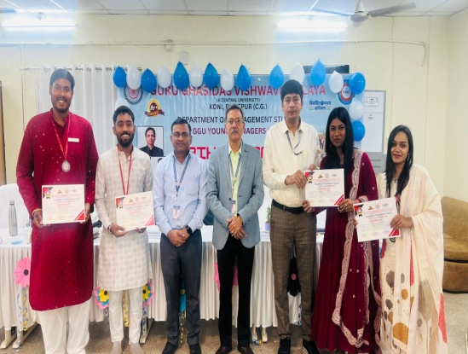

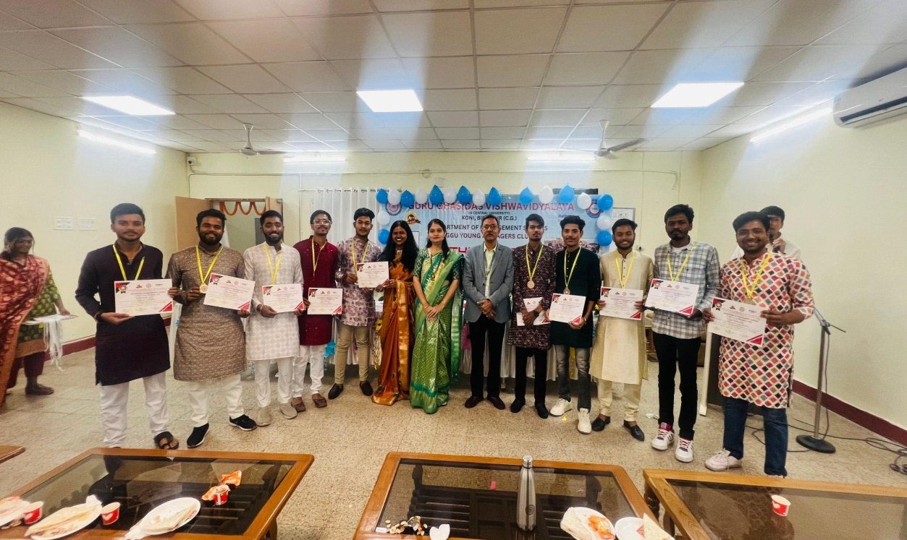

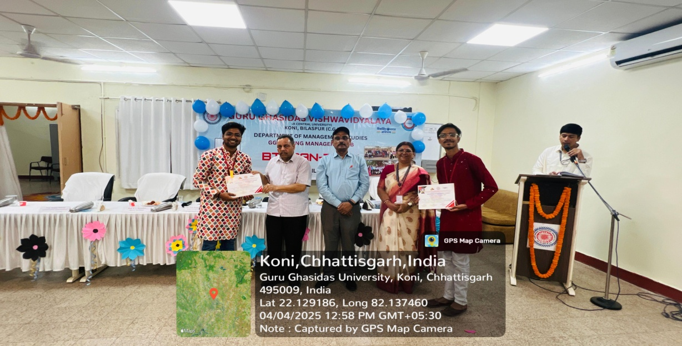

1. **Cultural Performances**

As part of the cultural segment of the event, students showcased their talent through various performances. These included singing, dancing, and other creative expressions. The performances were greatly appreciated by both students and faculty, adding vibrancy to the occasion.

1. **Faculty and Student Engagement**

The event was marked by a spirit of camaraderie, as students and faculty members interacted, celebrated achievements, and enjoyed the cultural performances. It was evident that the occasion brought a sense of pride and accomplishment to all participants.

1. **Vote of Thanks**

The event concluded with a heartfelt **Vote of Thanks**, delivered by **Riya Advani**, Secretary of the Young Managers Club. In her speech, she expressed gratitude to the faculty, dignitaries, and participants for making the event a success.

**Conclusion**

The Annual Day Function of Young Managers Club – BIHAAN 2025 was a resounding success. It not only celebrated the academic, extracurricular, and sports achievements of students but also fostered a sense of unity and school spirit. The event proved to be an excellent platform for students to showcase their talents and gain recognition for their hard work. As the event concluded, there was a renewed sense of motivation and inspiration among the students, pushing them to strive for greater achievements in the future.

The Young Managers Club continues to play a pivotal role in the development of students, encouraging them to engage in activities that nurture their holistic growth. The department looks forward to more such successful events in the coming years.